GOVERNMENT COLLEGE FOR WOMEN (A) GUNTUR
DEPT OF POLITICAL SCIENCE
CERTIFICATE COURSE IN HUMAN RIGHTS

16-11-23 to 28-12-23
BROCHURE

Government College for Women (A), Guntur
Department of Political Science
Certificate Course in HUMAN RIGHTS
Join us for an enriching journey into the heart of HUMAN RIGHTS!
Course Overview:
- Exposure to the meaning, scope, and importance of human rights as universal and inalienable rights of every person.
- To trace the emergence and evolution of universal human rights from historical and contemporary perspectives
- Learn from esteemed experts in the field.
Course Details:
- Duration: 16th November 2023 to 28th December 2023
- Total Hours: 32 hours
- Class Timings: 4 pm to 5 pm
Don't miss this opportunity to delve into Human Rights!
Register Now , All students are eligible to enroll

Contact Information:
Department of Political Science

Government College for Women (A), Guntur
,
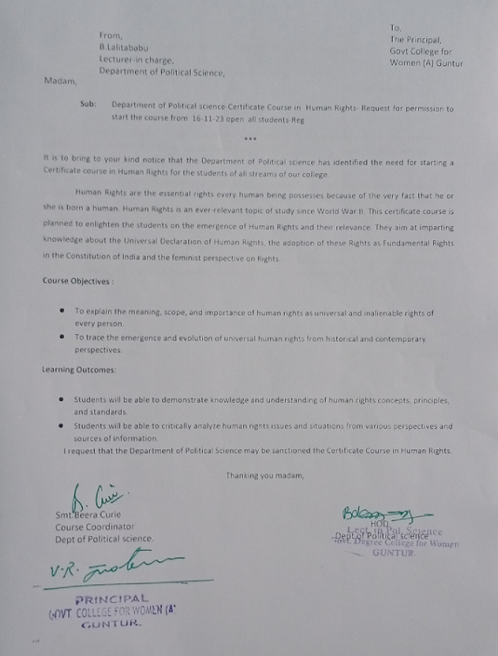

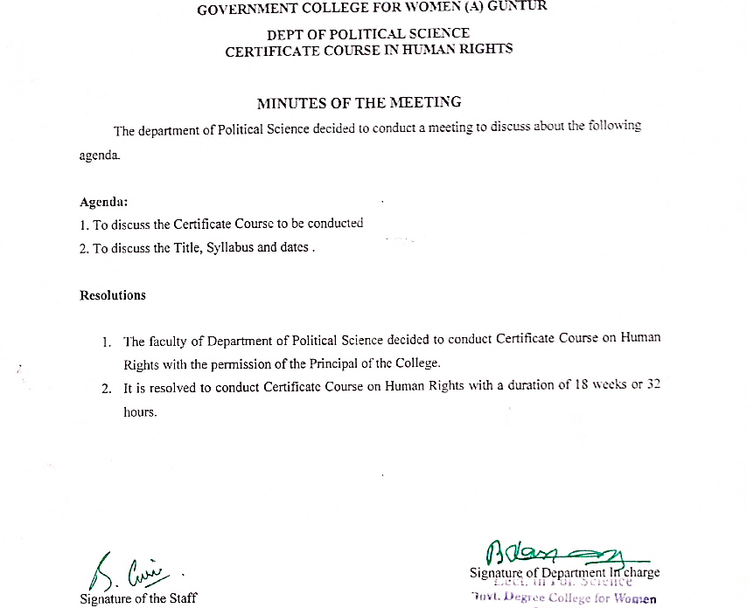

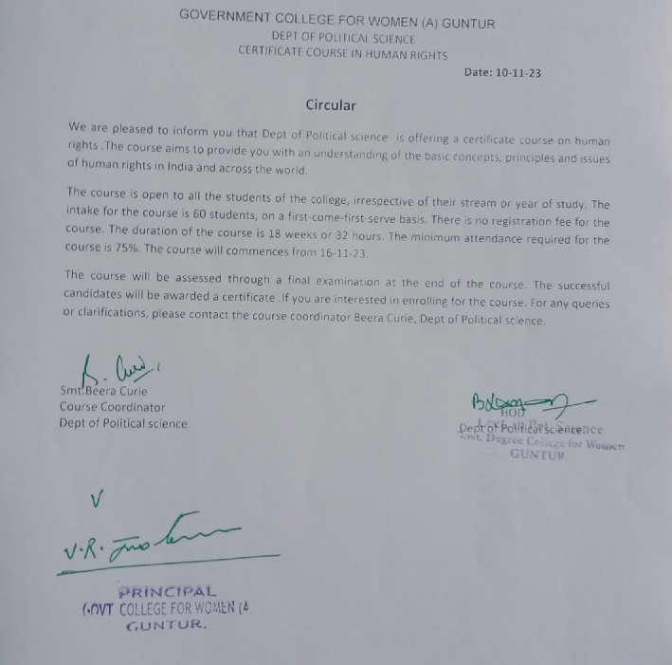

GOVERNMENT COLLEGE FOR WOMEN (A) GUNTUR
DEPT OF POLITICAL SCIENCE
CERTIFICATE COURSE IN HUMAN RIGHTS

NO of students enrolled : 102
NO of students Discontinue : 13
NO of students Absent to the Exam : 11
NO of students Attended Exam : 78
NO of students Passed Exam : 78

GOVERNMENT COLLEGE FOR WOMEN (A) GUNTUR
DEPT OF POLITICAL SCIENCE
CERTIFICATE COURSE IN HUMAN RIGHTS
The course is significant because it aims to:
- Develop a understanding of human rights concepts, principles, and standards among students.
- Enhance students’ skills in applying human rights knowledge to their own contexts and situations.
- Foster students’ attitudes and values that respect and promote human rights for themselves and others.
Course Objectives on Human Rights :
- To explain the meaning, scope, and importance of human rights as universal and inalienable rights of every person.
- To trace the emergence and evolution of universal human rights from historical and contemporary perspectives.
- To analyze the Universal Declaration of Human Rights and its significance for the protection and promotion of human rights worldwide.
- To understand the making of rights in India and the role of the Constituent Assembly in drafting the Fundamental Rights and Directive Principles in the Indian Constitution.
- To evaluate the enforcement and protection of human rights in India, with a focus on the various commissions for the rights of vulnerable groups.
Learning Outcomes:
- Students will be able to demonstrate knowledge and understanding of human rights concepts, principles, and standards.
- Students will be able to critically analyze human rights issues and situations from various perspectives and sources of information.
- Students will be able to apply human rights knowledge and skills to their own contexts and situations, and identify potential solutions and actions.
- Students will be able to communicate effectively and respectfully about human rights with diverse audiences and stakeholders.
- Students will be able to develop attitudes and values that respect and promote human rights for themselves and others.

Learning Outcomes:
Human Rights are the essential rights every human being possesses because of the very fact that he or she is born a human. Human Rights is an ever-relevant topic of study since World War II. This certificate course is planned to enlighten the students on the emergence of Human Rights and their relevance. They aim at imparting knowledge about the Universal Declaration of Human Rights, the adoption of these Rights as Fundamental Rights in the Constitution of India and the feminist perspective on Rights.
CERTIFICATE COURSE IN HUMAN RIGHTS – 32 HOURS
Sl. No. | Syllabus | No. of Hours | No of Credits
1 | Human Rights: Meaning, Scope and Importance | 4 | 2
2 | Emergence of Universal Human Rights | 4
3 | Universal Declaration of Human Rights | 4
4 | The Making of Rights in India – The Constituent Assembly | 5
5 | Fundamental Rights and Directive Principles in Indian Constitution | 5
6 | Enforcement of Human Rights in India – Various Commissions for protection of Rights of Vulnerable Groups in India | 5
7 | Feminist Perspective on Rights | 5
 | Total No. of Hours | 32 | 2

Circular among students: General information about the Certificate course:
- Eligibility: Any student interested in the contents of the course
- Minimum number of students intake into the course is 20.
- There is no registration fee for the course.
- The duration of the course is 18 weeks of teaching-learning with a minimum of 30 hrs contact hours spread over a period of 3 months from16-11-23 to20-01-24
- There shall be a minimum of 75% of students’ attendance in the course.
- Handouts , worksheets and other relevant material will be provided
- The evaluation is based on attendance in the sessions, completion of a course project, Formative and Summative assessment.

