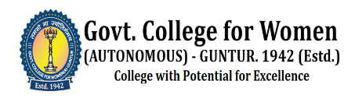
LADY HOPE ALUMNI ASSOCIATION
GOVERNMENT COLLEGE FOR WOMEN, GUNTUR
Regd. No:132 of 2020
ACTION PLAN-2020-2021

S.No | Tentative Dates | Name of the Activity | Resource Person/Organization
1 | 05 Nov 2020 | BoS Meeting of Home Science Department  ( Online) | Dr. J. Lakshmi, ANGRAU, Guntur
2 | 20 April 2021 | Contribution for CC TV Cameras Installation | Mrs G. Annie Amrutha Niharika (Australia)
3 | 28 Dec 2021 | Donation of Geysers to Student Managed Hostel | Dr. R. Sarah Kamala & Alumni of 1976-79 Batch
4 | Throughout Pandemic | Distribution of Food and Groceries to the Needy | Mrs. B. Vara Lakshmi, Lec. in English (Rtd)

LADY HOPE ALUMNI ASSOCIATION
GOVT.COLLEGE FOR WOMEN, GUNTUR

Our college is proud to host the Lady Hope Alumni Association, an organization registered under number 132/2020, boasting over four hundred dedicated members. This vibrant association plays a crucial role in supporting the institution both financially and academically, demonstrating an unwavering commitment to the college’s growth and success.
Despite the challenges posed by the COVID-19 pandemic, which rendered physical gatherings impossible, our alumni displayed remarkable resilience and dedication. They adapted to the circumstances by providing essential local assistance to those in need during this unprecedented period, highlighting the spirit of community and service that defines our alumni network.
A shining example of our distinguished alumni is Dr. J. Lakshmi, a prominent figure in the field of Food Science and Nutrition. Dr. Lakshmi holds esteemed positions as Principal Scientist, Associate Dean, and Head of the Department of Food Science and Nutrition at Acharya N.G. Ranga Agricultural University (ANGRAU) in Guntur. Reflecting her deep connection to our college and her expertise, Dr. Lakshmi served as a subject expert during the Board of Studies (BoS) meeting for the Home Science Department at Government College for Women (GCW), Guntur. This meeting, held online on November 5, 2020, benefitted immensely from her insights and guidance.
The ongoing contributions of our alumni, exemplified by the efforts of individuals like
Dr.J. Lakshmi, underscore the lasting impact of our college’s education and the strength of our alumni network. We remain grateful for their continued support and their dedication to fostering excellence within our academic community.

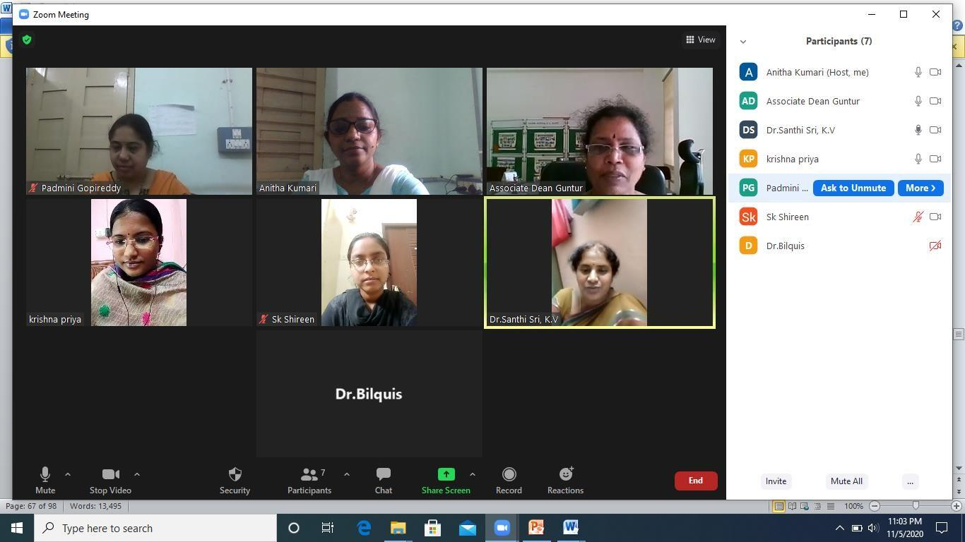
Bos member Dr. J. LAKSHMI, principal scientist, associate dean and Head,Dept of Food Science and nutrition, ANGRAU, GUNTUR

2.Arrangement of CC cameras
2.In April 2021, Mrs. D.Uma Botany lecturer and Annie Amrutha Niharika from Australia, generously contributed ₹50,000 to enhance the security of the hostel. Their thoughtful donation was used to purchase CCTV cameras, ensuring a safer environment for all residents of Hostel.
3.Installation of Geysers for Hostel
On December 28, 2021, distinguished alumni Dr. R. Sarah Kamala, a principal scientist at the Agricultural University in Telangana, along with Mrs. N. Aruna Mani and Mrs. Dhana Lakshmi from the 1976-79 batch, generously donated two 100-liter capacity geysers to the student-managed hostel at our college. Their contribution significantly enhances the hostel's facilities, providing students with improved amenities and demonstrating the enduring support and commitment of our alumni community.

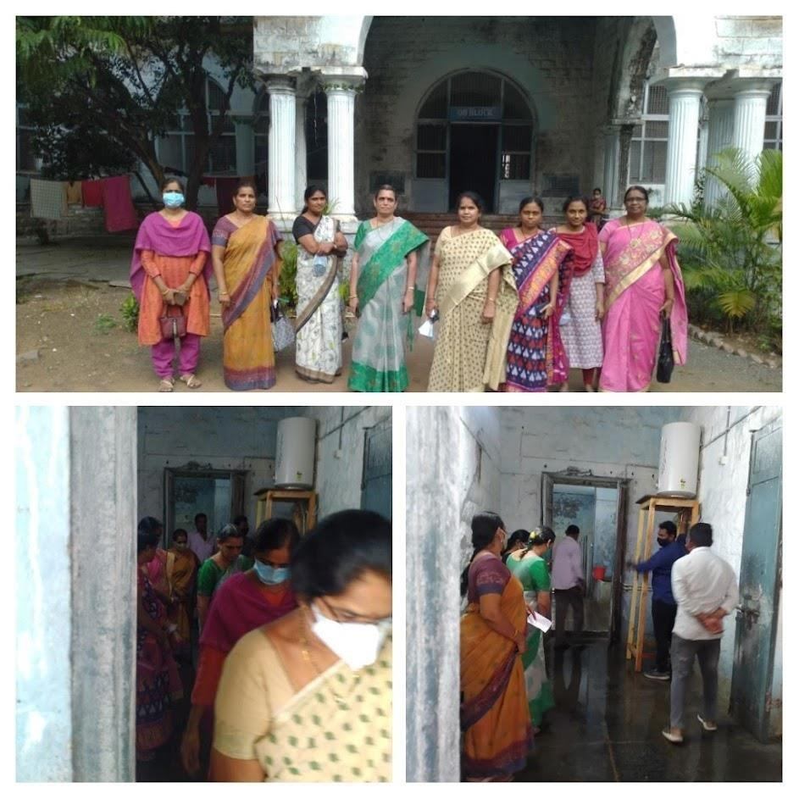

Mrs B. Vara Lakshmi Lec .in English (Retd) distributed food and groceries to the needy during the pandemic time.



