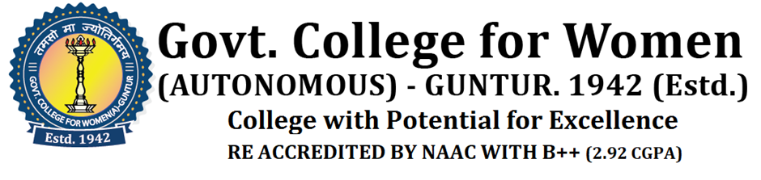
POLICY ON ALUMNI ENGAGEMENT

Government Degree College for Women (A) Guntur aims to maintain a strong and positive relationship with its alumni, recognizing that active alumni involvement is mutually beneficial. Alumni with an emotional bond to their alma mater are more likely to stay connected and contribute to the college. A thriving and engaged alumni community can significantly aid in the institution's development.
Rationale:
A formal policy document on alumni participation is essential as it outlines the framework for all alumni-related activities. The college encourages alumni to engage in various roles, including academic support, student mentorship, and infrastructure development. These initiatives not only benefit the institution but also offer positive experiences for the alumni. An active alumni network is a valuable asset, bridging different generations of students and strengthening the foundation for all academic, administrative, and quality enhancement activities.
Statement of Policy:
The college aims to build and maintain a robust alumni network. Alumni will be encouraged to give back to their alma mater by mentoring current students, providing skill development training, and offering career guidance. They can also serve as brand ambassadors, helping to enhance the college's image through advocacy.
AIMS and Objectives:
To foster strong and lasting alumni engagement.
- To motivate alumni to contribute their services for the institution's benefit, whether financially or otherwise.
- To install a sense of pride and loyalty among alumni, encouraging them to give back to the college.
- To ensure current students feel valued, fostering enduring relationships that continue post-graduation.
- To gather feedback from alumni on the curriculum and facilities, using it for continuous improvement.
- To formally register the Alumni Association.
Implementation:
Contribution in Academic Matters: Alumni have shown great enthusiasm in contributing to the college's academic activities. Some have delivered lectures on key topics for current students. The college also collects feedback from alumni on the curriculum and overall performance, using their suggestions for quality enhancement.
Membership: Successful alumni are invited to share their experiences and challenges, serving as role models and sources of inspiration for current students.
Skill Development: Some alumni actively provide skill-based training to current students, fostering bonds and sharing valuable knowledge.
Mobilization of Resources: While alumni have not made significant financial contributions, they are proactive in resource mobilization activities. They often accompany staff when approaching public representatives and philanthropists for support.
Community Awareness: A few alumni have taken on the task of raising community awareness about the college's activities and achievements.

Policy Title | Alumni Engagement Policy
Ratified by College Planning and Development Council | February 2019
Policy for review | February 2023

PRINCIPAL

