DEPARTMENT OF ENGLISH
ACTIVITIES FOR THE YEAR 2023-24

AECC (Ability Enhancement Certificate Course): “Reading for Pleasure”

The department has designed and offered an Ability Enhancement Certificate Course, titled, “Reading for Pleasure” for the first semester B.A., English Major students. This course is offered as an introductory course for 30 days from 25-09-2023 to 02-12-2023 to create an aptitude towards literature among students from diverse disciplines. The entire course material was selected from the books published by the National Book Trust of India and was graded to suit the weekly progress of the students. The visual content of the books during the first two weeks is gradually replaced by the verbal content. The department has designed worksheets for each story to aid and check the comprehension of the students. The students were also checked for their oral reading skills. The final assessment was done on two levels with an oral presentation of their favourite story and a written test created from a new story.

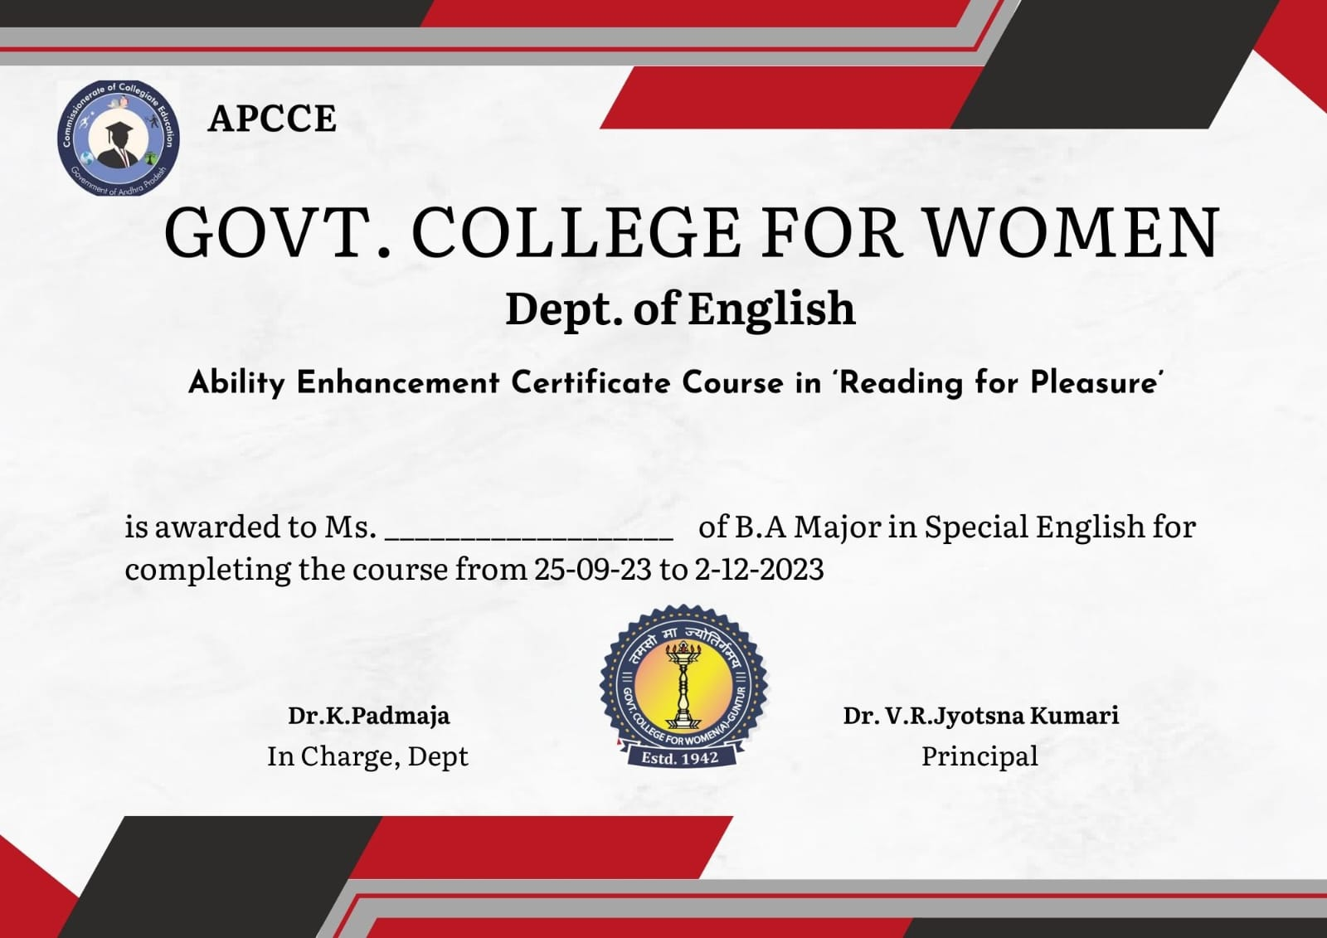

Faculty Exchange Programme at P.B. Siddhartha College, Vijayawada
The Department of English, GCW (A), Guntur has exchanged an MOU with the Department of English, P.B. Siddhartha College of Arts & Science. A Faculty Exchange programme was organized as a follow-up activity on 15-11-2023. Dr N. Santhi Sri Devi and Dr G. Seshu from the department were invited to train V Semester Computer Science students at P.B. Siddartha College of Arts & Science on Interview Caveats and Workplace etiquette. The programme was conducted in an interactive mode for two sessions and proved to be helpful to the students before attending campus drives.

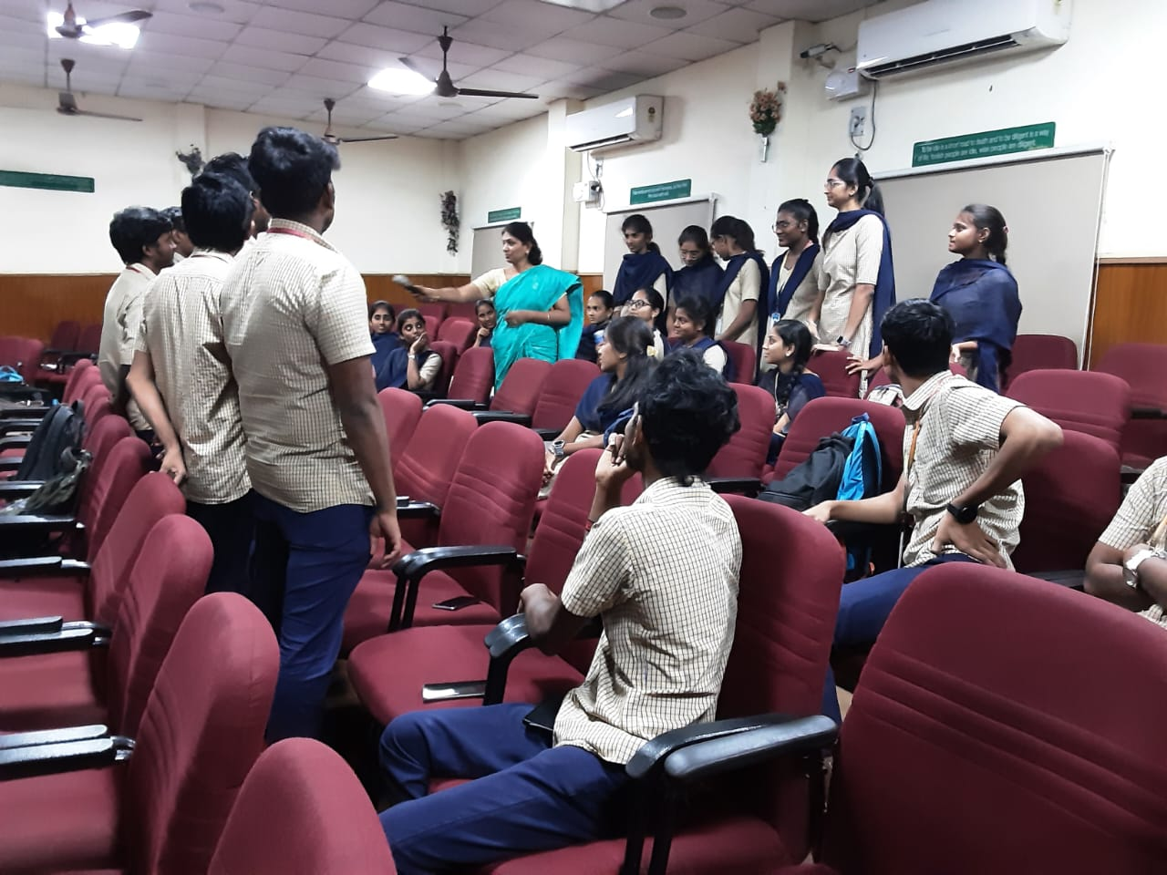
.
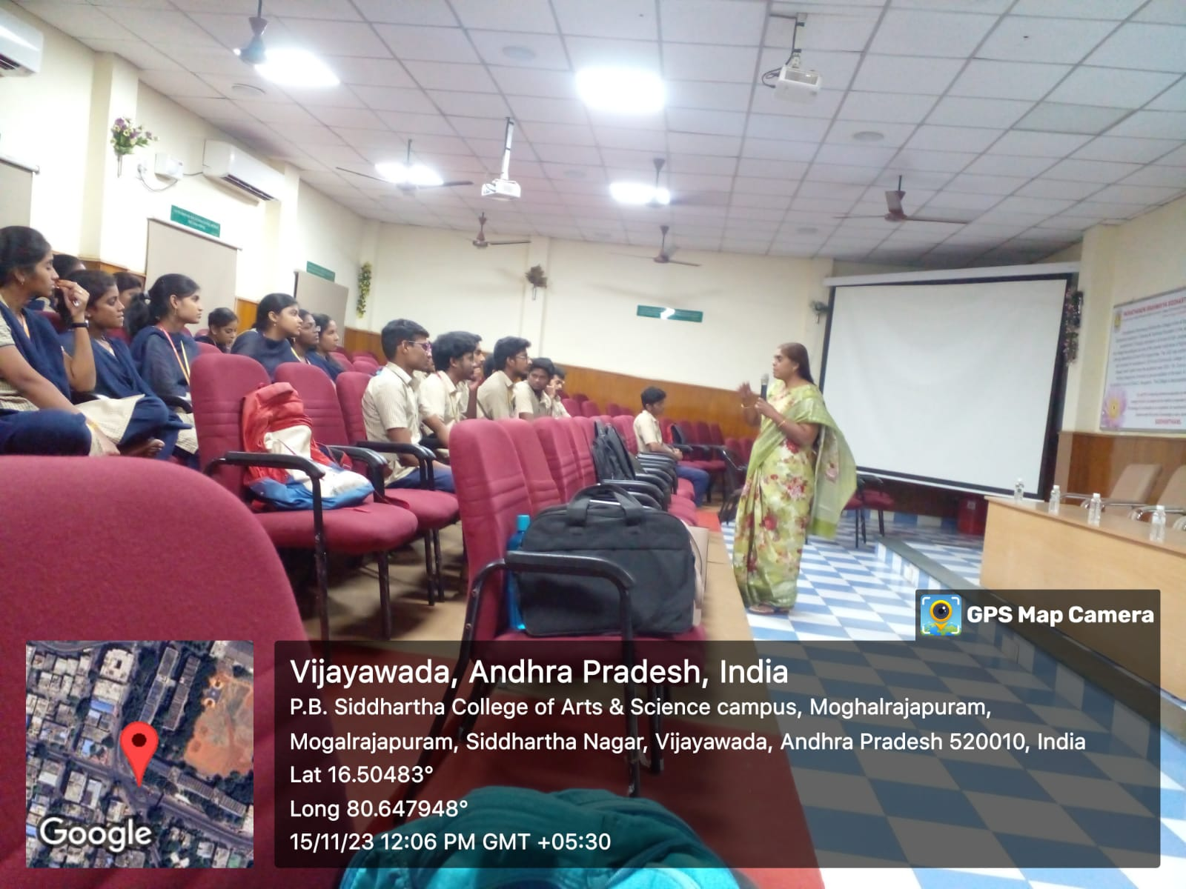

Write Your Way to Employment (A Two-Day Workshop on Writing Skills Required for the Job Market)
The department has conducted an exit-level workshop for two days on 23-11-2023 & 24-11-2024 on writing skills for the benefit of V semester students. The workshop was held in four sessions to equip the students with certain necessary and specific writing skills to face the screening for higher education or a job interview. The sessions on Resume preparation, Workplace correspondence, Essay writing and Writing a Statement of Purpose for admission into universities abroad delivered by eminent resource persons were received well by 116 final-year students.
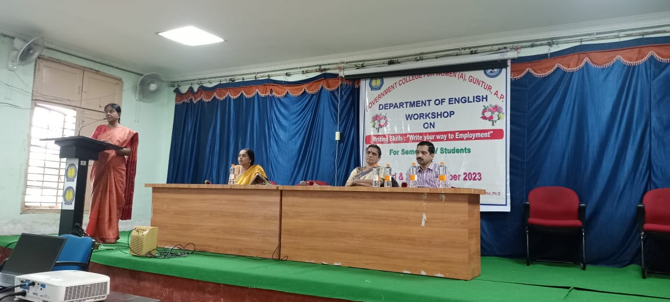
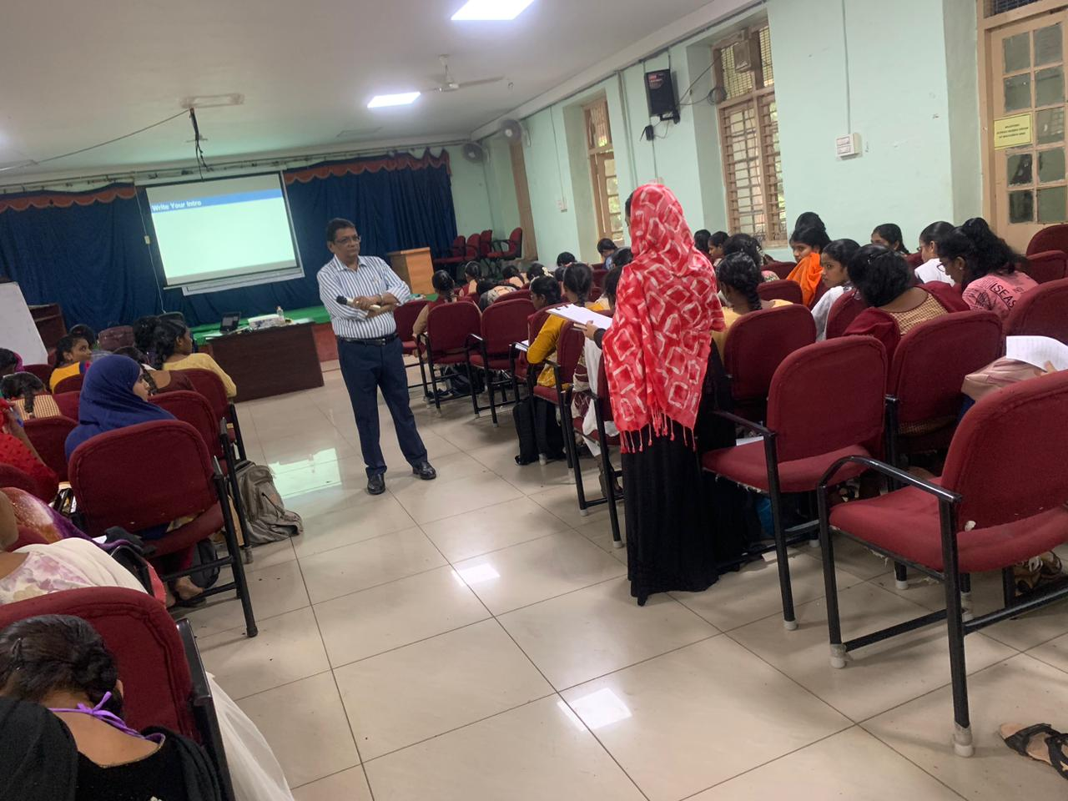
A Field Trip to Guntur Book Festival
The department has organized a field trip with first-semester students on 21-12-2023. Approximately forty students were taken to the Guntur Book Festival to create awareness of the various books available in the market. Students came to know about some popular publishing houses that specialized in publishing books on literature, science and technology, biographies and autobiographies. Many of the students purchased books useful for competitive exams.

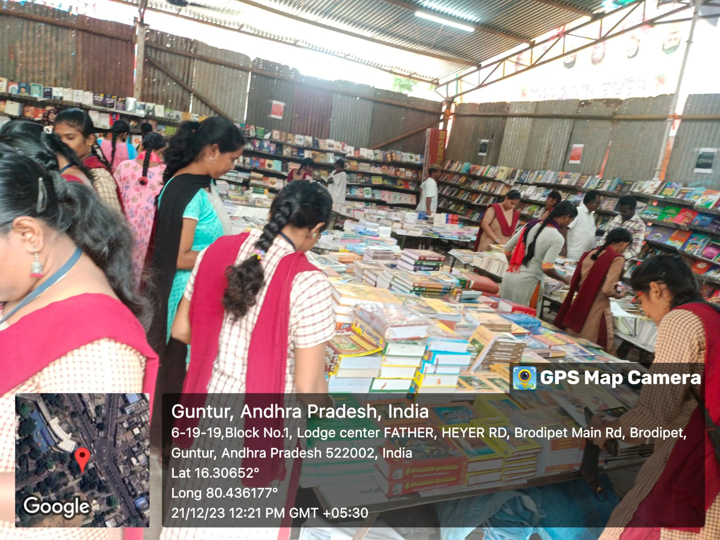
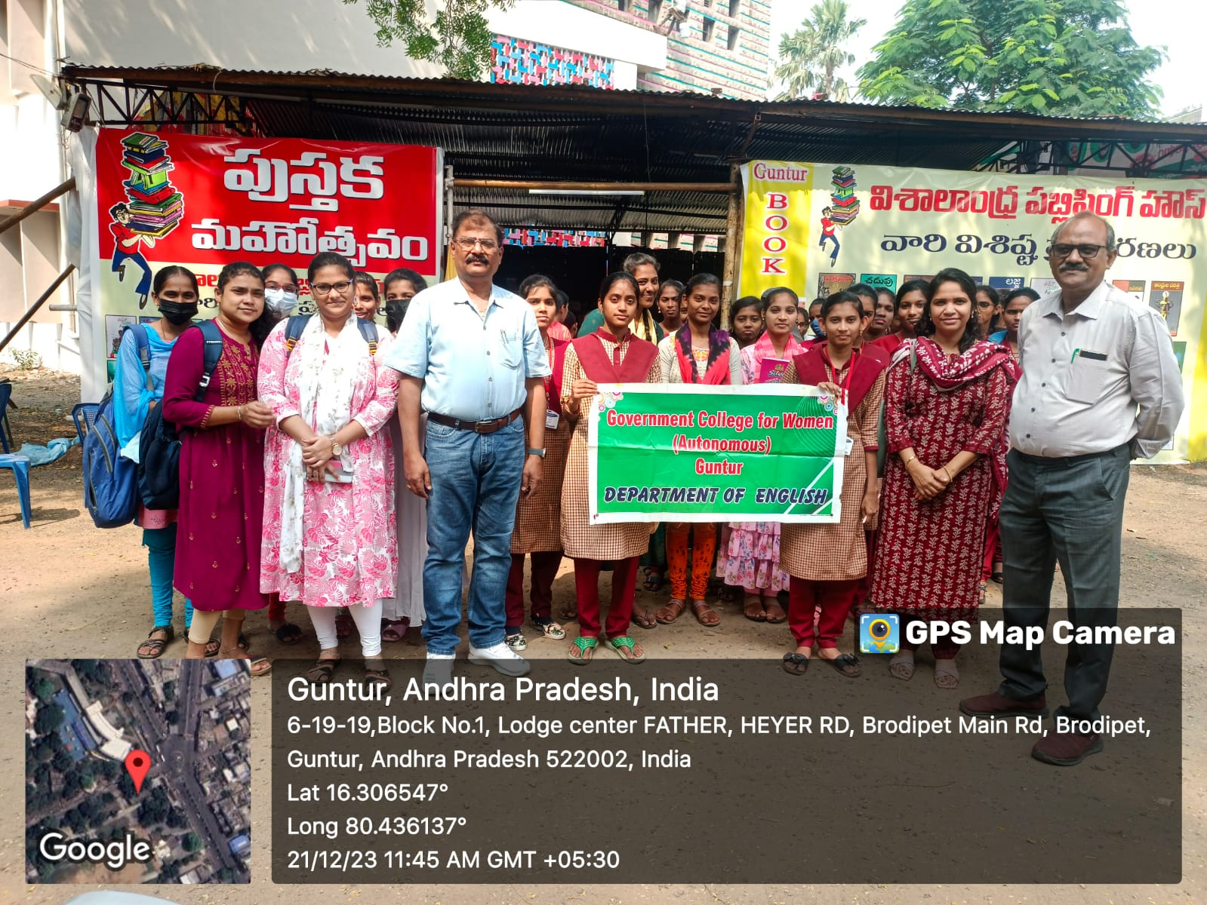

Extension Activity at Samarthanam Trust for the Disabled, Guntur
The department reaches out to the unreached sections of the society as a part of the flagship programme titled, ‘Ananta Mythri’. An extension activity was conducted at Samarthanam Trust for the Disabled, Guntur for two days on 29-12-2023 & 30-12-2023. Faculty from the department trained the differently abled people staying in the trust on basic communication skills such as letter writing, e-mail composition and interview skills prescribed as a component of the Livelihood Resource Project offered by the trust.

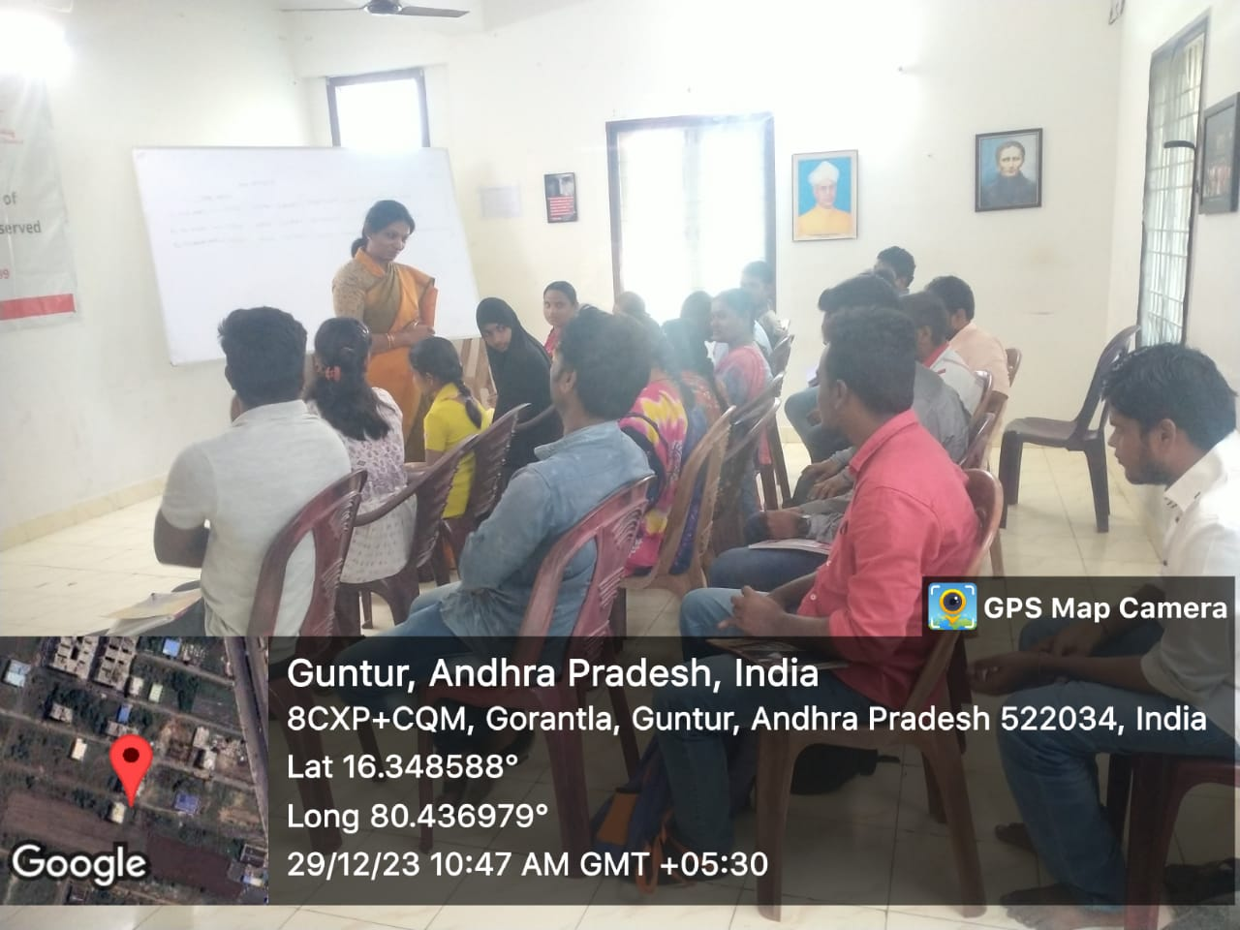

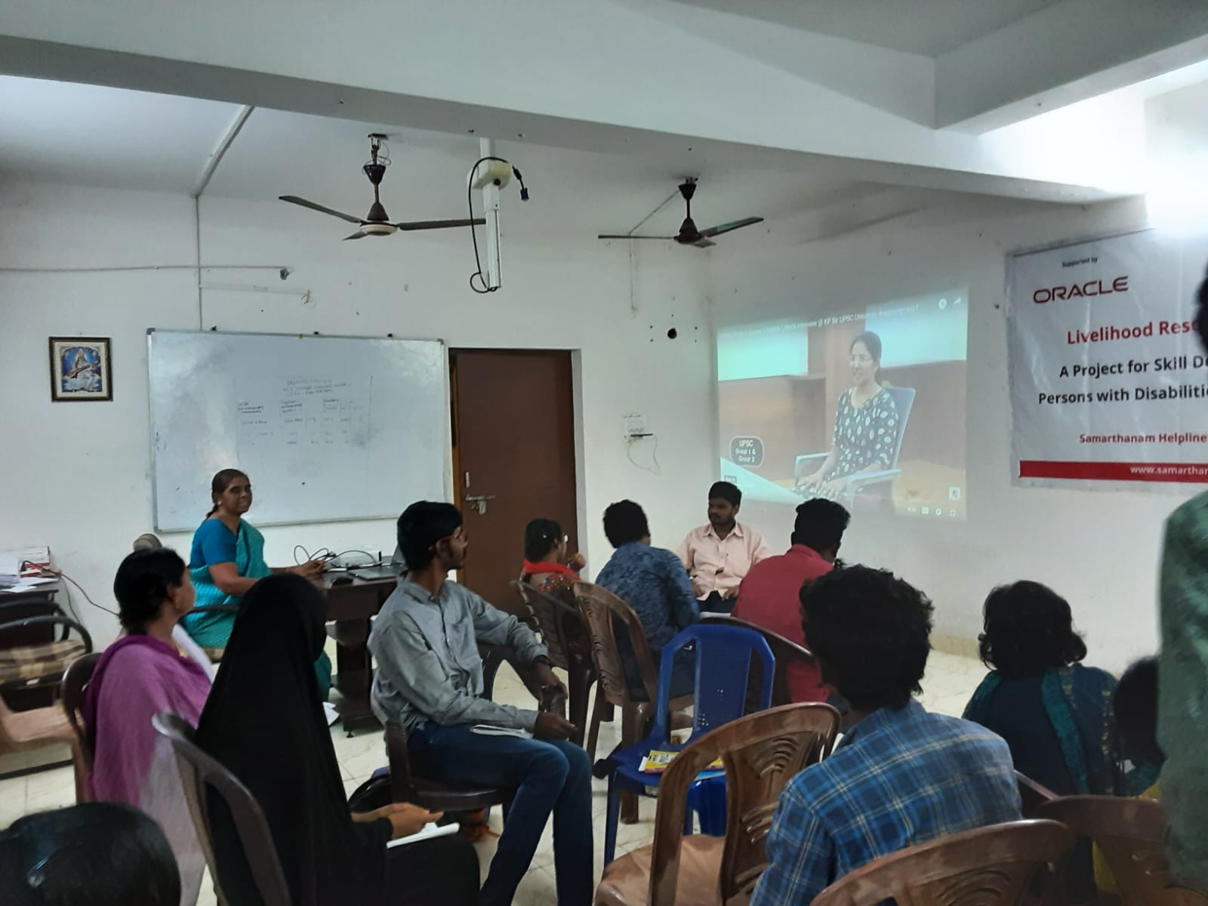

Two-Day National Level Webinar on ‘Narratives of Identity”

A Two-Day National Level Webinar titled, “Narratives of Identity” was organized by the department on 28-02-2024 & 29-02-2024. The keynote address was delivered by Dr. Urmi Satyan from Pandit Deen Dayal Energy University, Gujarat. Around fifty participants explored the different dimensions and roles of identity through storytelling, cultural perspectives, personal journeys, digital, art and literature.

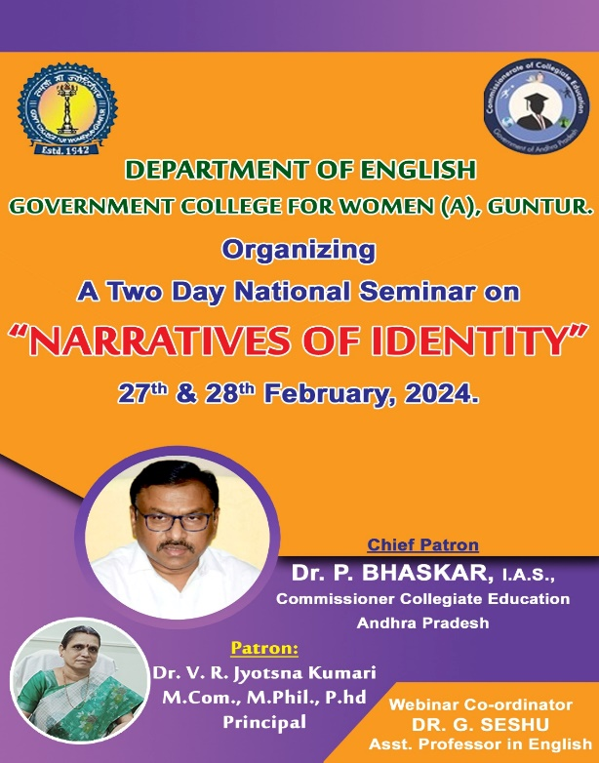

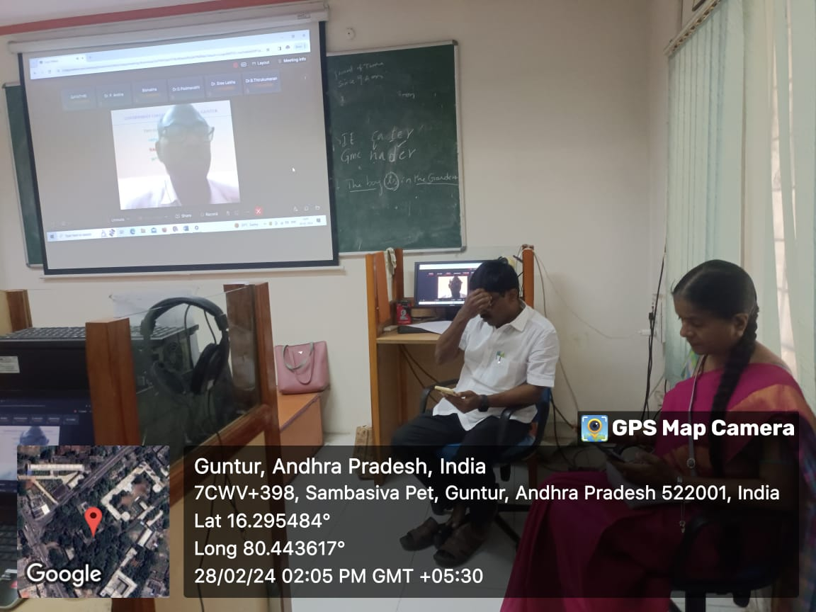
State level One-Day Orientation Programme on English-Pro-I (A Course Book Designed and Developed by the CCE., A.P.) for the English Faculty of GDCs in A.P

The Commissioner of Collegiate Education, Andhra Pradesh has constituted a team of lesson writers to design a course book for the third-semester students as they don’t have language courses after the second semester in the single major system. It is a matter of pride for the department that Dr K. Padmaja, in charge of the Department of English at Government College for Women(A), Guntur is the co-editor of this communication skills book. An orientation programme to familiarize English teachers with this book was organized by the department on 24-04-2024. This orientation programme was organized on the occasion of ‘English Language Day’ celebrated to commemorate William Shakespeare’s birthday every year. Around 300 English teachers across the state of Andhra Pradesh have participated in this orientation programme and were briefed about activity-based language teaching.

