DEPARTMENT OF ECONOMICS
ACTIVITIES FOR THE YEAR 2023-24

A CERTIFICATE COURSE IN ENVIRONMENTAL ECONOMICS

The department has designed and offered an Ability Enhancement Certificate Course, titled, “ Environmental Economics” for the Second Year III semester B.A (HEP,CE,PEP & FE), students. This course is offered as an introductory course for 30 days from 16-08-2023 to 26-09-2023. The course focuses on providing knowledge about the economic analysis of With out polluted Economic growth in India.
OUTCOMES OF CERTIFICATE COURSE: On the successful completion of this course, the students will able to
- Understand the environmental issues in relation to the theory of externalities, public good and welfare.
- Discuss the various approaches and methods developed for valuing environmental goods and services.
- Illustrate and examine economic principles concerning the choice of instruments for controlling pollution and the relative strength and weakness of environmental policies based on command and control vis-à-vis market-based instruments.
- Examine the issues in the contemporary environmental discourse from an economist’s point of view.

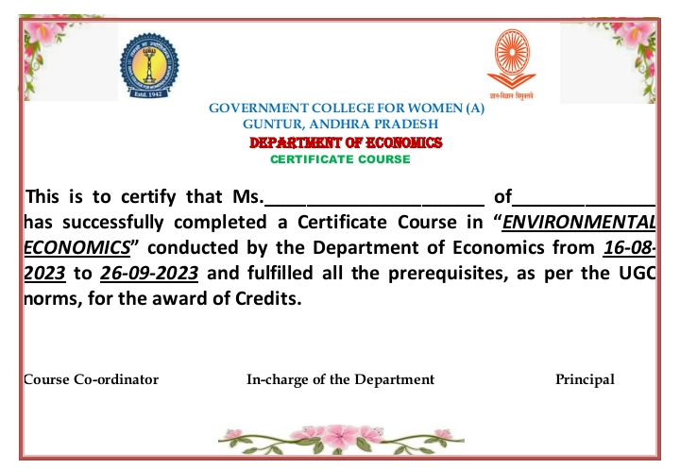

A CERTIFICATE COURSE IN BANKING, INSURANCE & STOCK MARKETS

The Department of Economics conducted ability enhancement certificate course on Banking, Insurance & Stock Markets offered for I BA, 2nd Semester Single Major course students
About the certificate course: The course focuses on providing knowledge about the economic
analysis of With Recent trends in Banking Sector growth in India.
OUTCOMES OF CERTIFICATE COURSE: On the successful completion of this course, the
students will able to
1. Students will demonstrate an understanding of the fundamental principles of banking, including account opening
and closing procedures, KYC (Know Your Customer) norms, and the significance of negotiable instruments in
banking operations.
2. Students will be able to assess the various e-banking facilities such as net banking and mobile banking and
understand their functionalities, advantages, and potential risks.
3. Upon completion of the course, students will be equipped with the knowledge of insurance principles and types,
including the registration process for insurance agencies, policy issuance procedures, and the concepts of
nomination and policy surrender.
4. Students will demonstrate proficiency in portfolio management techniques and understand the dynamics of the
stock market, including the process of opening a D-mat account, trading and investing in stocks, and the
implications of trading in derivatives.
5. Students will be able to analyze and evaluate different strategies for trading in the stock market, including intra-day
and overnight contracts, and comprehend the associated risks and rewards.
6. Upon completion of the course, students will develop essential skills in risk management within the context of
banking, insurance, and stock market operations, enabling them to make informed decisions and mitigate potential
financial risks effectively.

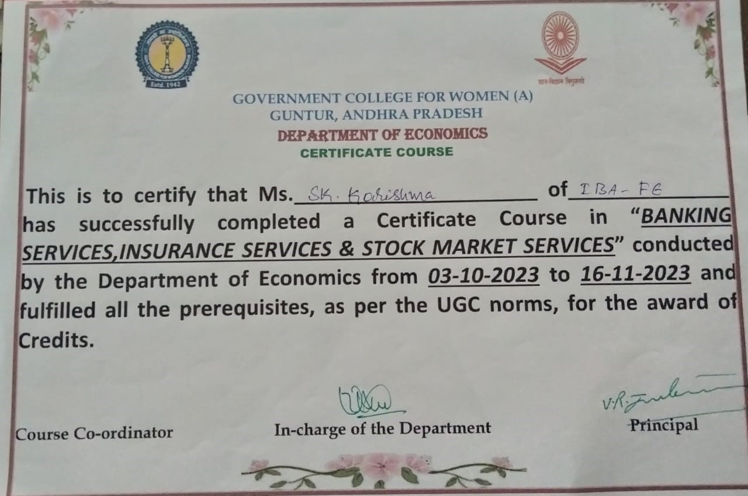

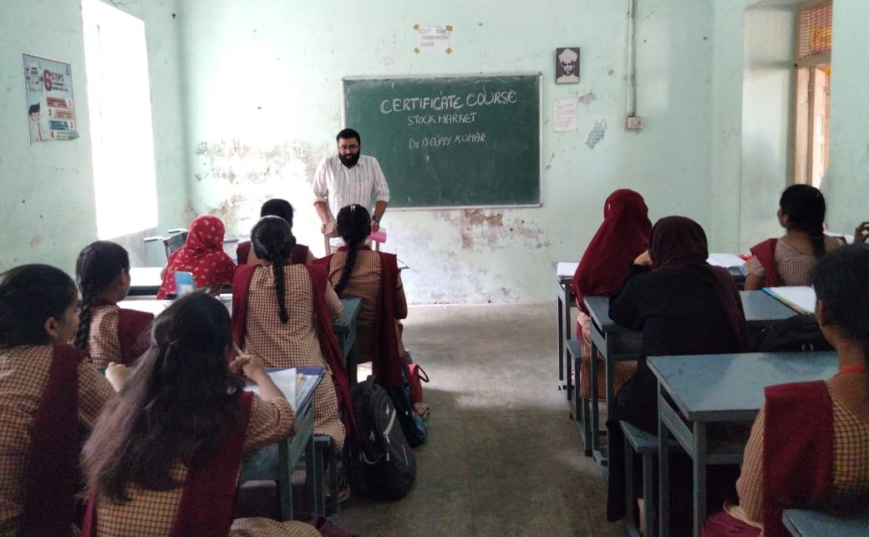

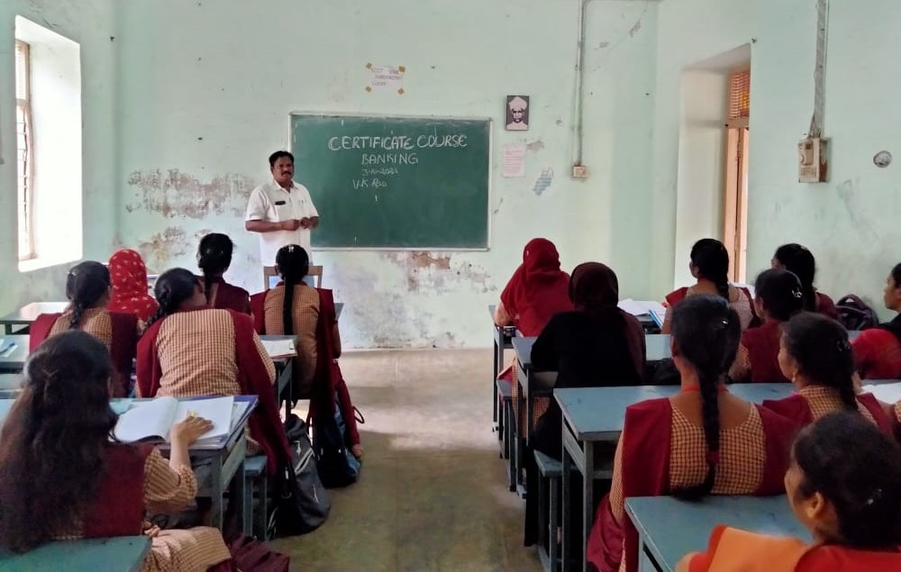

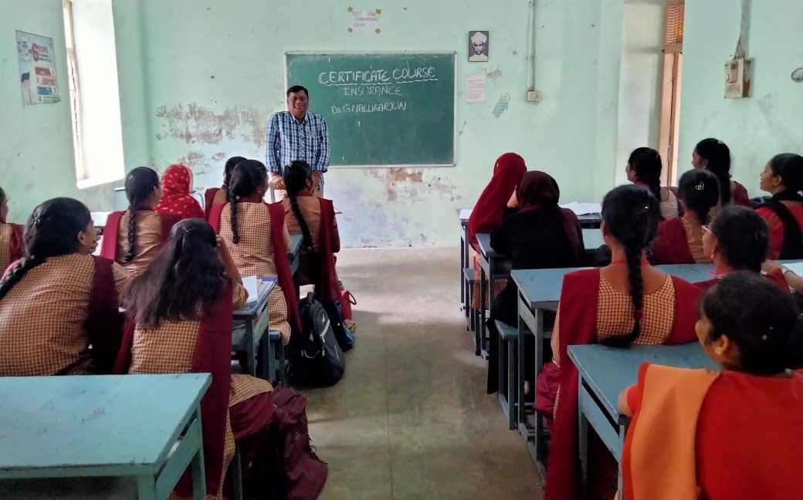

Field visit: As a part of the course II and III year students visited Kalankari Industry at Pedana village, Krishna District. Employees working in this industry explained and clarified the doubts raised by the students. Students observed the different stages involved in this industry. Students also collected data with the consulting the managements of this industry. How many employees are working in these industries and how much wages paid to the employees, what are the facilities provided to the employees. .
Outcomes:
• Developed various skills which aids in building self confidence
• Able to assess their ability to collaborate with others in teams.

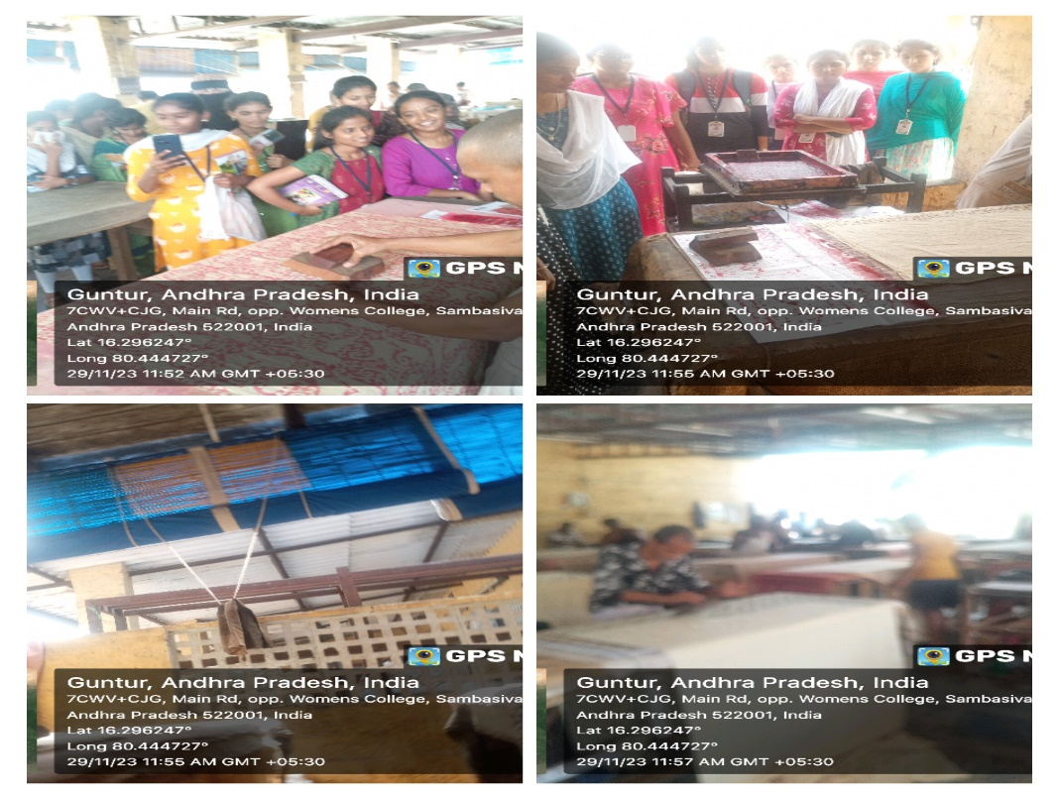

Field Trip to Chirala to visit Handloom Manufacturing Industry

Department of Economics conducted Field Trip programme on 15-02-2024 to visit handloom manufacturing Industry in Chirala. 44 no of students and Faculty of department of Economic are participated on that programme, most of the students understood role of handloom manufacturing industries for economics development in developing countries like India

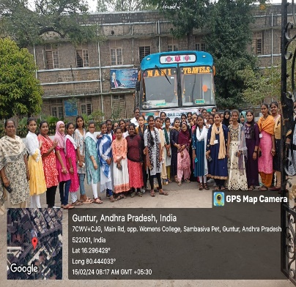
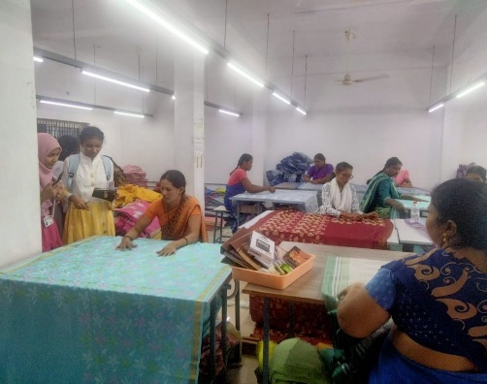

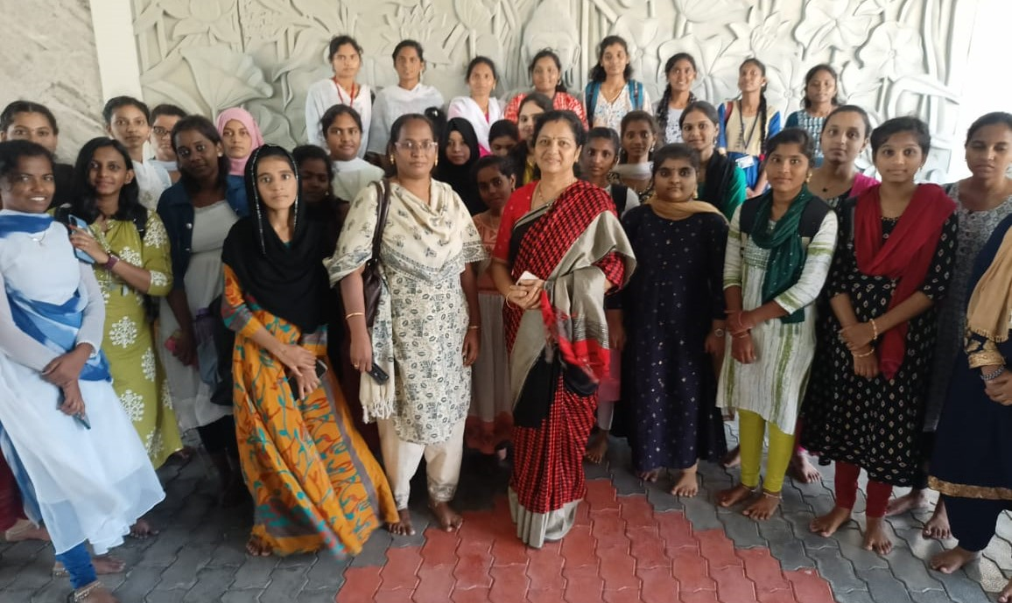

Extension Activity on the occasion of National Girl child Day to visit Golusu Nancharam Minicipal Girls’s High School
Department of Economics conducted extension activity on the occasion of National Girl Child Day Extension activity PG and UG Economics Students and Faculty of department of Economics GCW(A) Guntur visited Golusu Nancharam Minicipal Girls’s High School , Railpet2nd line, Guntur. Some students are delivered message importance of girl child Education in present society

