DEPARTMENT OF CHEMISTRY
ACTIVITIES FOR THE YEAR 2023-24
Ozone Day
(16-09-2023)
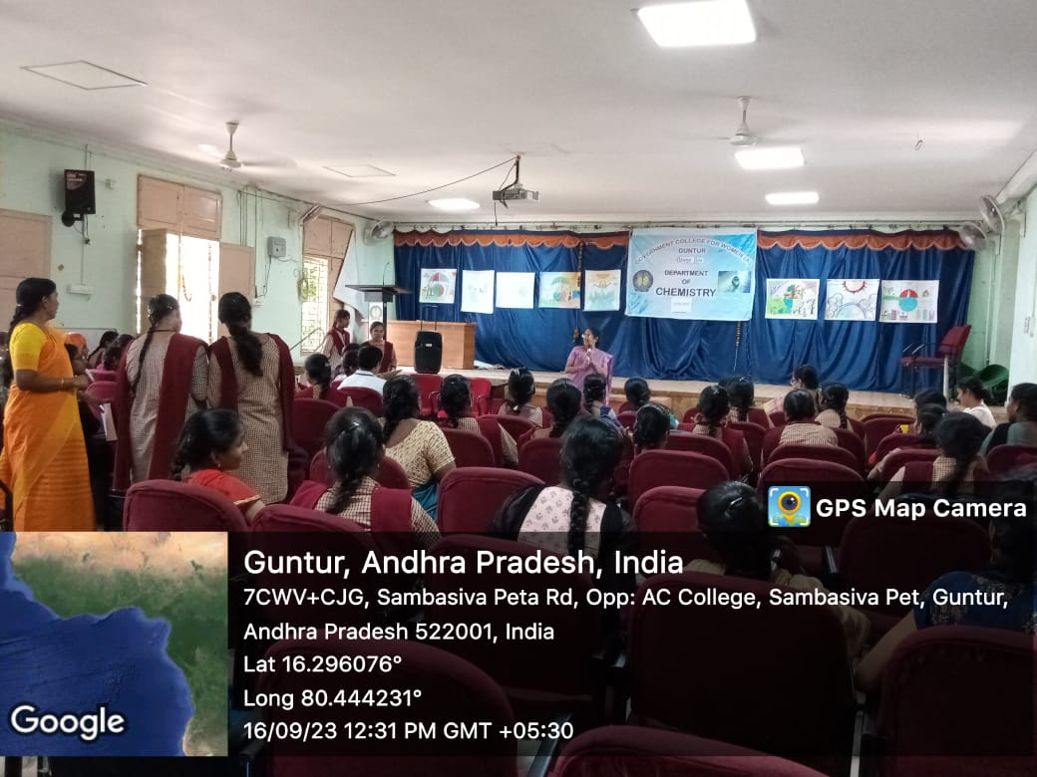
The department organized a poster presentation followed by a skit. Many interesting posters were prepared by students and were exhibited in the assembly hall. Prizes were given away for the best posters. A skit conducted by B9-BtZC students demonstrated the importance of the ozone layer.
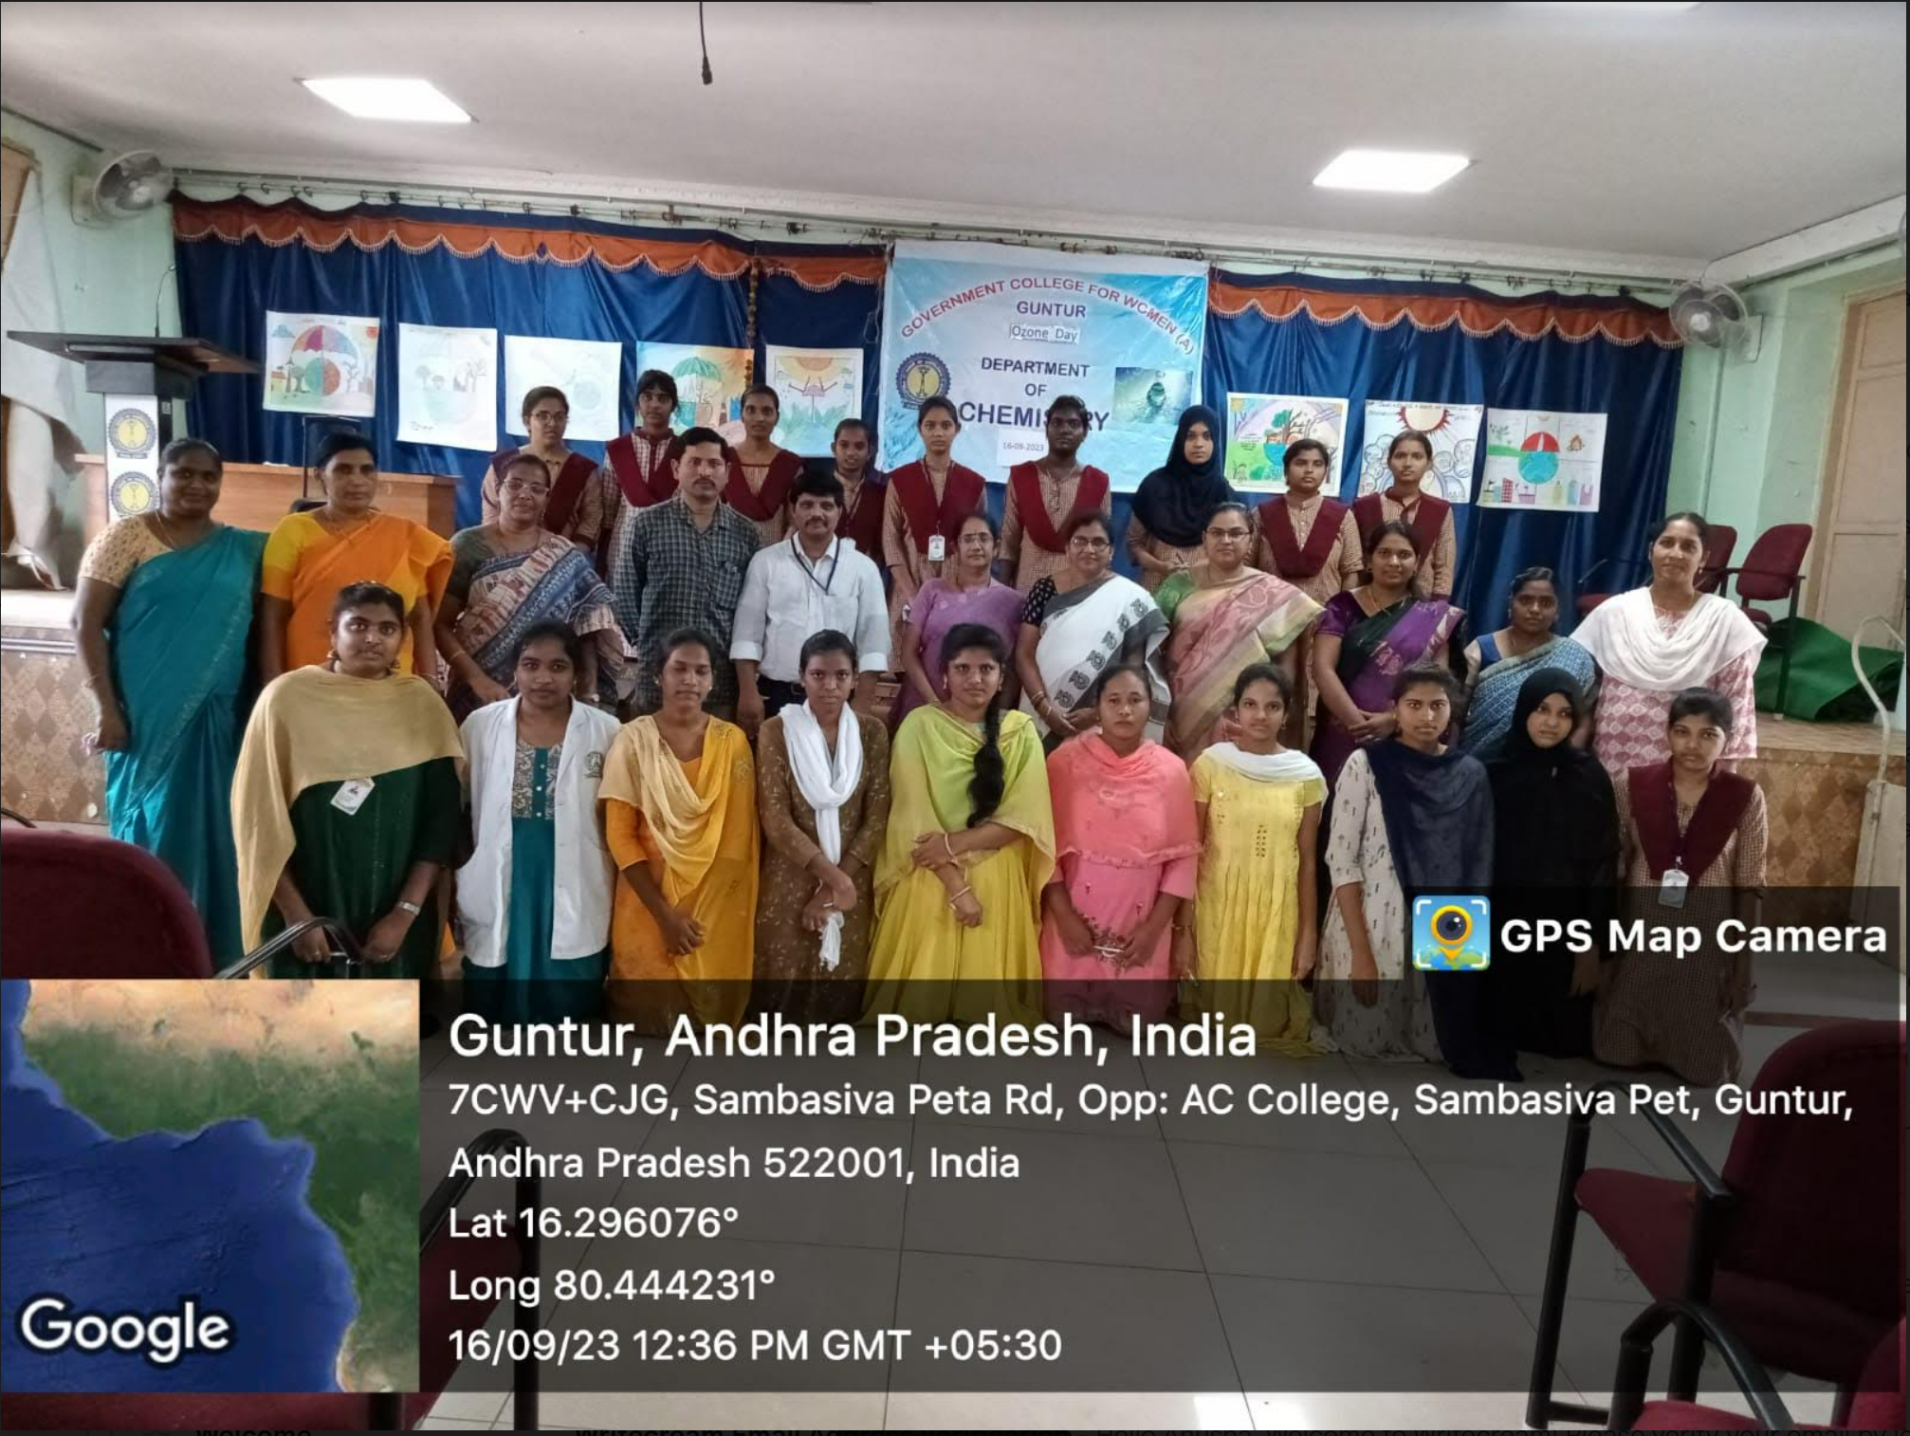

Ecofriendly Ganesh Idols Distribution( 17-09-2023)
The Eco-friendly Ganesh Idol distribution program was organized on the previous day of Ganesh Chaturthi on 17.09.2023 to encourage the usage of clay idols by explaining the harmful effects of POP on the environment. In this connection, the Department of Chemistry, GCW(A), Guntur in association with the Suksham eye donation organization distributed the clay Ganesh idols in Lakshmipuram, Guntur.
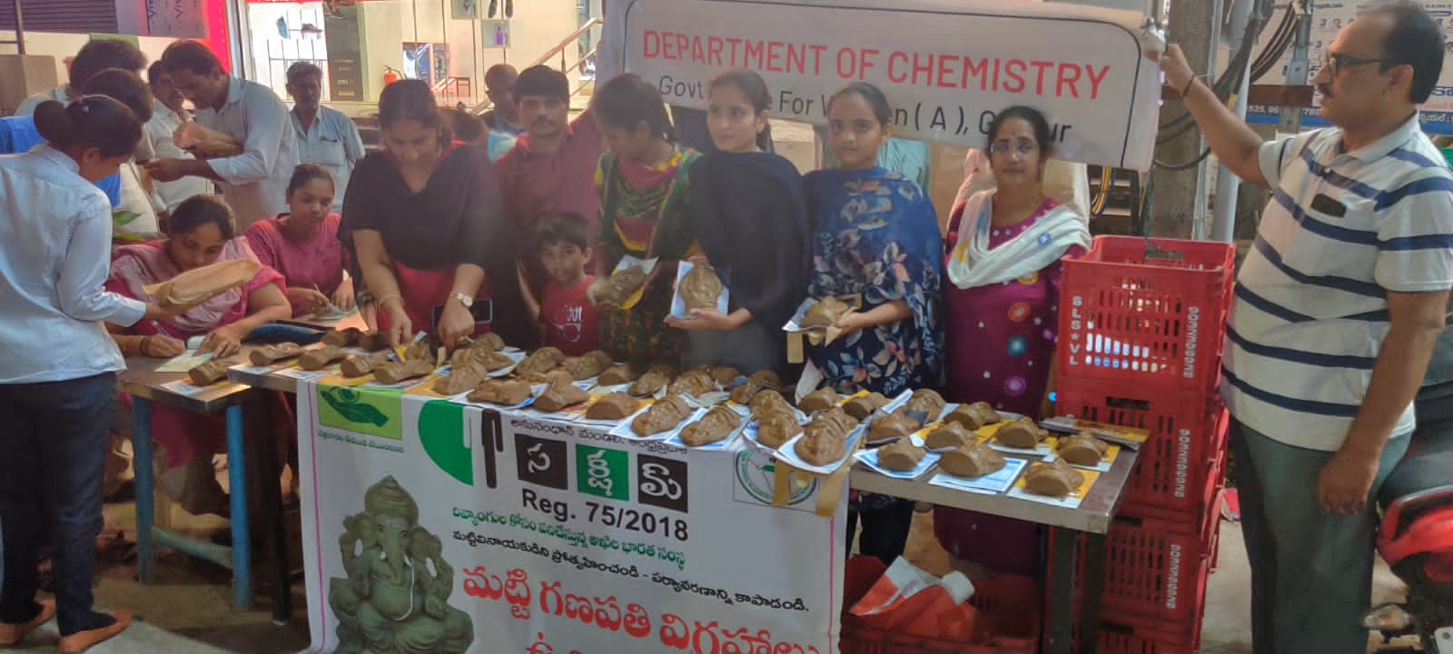
.
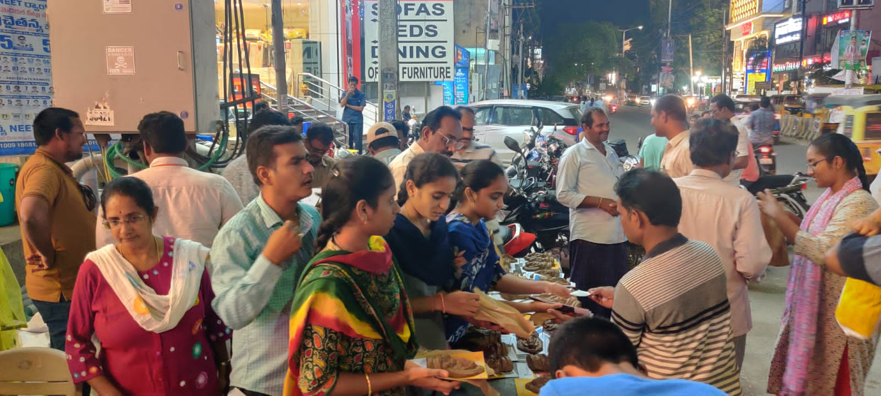

Hands-on preparation of different types of bulbs (23/09/2023):
To provide students with comprehensive knowledge and practical skills in creating various types of bulbs used in lighting applications the Department of Chemistry organized a workshop on the Preparation of bulbs on 23-09-2023. Students learn the preparation of various types of bulbs, prepared and sell them to the faculty of various departments.
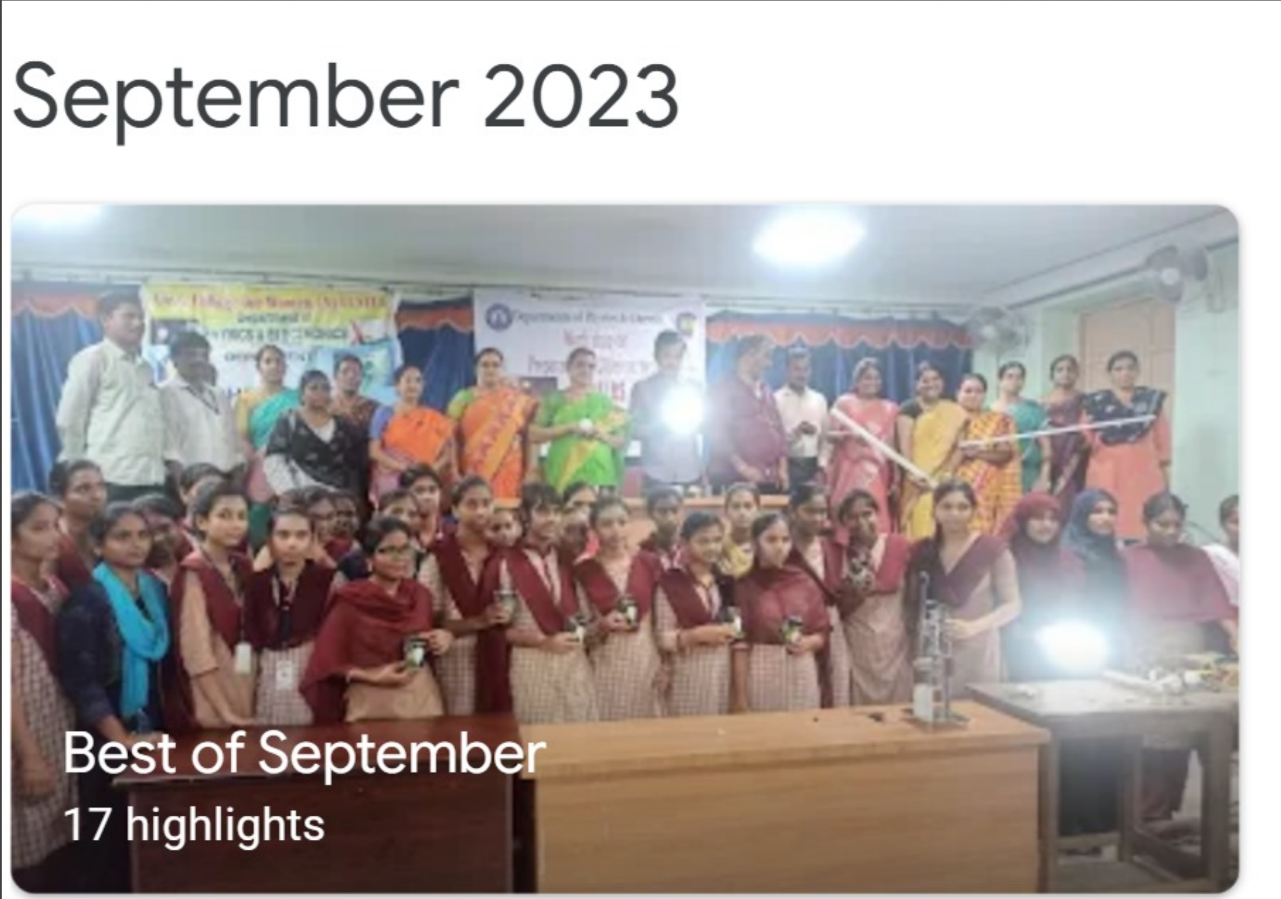
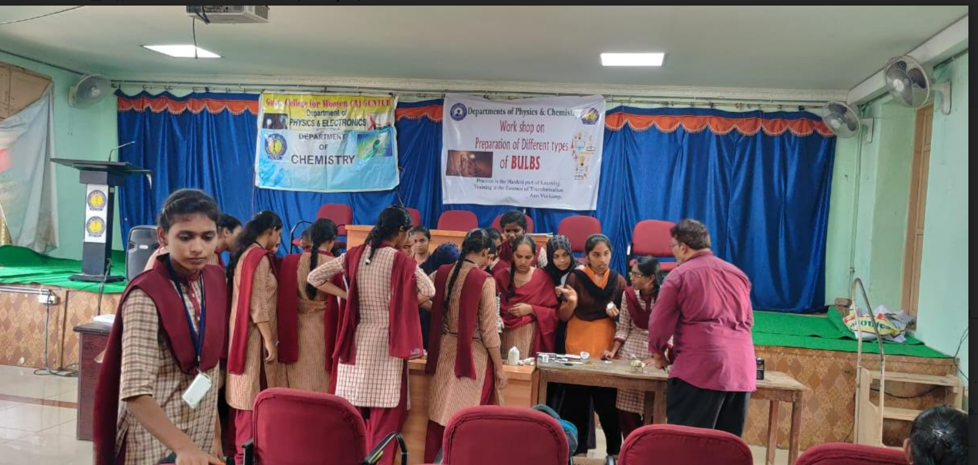
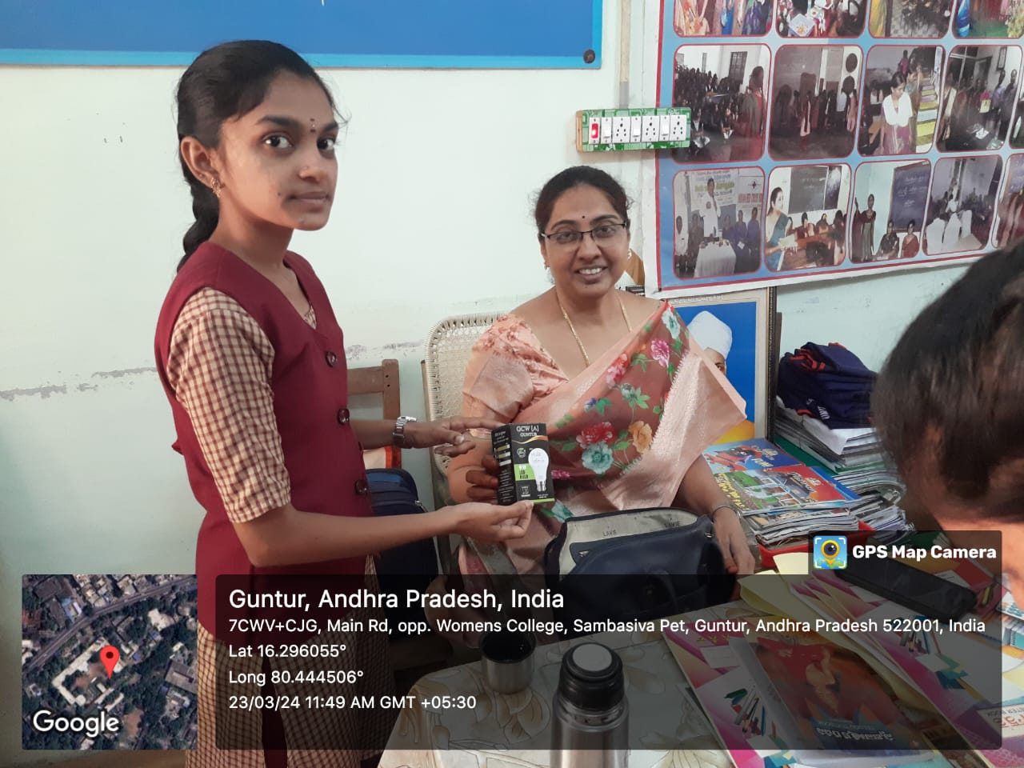

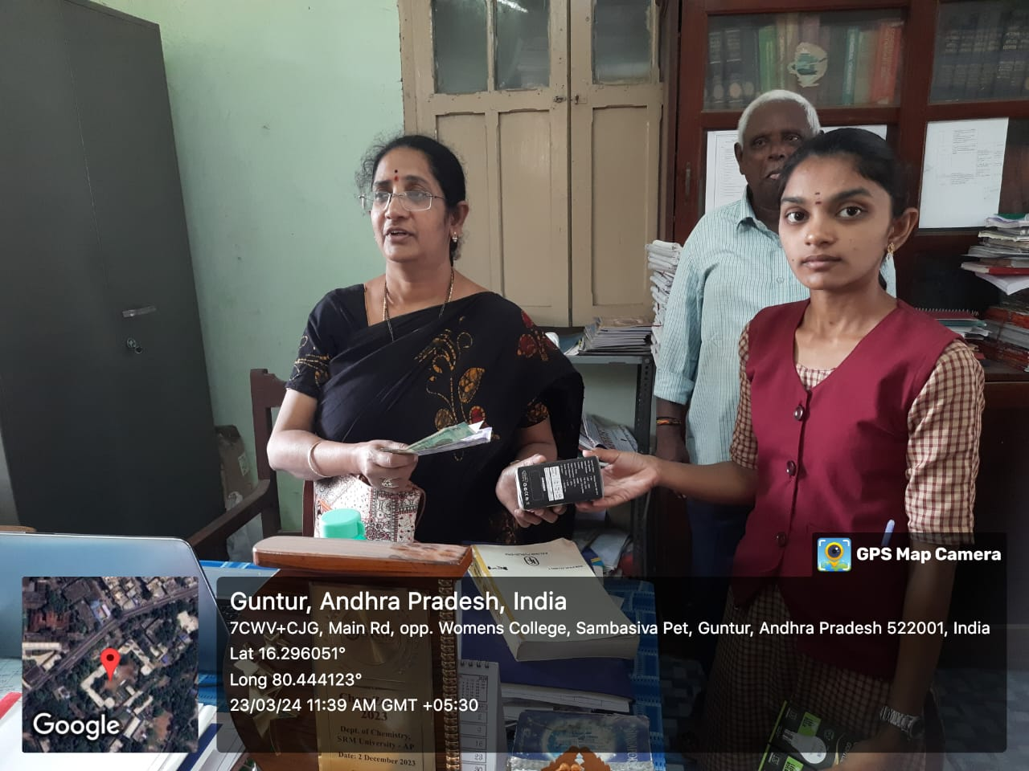
Field Visit To Hindu College Of Pharmacy On 21-11-2023
The department motivates the students to participate in the workshop conducted by the Hindu College Of Pharmacy on 21-11-2023“One day workshop on Sophisticated analytical Instruments”.Students were encouraged by showcasing the real-world applications of analytical methods across various scientific disciplines. A total of 60 Students attended the Programme.
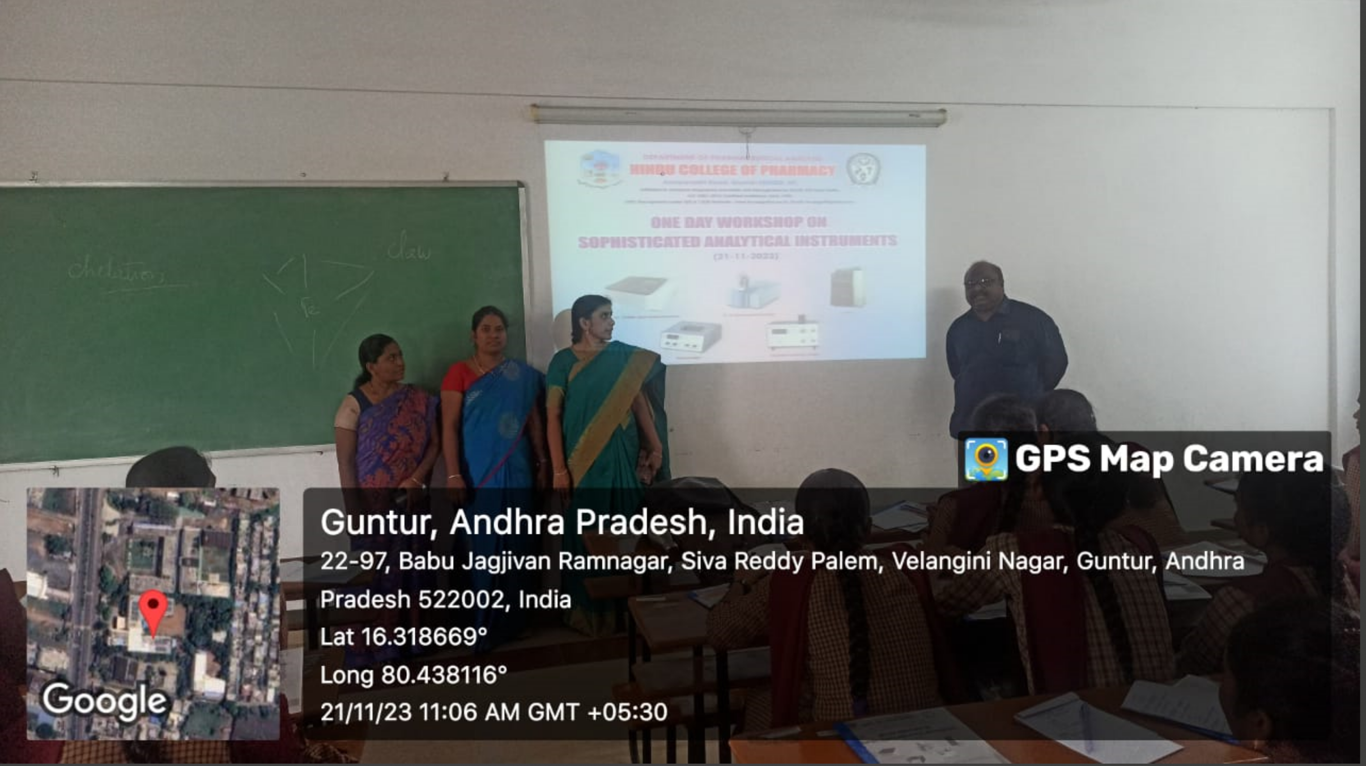
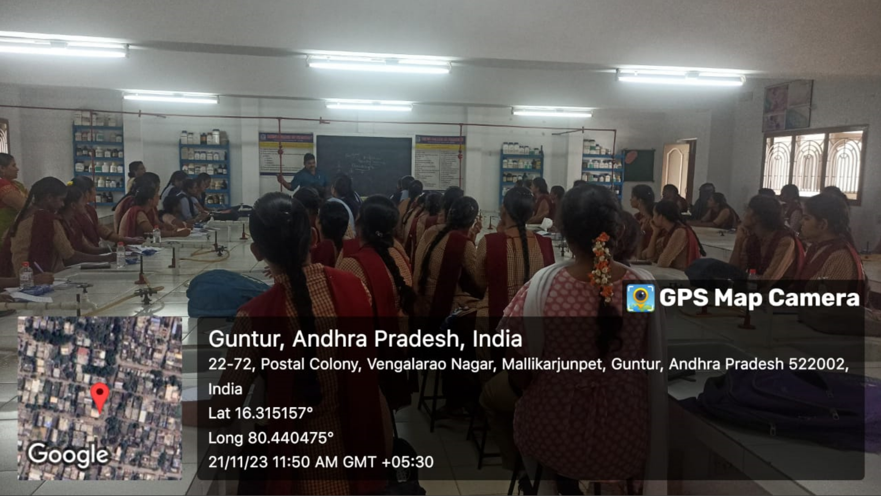
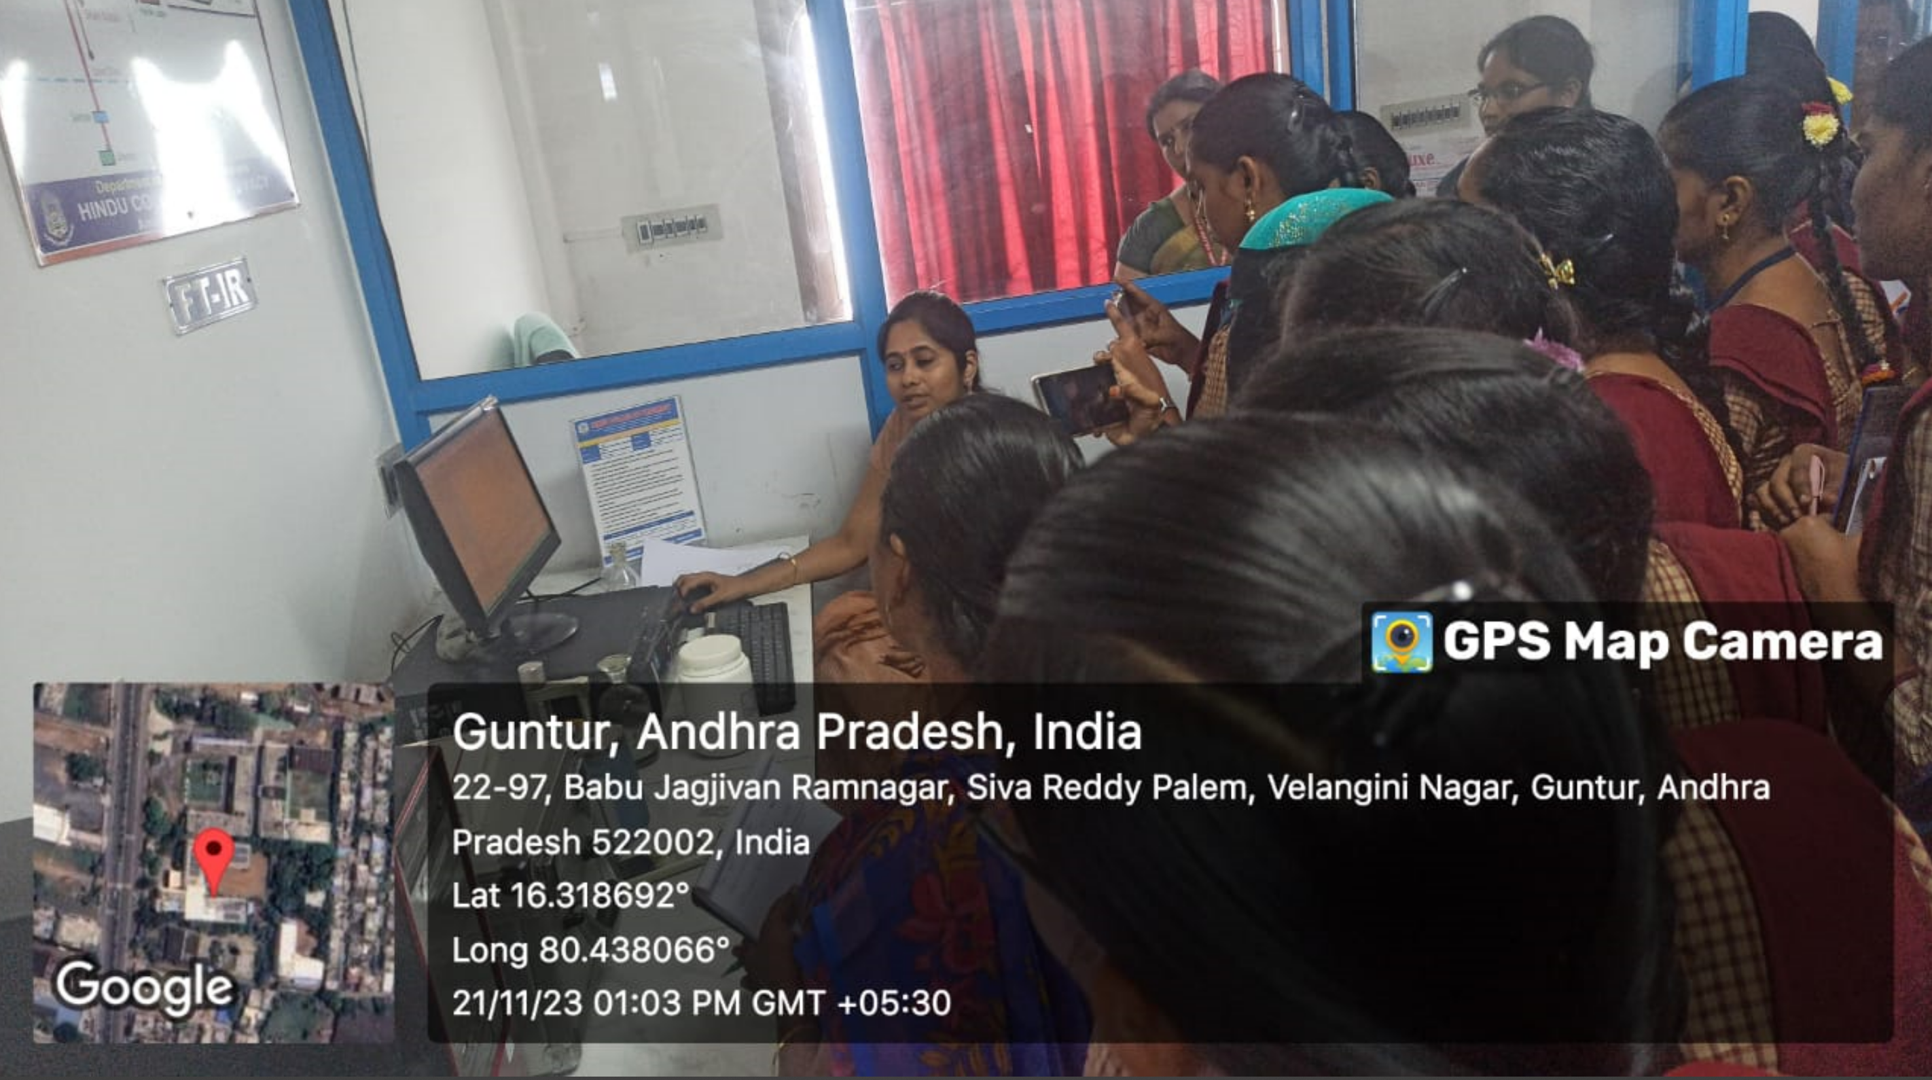
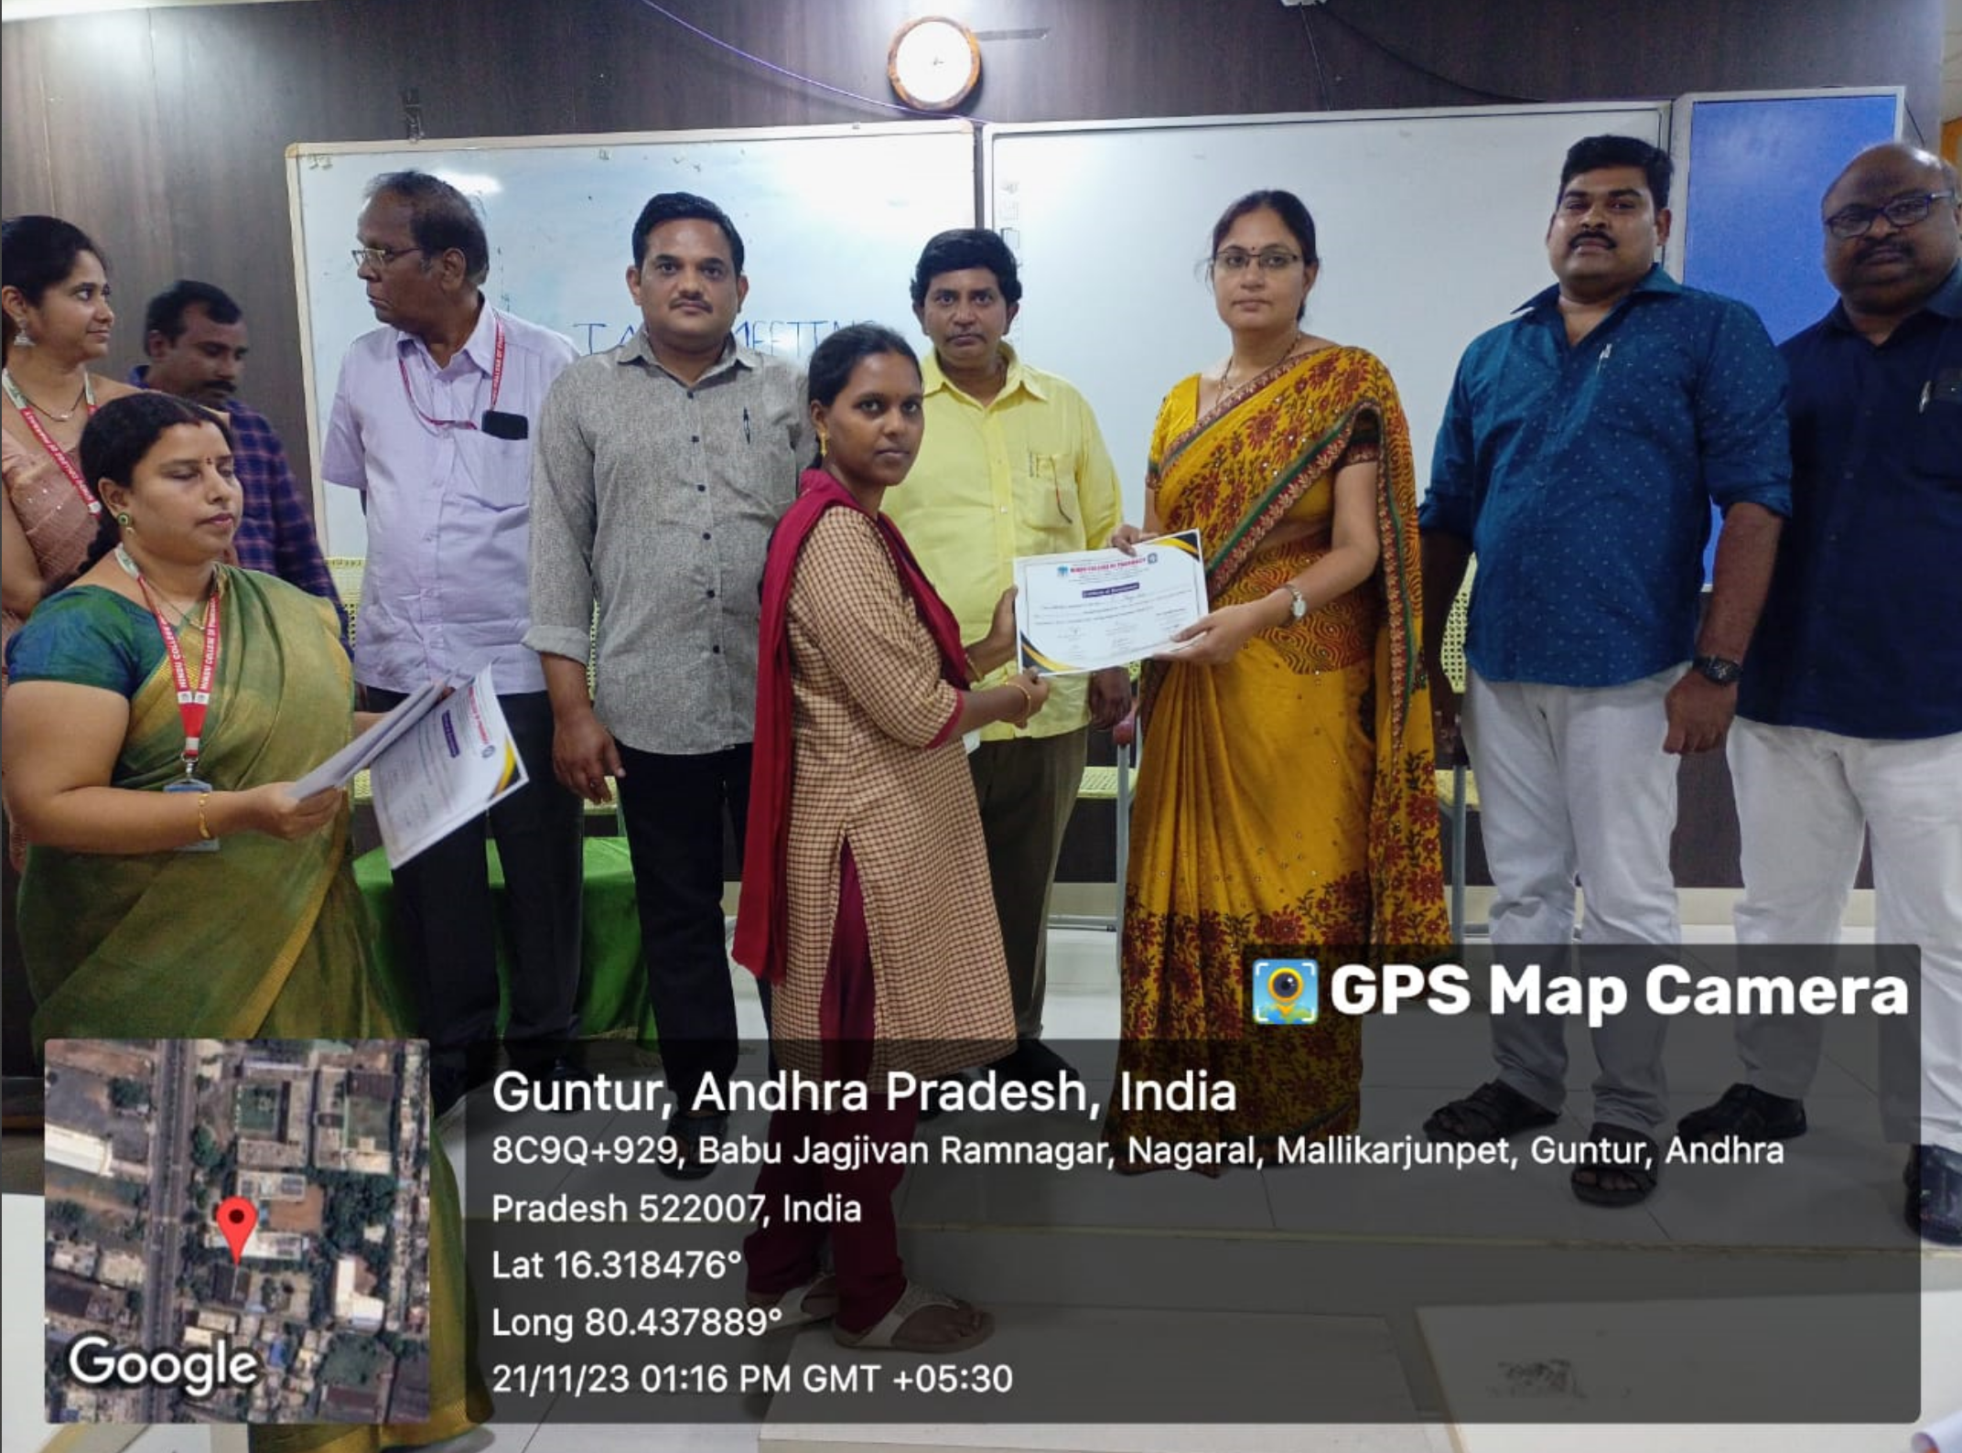

Guest Lecture On Spectroscopy(24/11/23)
The Department of Chemistry organised a guest lecture On the topic “Introduction to Spectroscopy and NMR spectroscopy” by Dr.Jala Babu, Lecturer in Chemistry, YVNR Govt. Degree College, Kaikaluru, Eluru (Dt.) on 24-11-2023 to motivate the students to learn the importance and applications of spectroscopy in various fields.
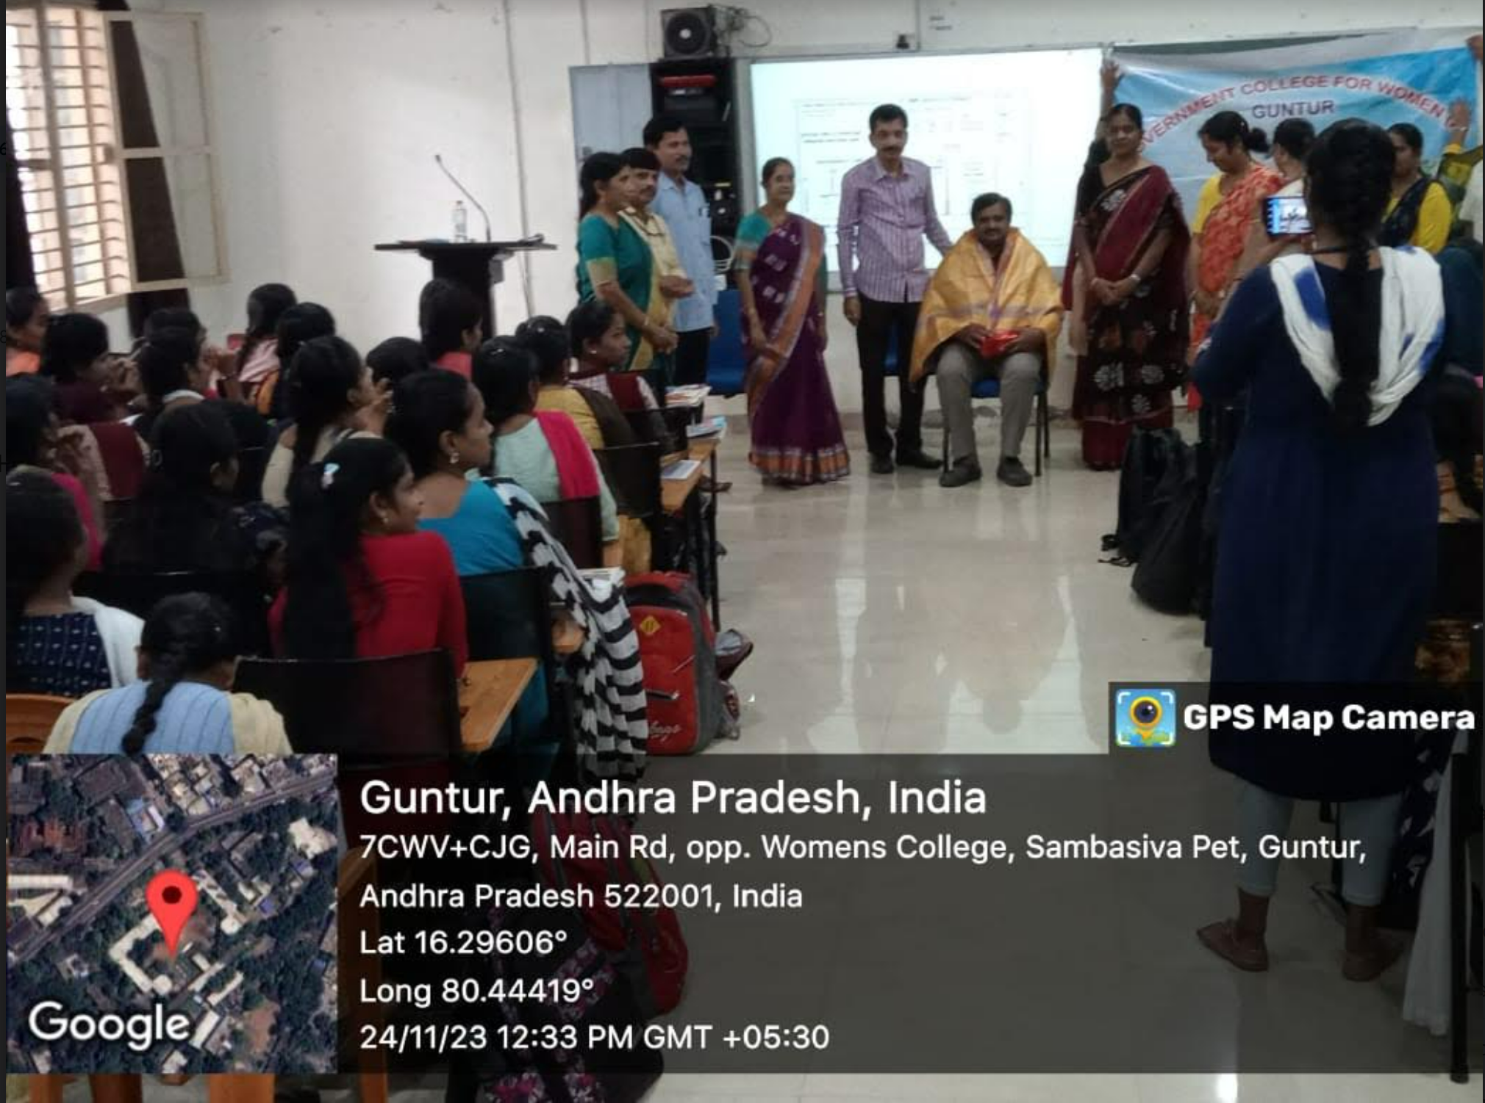

Field visit -Central research lab, Vignan University, Guntur. 01-12 2023
The department of chemistry along with the students visited the central instrumentation laboratory of the Vignan University, Vadlamudi. The coordinator and senior scientist Dr N. Satya Vijay Kumar interacted with the students and briefed them about the functioning of the lab and the services provided to encourage and motivate students and faculty towards science research. The working and applications of instruments like elemental analysis, SEM, TEM, IR spectrometer, XRD mission, GC-MS, and HPLC are explained by the research scholars and instructors. By this activity, students got the opportunity to observe the working principles of various instruments, which they have learned in class.
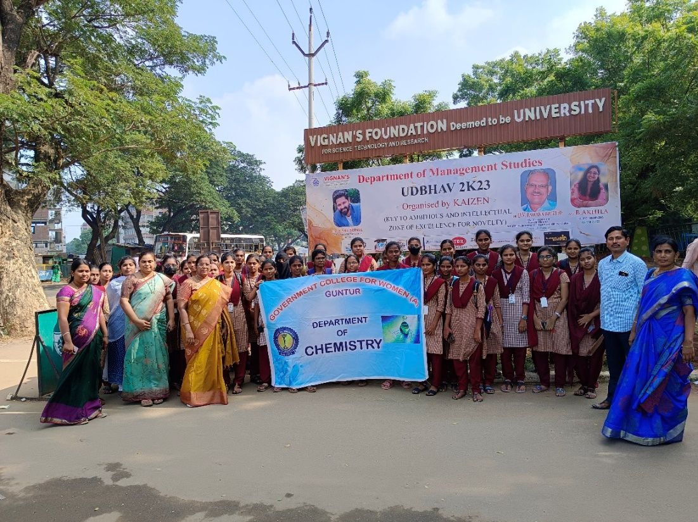

National Pollution Control Day(2-12-2023):
The Department Of Chemistry has conducted the “National Pollution Control Day “ which catalyzes action, driving individuals, communities, and governments to work together towards a cleaner, healthier, and more sustainable future for present and future generations. Students present their posters in this Programme.
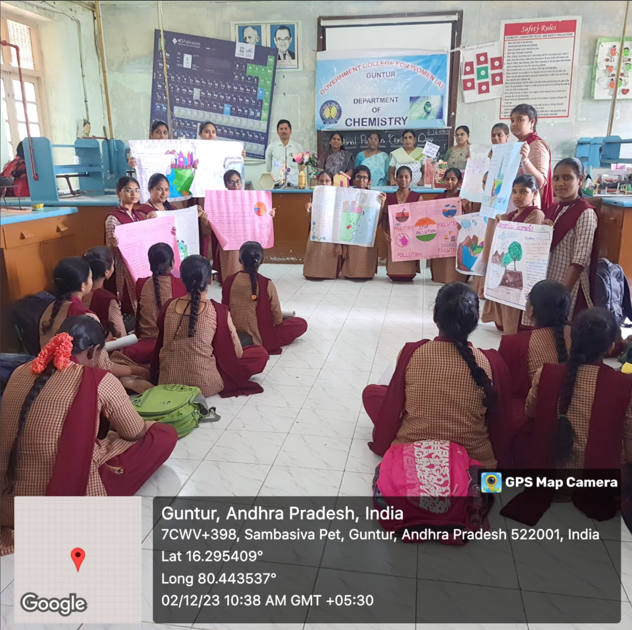

Educational Tour to SRM University AP-02-12-2023
SRM University AP organized “ChemZeal 2” a program aimed to create awareness about chemistry, career opportunities in chemistry, and hands-on experience with research equipment on their campus on 02-12-2023. In this regard, the Department of Chemistry has taken students to this program to help them get exposure to the well-equipped laboratory, and to gain awareness of career opportunities and interaction with the scientific community. In this educational tour, students have participated in quiz competitions conducted by the Department of Chemistry, SRM University AP. Our students secured second prize in this competition. In addition, we have also participated in a seminar program on career opportunities in chemistry. Finally, faculty and students have also visited various laboratories in the Department of Chemistry, SRM University AP to learn about the research that going on presently at that University.
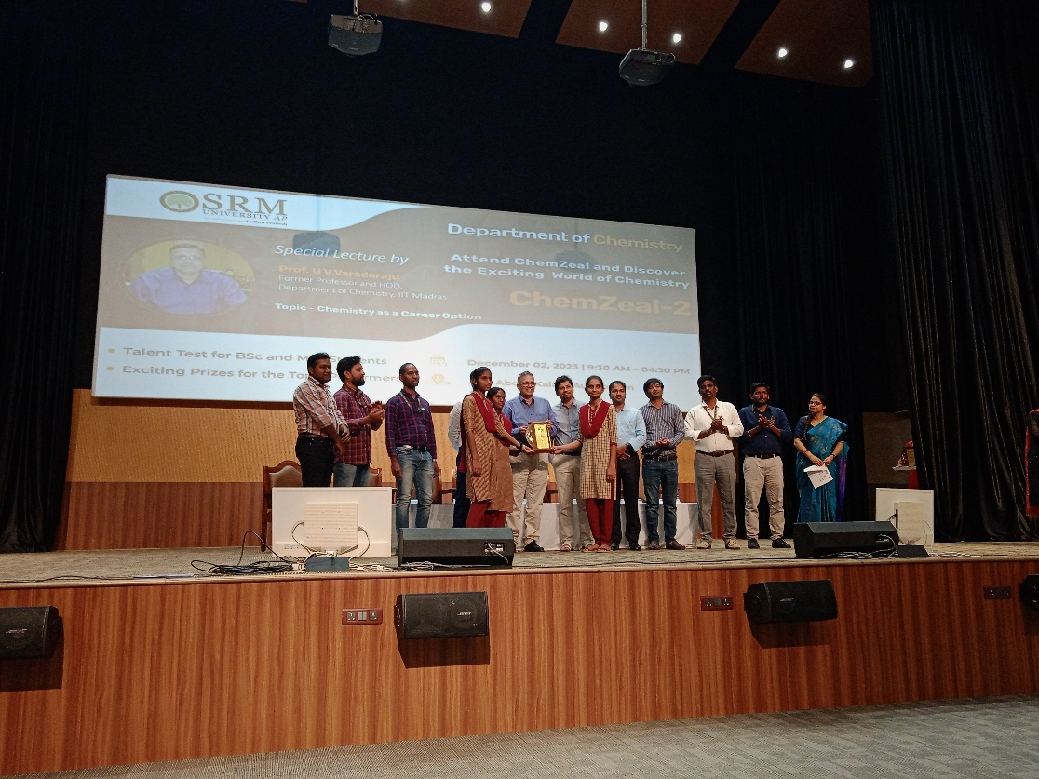

A Value-added course in “Hands-on training in Basic Chemistry soft wares” from 7th December 2023 to 31s^{t} December 2023.
The course is designed to develop student’s interest in household chemistry and also to prepare them for industrial exposure. The content of the course is well-defined to engage them in an intellectually challenging learning experience in a supportive atmosphere. This course is aimed at imparting skills on the use of various open-source chemistry tools that are essential for any student or researcher with chemistry as a major subject. At the end of the course, the participants will be able to use this software for drawing chemical structures, generation of their names, retrieving information about physical properties calculations, three-dimensional molecular structure calculations, spectroscopic signatures, chemical reaction pathways prediction, molecular functional groups, docking sites predictions, and other parameters efficiently.

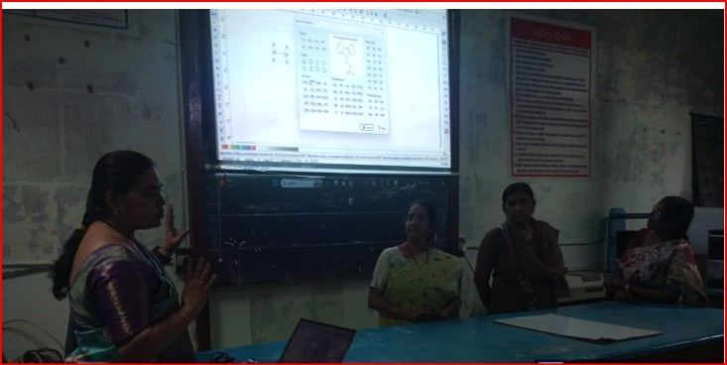
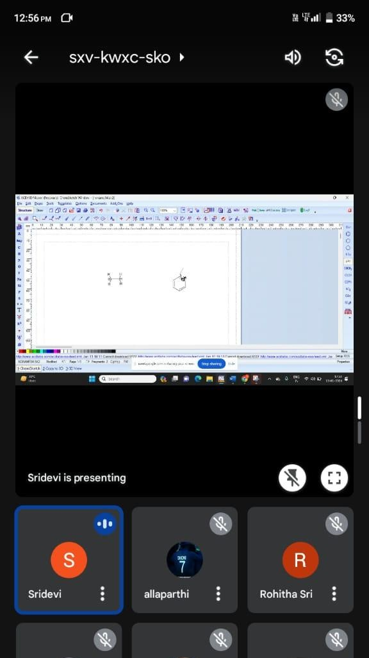
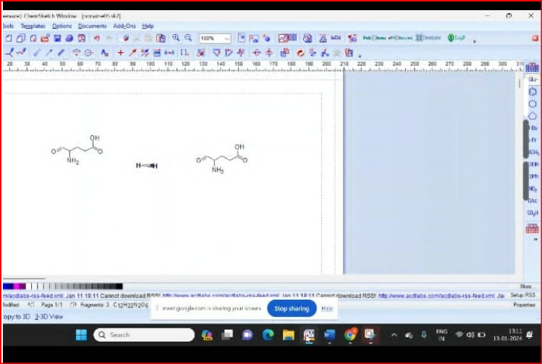

Harmony in hormones
“ Gender Sensitization for Hormonal Equity"
08-12-2023
The Department of Chemistry organized an awareness program on “ Harmony in hormones: Gender Sensitization for Hormonal Equity" online mode on 08-12-2023. for this, Dr. Priti Boora Doon,(Associate professor, Department of Chemistry M.D. University, Rohtak) was the Resource person. This webinar was Organized by Dr. B. Sridevi through Webex. The President of the Programme, Dr. V. Rama Jyosthna Kumari RJD, Principal, Govt. College for Women has explained the importance of hormones. M. Kamala karuna introduced the speaker, Dr.Priti Boora Doon, she continued the session by explaining the importance of hormone balance and explored the highlights of common hormonal disorders and different types of brain chemicals. this webinar ends with queries followed by a vote of thanks by H.O.D Dr.K. Aparna Seetharam. Gender sensitization presides over gender sensitivity, the modification of behavior by raising awareness of gender equality concerns.[1] Sensitization in the domain of chemistry is seen as an awareness informed on the importance of different types of hormones in regulating numerous bodily functions and wellness, This can be achieved by conducting various sensitization campaigns, webinars, workshops, programs, etc.

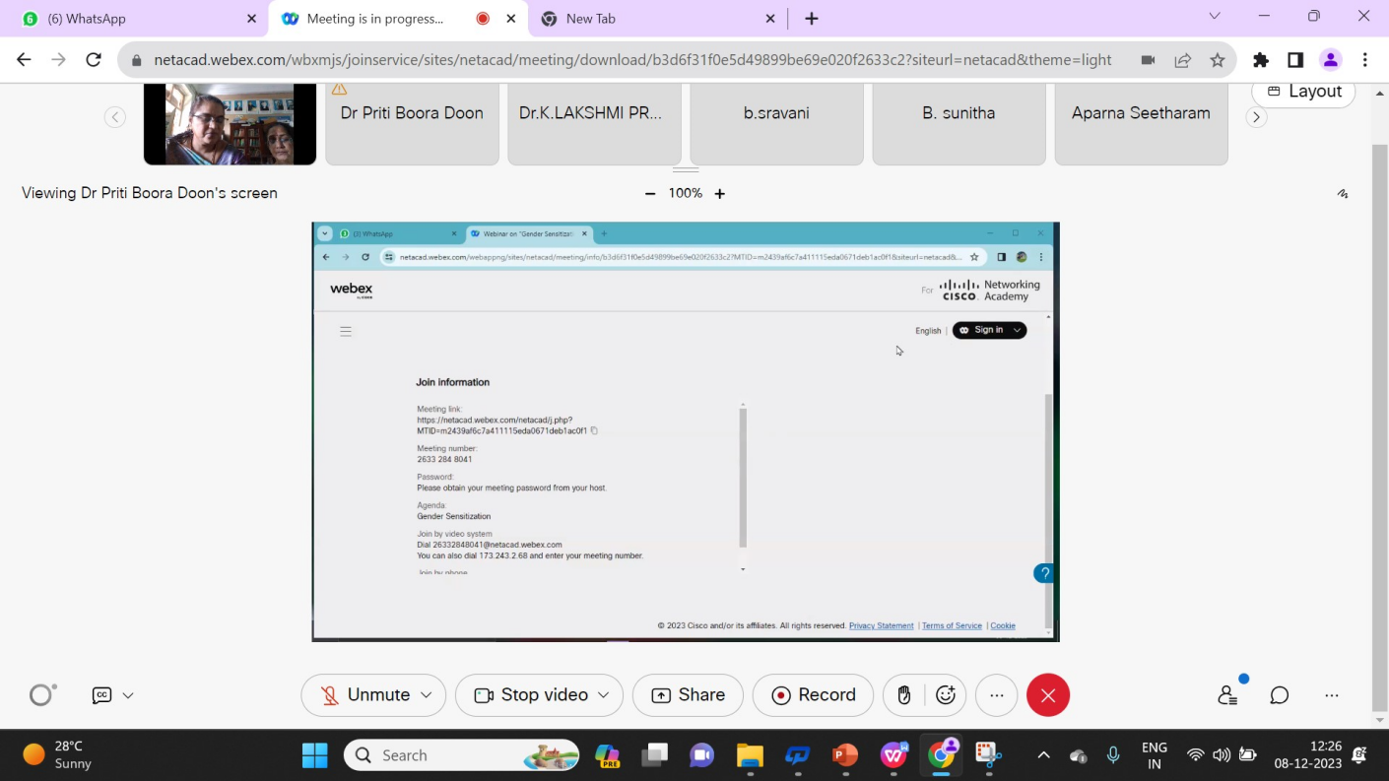
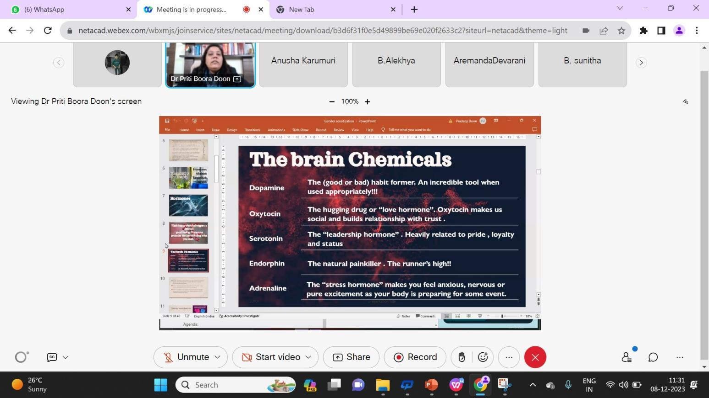

National Level Online Quiz on Nobel Prize Day Ceremony-10-12-2023
The national-level online quiz was organized by the department of chemistry on the occasion of the Noble Prize Day ceremony on 10-12-2023, 58 members participated in this online quiz by quiz coordinator Dr. B. Sridevi to inculcate awareness of noble laureates and noble prizes.
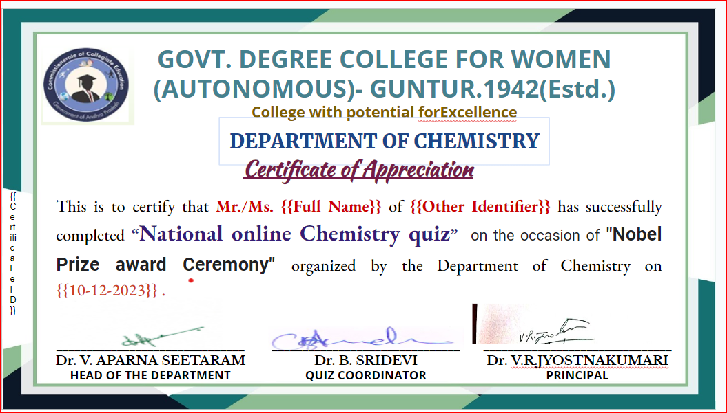

Field Trip to ONGC and NFCL Kakinada
16-12-2023
A direct exposure to the manufacture and processing operations of chemicals and energy sectors provides students with comprehensive knowledge and a deeper understanding of the subject. In this context, this field trip was organized by the Department of Chemistry to Nagarjuna Fertilizers and Chemicals Ltd. (NFCL) Kakinada and Oil and Natural Gas Corporation Ltd. (ONGC), Odalarevu on 16th Dec 2023 to bridge the gap between theoretical knowledge and real-world applications, offering students valuable insights into industrial processes. A total of 68 students, accompanied by 3 teaching and one non-teaching faculty member, participated in the field trip. The group traveled to Kakinada by hiring an RTC bus, ensuring safe and comfortable transportation for all attendees. The journey began with a morning visit to Nagarjuna Fertilizers and Chemicals Ltd. where students received a briefing from the management before embarking on an industry tour to observe production processes and facility operations.
Following the NFCL visit, the group proceeded to Odalarevu, where Oil and Natural Gas Corporation Ltd. (ONGC) hosted all the participants for lunch. After lunch, a briefing session was conducted, and explained the extraction and processing procedures of oil and gas resources by ONGC. Further students were taken to the site and field visit to witness the process of extraction, separation, and transporting of these valuable energy resources throughout the country. A total of 68 students, accompanied by three teaching and one non-teaching faculty member, participated in the field trip.
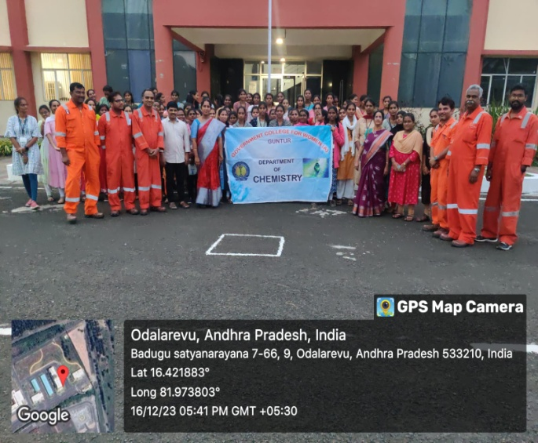
Certificate Course in Methods Of Chemical Analysis
(2-CHE-CC1)
A certificate course in methods of chemical analysis was conducted by the Department Of Chemistry from February 7^{th,} 2024 to March 15^{th,} 2024. Classes and lab sessions were taken from 9-10 am. 16 students were enrolled in this course. In this course, students learned about the classical methods of analysis and instrumental methods of analysis. Steps in chemical analysis and calibration of instruments and their working principles. On the 9th of February 2024, we visited the instrumentation lab of Shree Icon Labs, Vijayawada as they are conducting training for internship students in our college. We visited the regional soil testing laboratory, Guntur, so, as to gain knowledge about the various instruments used in the analysis of soil samples.
Students were asked to submit an assignment on the calibration of instruments pH meters and conductometer. An assessment test was conducted on 14-03-24. Two credits were given to this course. A total of 10 students have completed the course fulfilling the requirements. certificates were issued to them.
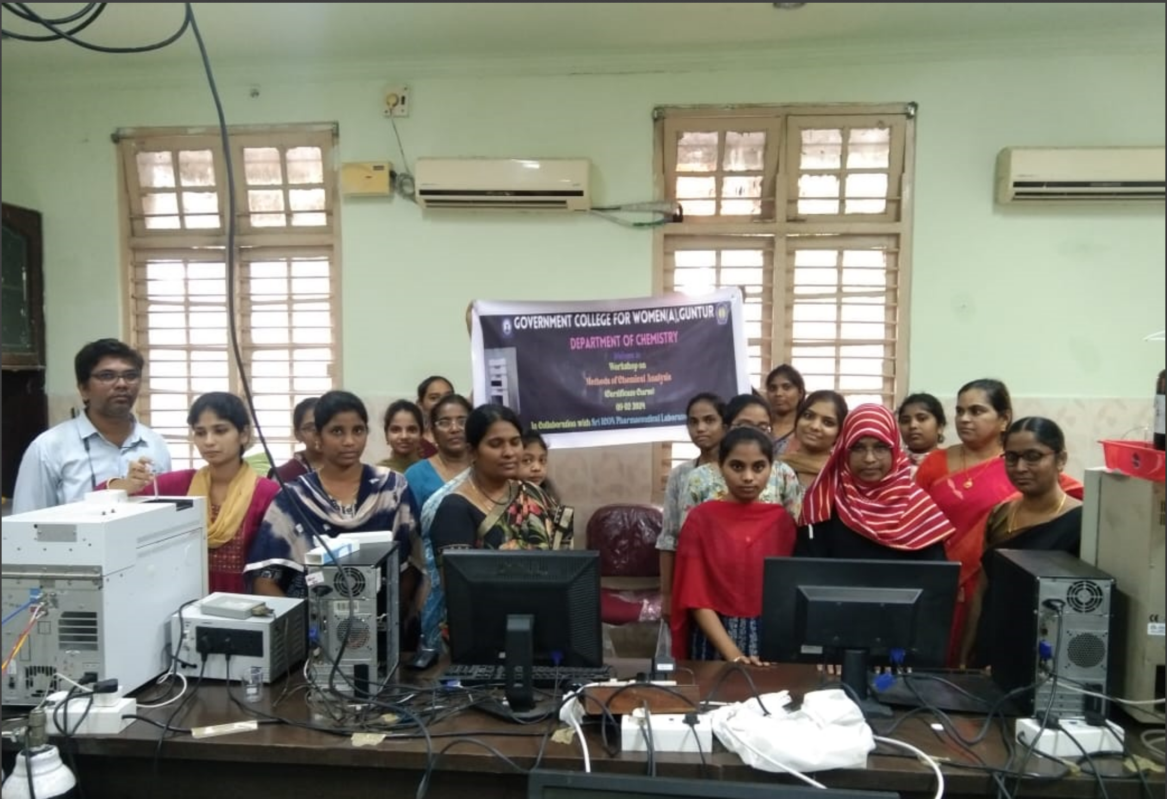

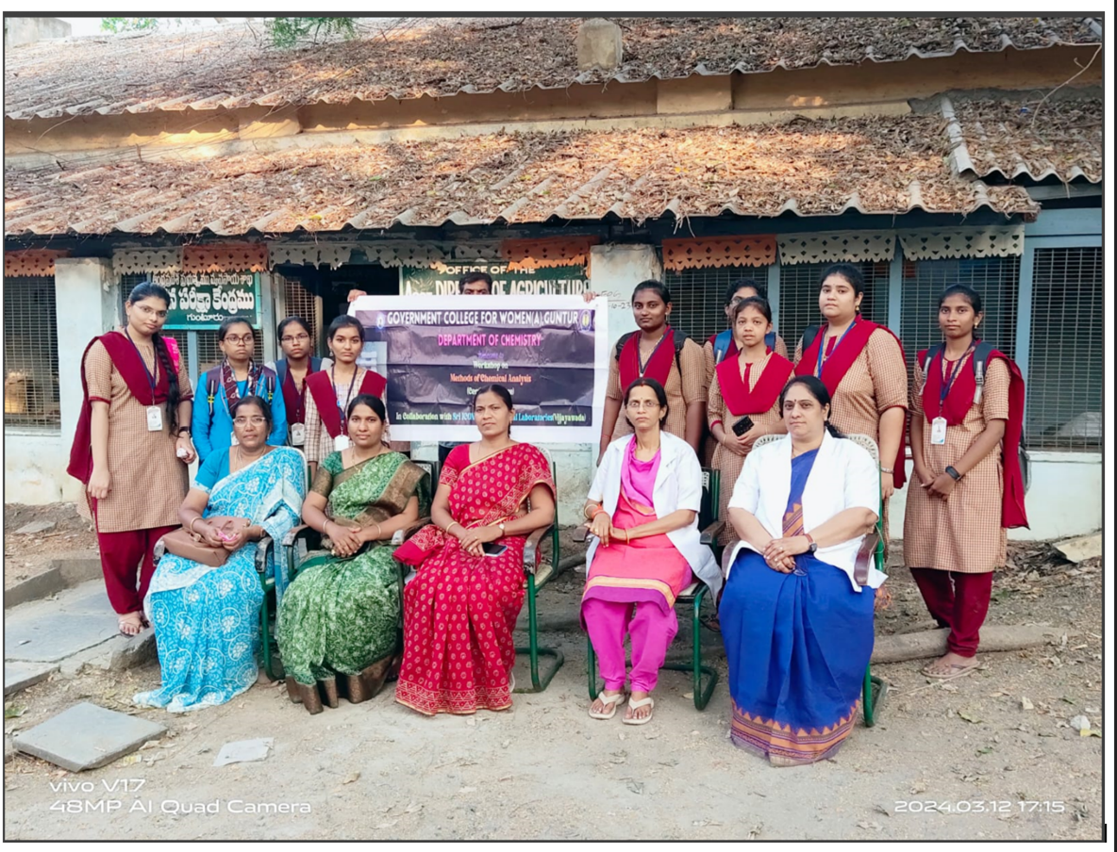
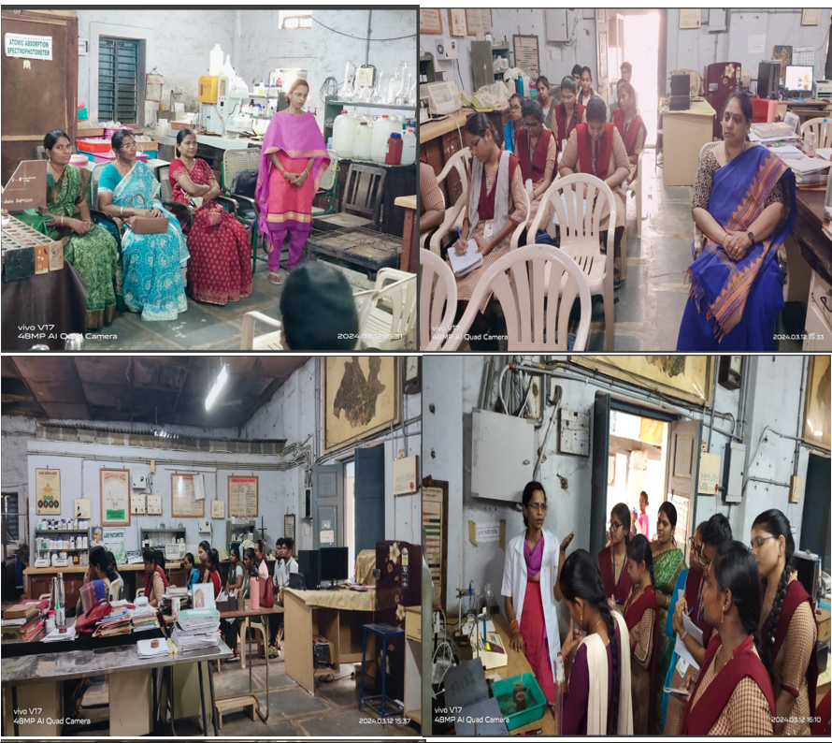
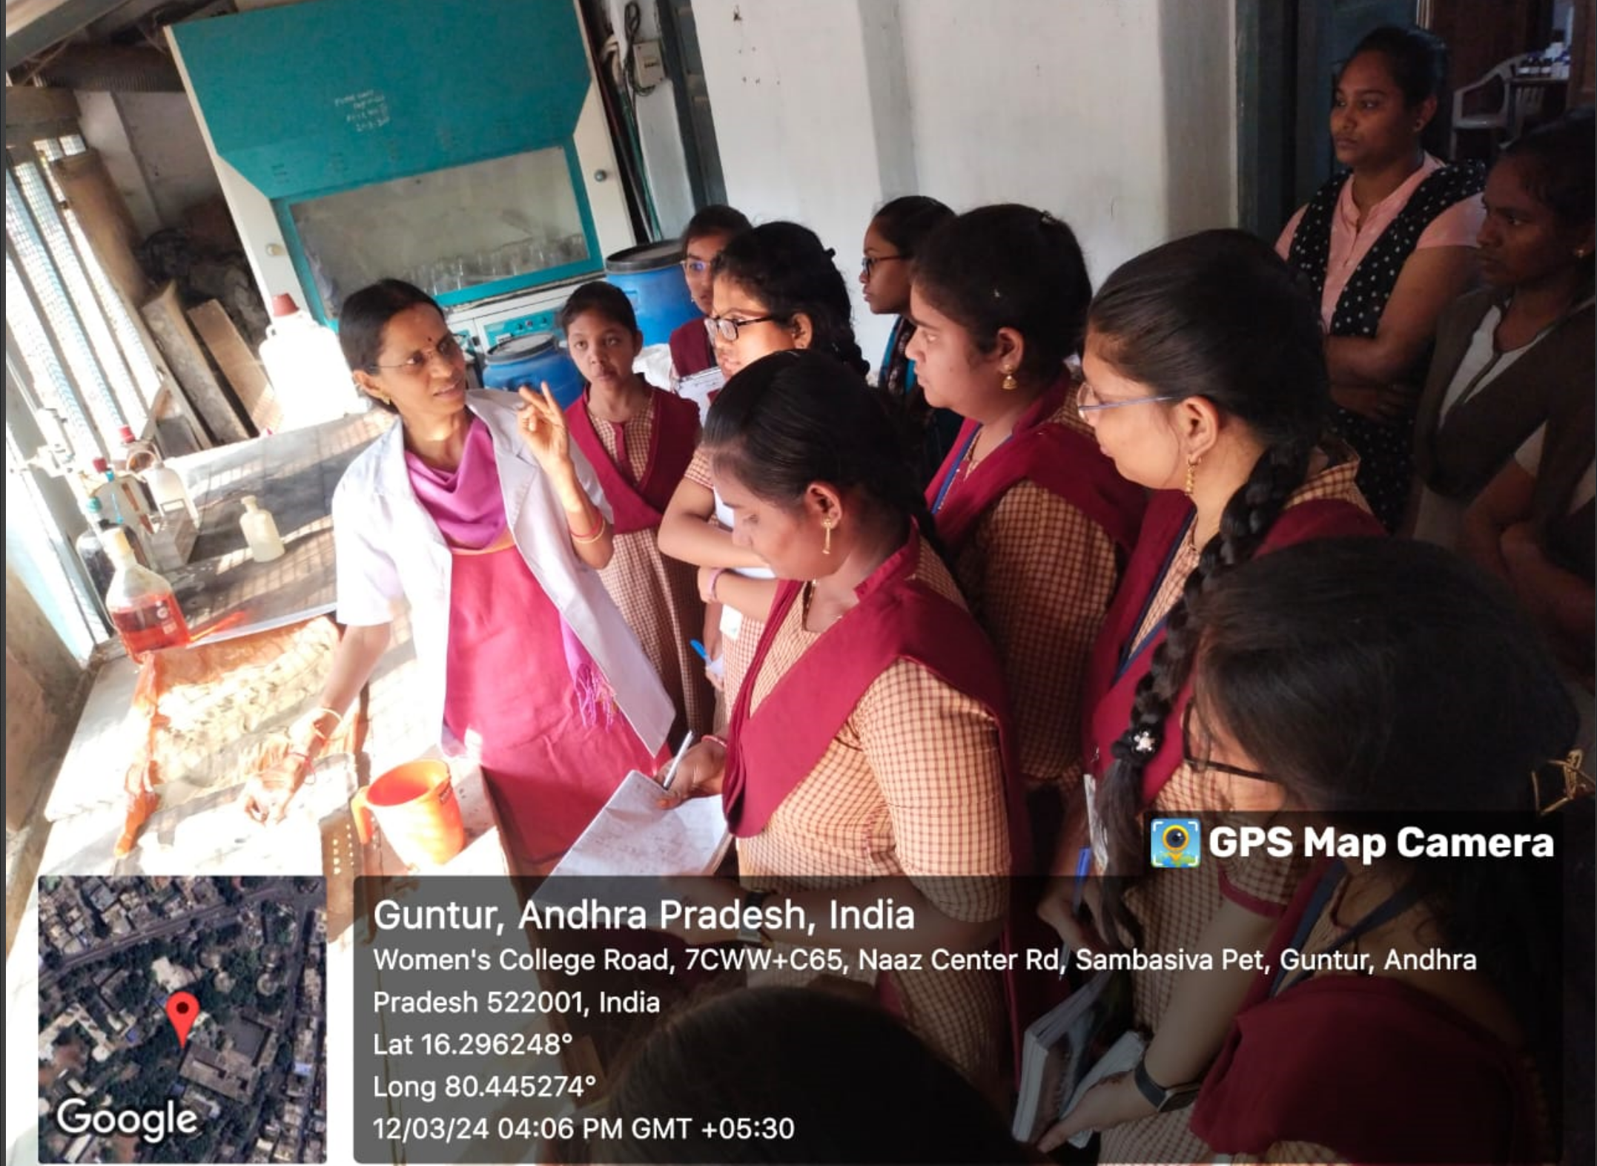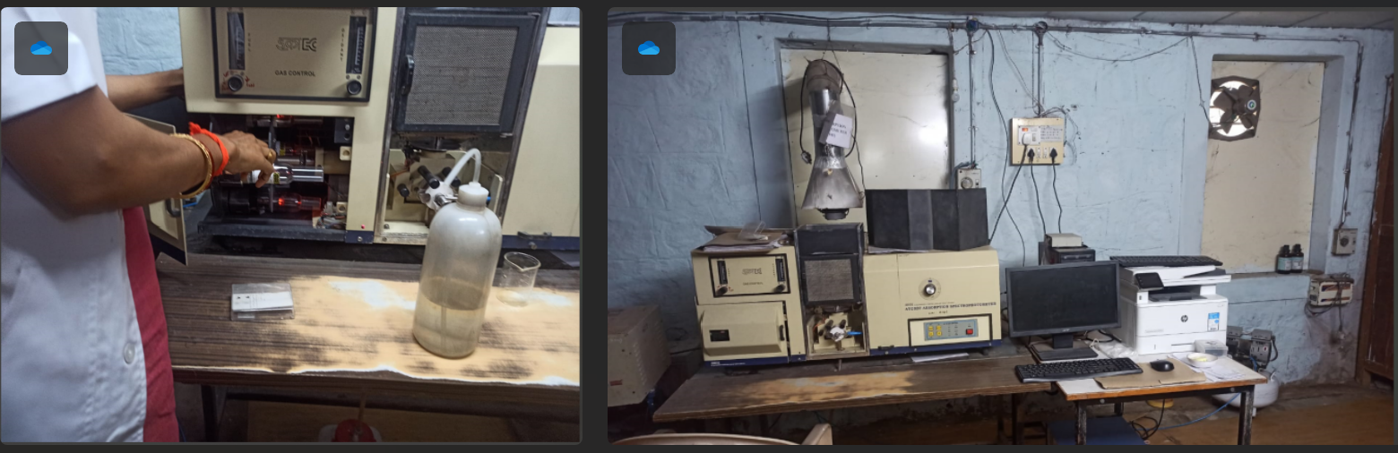
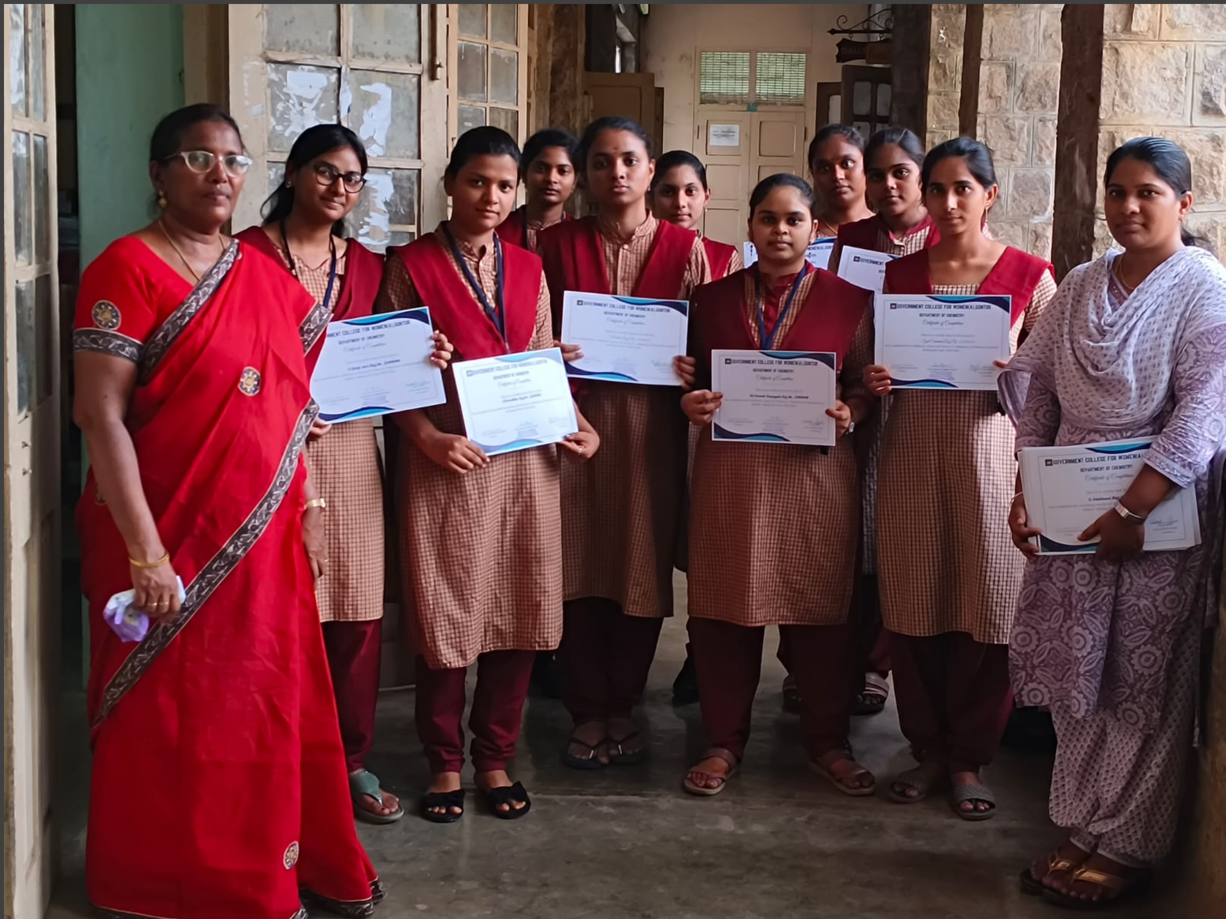
Intercollegiate Competitions
6-3-2024
Chemistry is considered one of the tough subjects among students. To remove this myth and help students prepare for entrance exams, the Department of Chemistry is conducting intercollegiate competitions in JAM, Seminars, and Quiz year for B.SC students. This not only helps to overcome the fear but imparts healthy competition among students of different colleges This academic year students from JKC, TJPS, and GDCW colleges participated in the program.
- The topic for Seminar is “Applications of Quantum dots in science and technology”
- A general quiz covering all branches of chemistry was conducted comprising three members in each team.
- JAM or Just Minute is an event where a student has to talk for a minute on the allotted topic which is chosen via chits
Dr. Hatti, Lecturer in Chemistry JKC College, Guntur, acted as a judge for the Seminar and JAM. Cash awards were given to the students who secured 1st and 2nd prizes.
The following students secured prizes in the events and cash awards
.

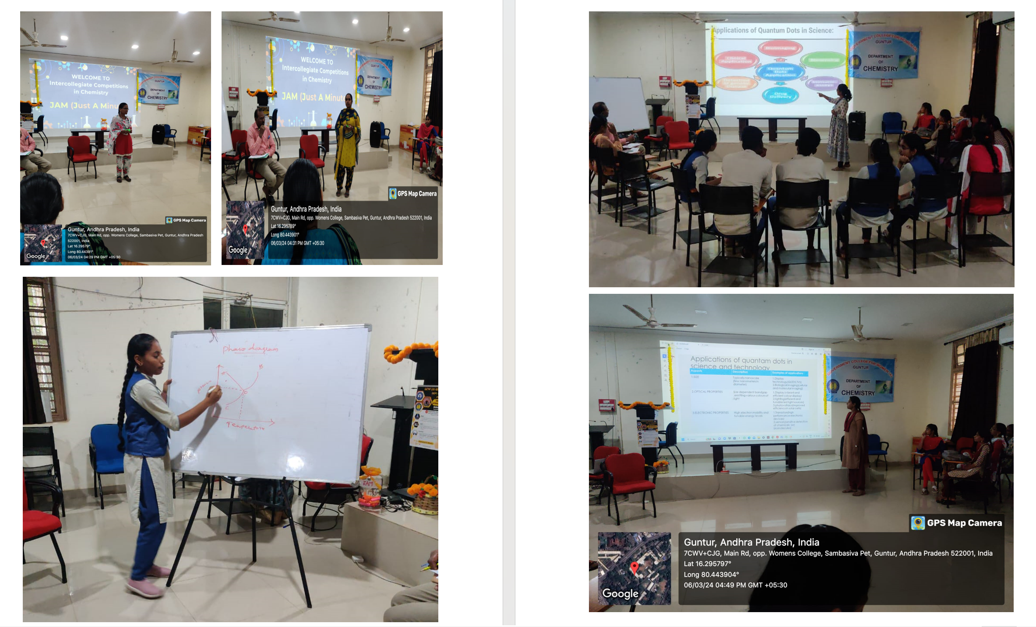
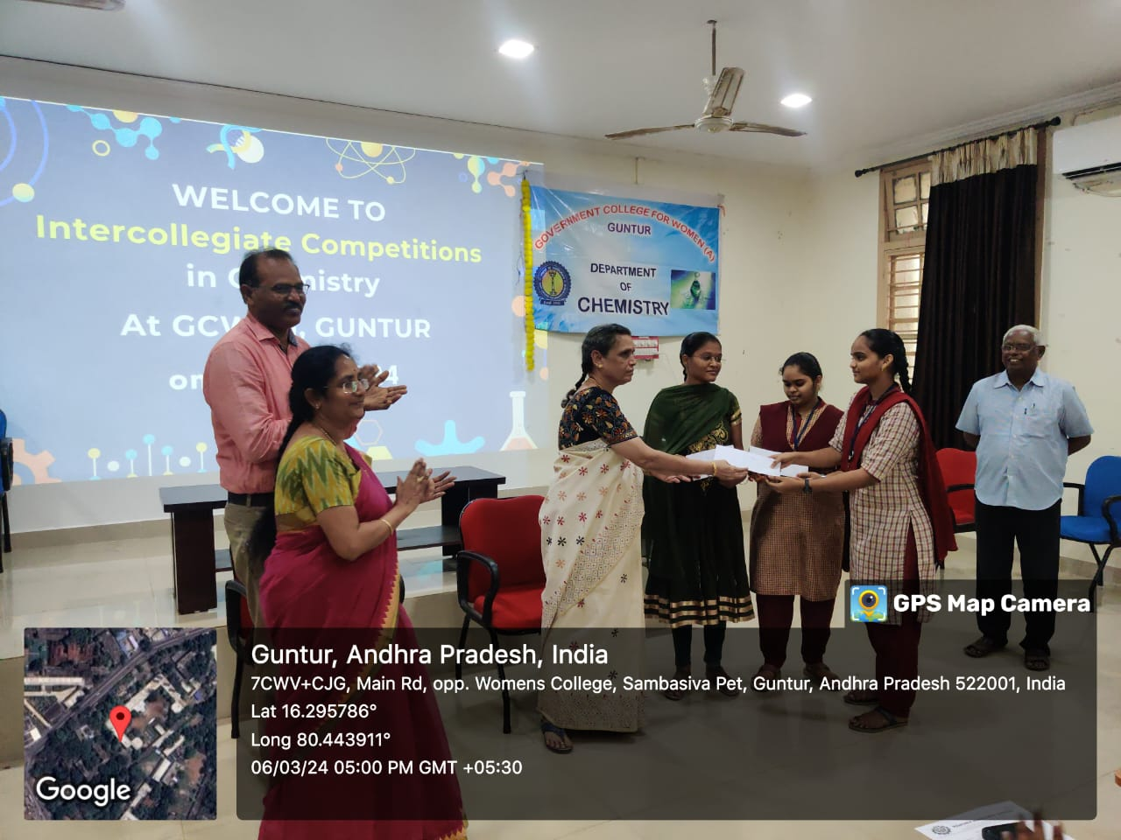
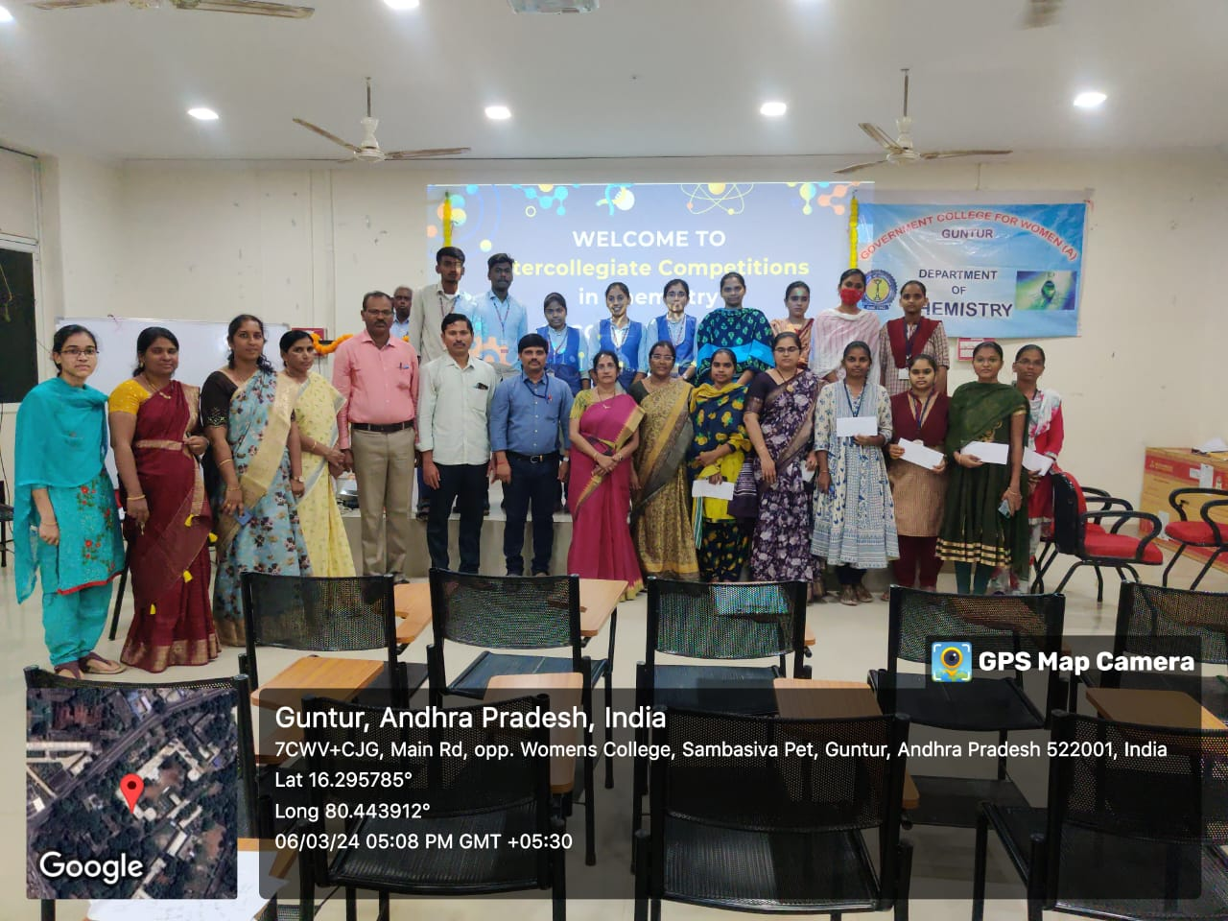

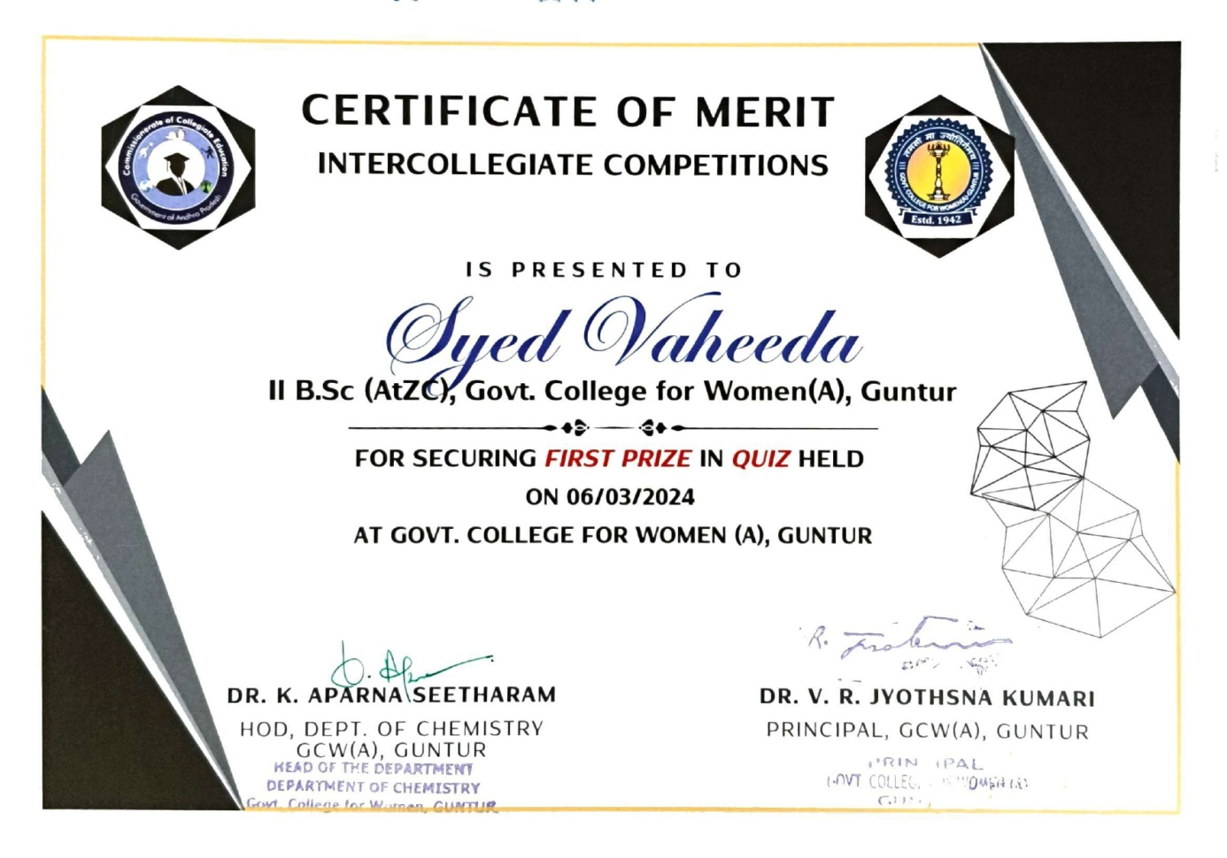

A certificate course in “Detection of Adulterants in Edibles”
From 27-01-2024 to 28-02-2024
The course is designed to ignite students’ curiosity about the chemistry involved in food safety and to equip them for practical application in the real world. Through this course, students will gain valuable insights into identifying and analyzing adulterants in food products, thereby fostering their understanding of food quality control and assurance. This knowledge is not only essential for maintaining public health but also serves as a foundation for potential careers in food chemistry, quality assurance, and regulatory compliance. The content of the course is well-defined to engage them in an intellectually challenging learning experience in a supportive atmosphere. The certificate course was conducted after regular college hours, from 5-6 PM, for enrolled students. Theoretical classes took place in either room 52 or 55, while demonstrations and practicals were held in Organic Chemistry Lab-1. Dr. K. Aparna Seetharam designed the course, with teaching responsibilities shared between Chemistry faculty members Dr. B. Latha and Mr. K. L. Krishna Rao.
At the outset of the course, a workshop in collaboration with Regional AGMARK Laboratories, Guntur, was organized to ignite student interest. This initiative attracted not only enrolled students but also additional participants. Toward the course's conclusion, students were taken on a field trip to the Spices Board of India, a Quality Evaluation Laboratory located at Chuttugunta Circle, Murikipeta, Nagarampalem, Guntur district which is a specialized Laboratory in chemical testing of spices. This direct exposure helps the students to elevate their theoretical and practical knowledge.
Furthermore, certificate course students actively participated in a school-to-lab program conducted by the Department of Chemistry on Science Day. They shared their knowledge with school students, aiming to raise awareness about food adulteration and its detection methods.
To ensure comprehensive learning, a final summative assessment for 50 marks was administered to students with over 50% attendance. All 26 registered students completed the course and received their certificates of completion.
