DEPARTMENT OF POLITICAL SCIENCE
ACTIVITIES FOR THE YEAR 2023-24

AECC (Ability Enhancement Certificate Course):“ HUMAN RIGHTS”

The department has designed and offered an Ability Enhancement Certificate Course, titled, “HUMAN RIGHTS” for the first semester B.A., POLITICAL SCIENCE Major students. This course is offered as an introductory course for 30 days from 16-11-2023 to 20-12-2023 to Enhance students’ skills in applying human rights knowledge to their own contexts and situations. The entire course material was selected from the standard books and Online sources. The final assessment was done on two levels with an presentation of their Assignment and a written test.
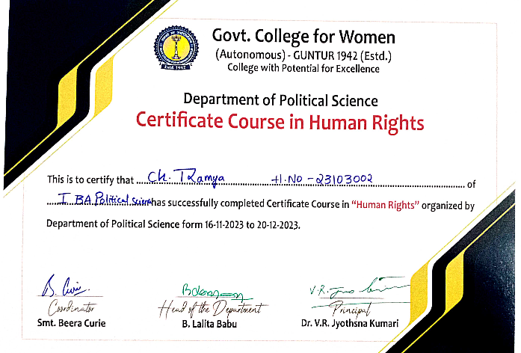

A Field Trip to AP Assembly ,AP Secretariat & High Court
The department has organized a field trip with Sixth and Fourth-semester students on 26-02-2024. Approximately Fifty students were taken to the AP Assembly ,AP Secretariat & High Court The field trip provided students with invaluable practical exposure to governance, history, and legal proceedings. It enhanced their academic experience, allowing them to apply theoretical knowledge to real-world contexts. Students left the trip with enriched perspectives and a deeper understanding of the functioning of government institutions and the cultural heritage of Andhra Pradesh.

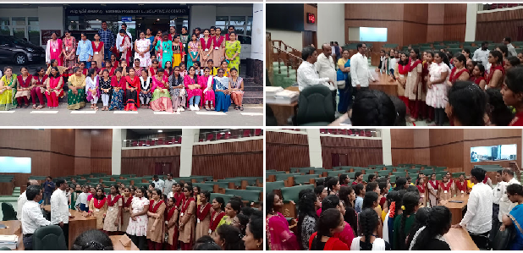
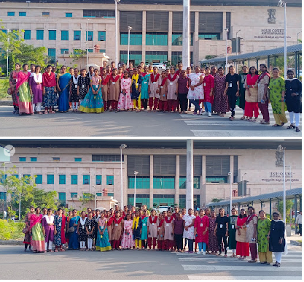
II- Extension Activity at Samarthanam Trust for the Disabled, Guntur
"The department conducts extension activities to reach out to unreached sections of society. Recently, an extension activity took place at Samarthanam Trust for the Disabled in Guntur. Over five days, from February 5th to February 10th, 2024, Mr. B. LALITABABU, a faculty member from the department, provided coaching on Indian Polity for competitive exams to differently-abled individuals residing in the trust.
During the sessions, participants learned about various aspects of Indian Polity, including the Constitution, Governance structures, and fundamental rights. The goal was to empower them with knowledge that would enhance their chances of success in competitive examinations. Mr. B. LALITABABU used interactive teaching methods, ensuring that the content was accessible and engaging for all participants.
Overall, the extension activity at Samarthanam Trust was a valuable initiative, promoting education and empowerment among the differently-able-students."

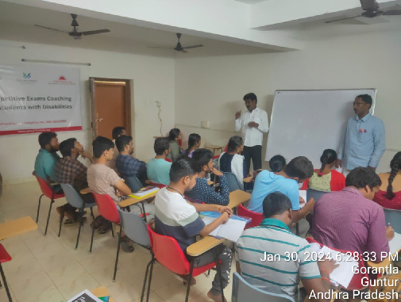

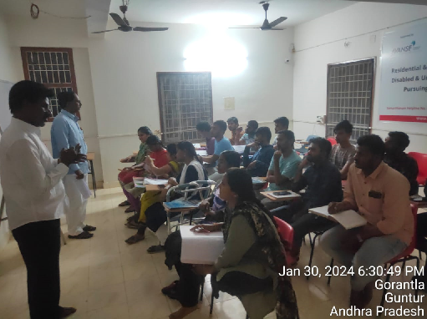

III- Extension Activity : “EVM Demonstration for Newly Enrolled Student Voters”
In a remarkable initiative, the students of Government College for Women (A), under the guidance of Head of Department B. Lalitababu, embarked on an experiential learning journey. Their visit to the Collectorate in Guntur was not only educational but also transformative. The objective was to empower the newly enrolled young student voters by providing practical insights into the Indian political process and government functioning. The students nearly 50 visited EVM Demonstration centre on 17-02-24 at Collectorate in Guntur .This initiative Educate the students on the functioning of Electronic Voting Machines (EVMs) and their role in democratic elections . It familiarize students with control units and the voting procedure to ensure their active participation in the democratic process. It Cultivate a sense of civic duty and responsibility among students by encouraging them to recognize the significance of voting in a democracy.
