DEPARTMENT OF SOCIOLOGY
ACTIVITIES FOR THE YEAR 2023-24

Awareness Programme on: “WORLD SOCIAL JUSTICE DAY” 20.02.2024

On 26th November 2007, The General Assembly declared that, starting from the 63rd session of the General Assembly, 20th February will be celebrated annually as the “World Day of Social Justice”. World Day of Social Justice is an international Day recognizing the need to promote social justice. Which includes efforts to tackle issues such as poverty, exclusion, gender inequality, unemployment, human rights and social protection. Every year on 20th February the World Day of Social Justice is observed worldwide. As grave injustices and widespread labor insecurity threaten social issues, the day stresses the need to build fairer and more equitable society.
Theme: World Day of Social Justice 2024: The theme of World Day of Social Justice 2024 is” Bridging Gaps, Building Alliances”. The United Nations choose This theme to emphasis the importance of collaboration and partnership in addressing the world challenges.
Significance of World Day of Social Justice 2024: The idea behind celebrating “World Day of Social Justice” 20.02.2024 is that improving social justice should be the primary goal of all national and international policies.
To aware students about social justice, gender inequality, Human rights and social protection. To educate them on national and international social justice.
Resource Persons: Mrs. S.B. A. Jhansi, B. Com, L.L.M, Member of National Legal Services Authority & Member of National Commission for Women and Member of Standing Council for A.P. Pollution Board, Guntur. Mrs. K. V. Padmavathi, B. Com, L.L.M (Constitutional Law), Advocate cum Legal Counselor in protection of women from Domestic Violence Act 2005.Sri. B. Lalitha Babu, Head, Dept of Political Science, In-Charge, Dept. of Sociology, GCW(A), Guntur. Dr. Naga Chandrika, Lecturer, Dept of Psychology. Dr. M. Swarna Latha, Lecturer in Sociology, Dr. D. Dhatri Kumari, Lecturer in Telugu, Dr. V. Bhavani, Lecturer in Telugu, Dr. P. Vijaya Lakshmi Lecturer, Dept. of Telugu, GCW(A), Guntur.

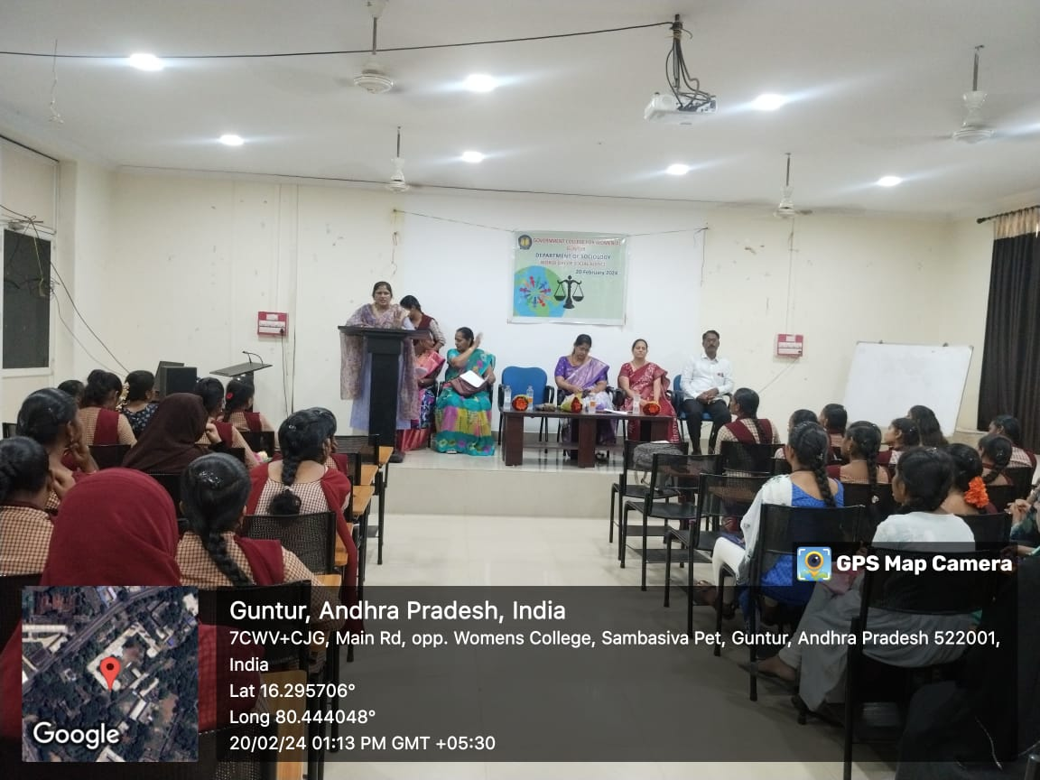

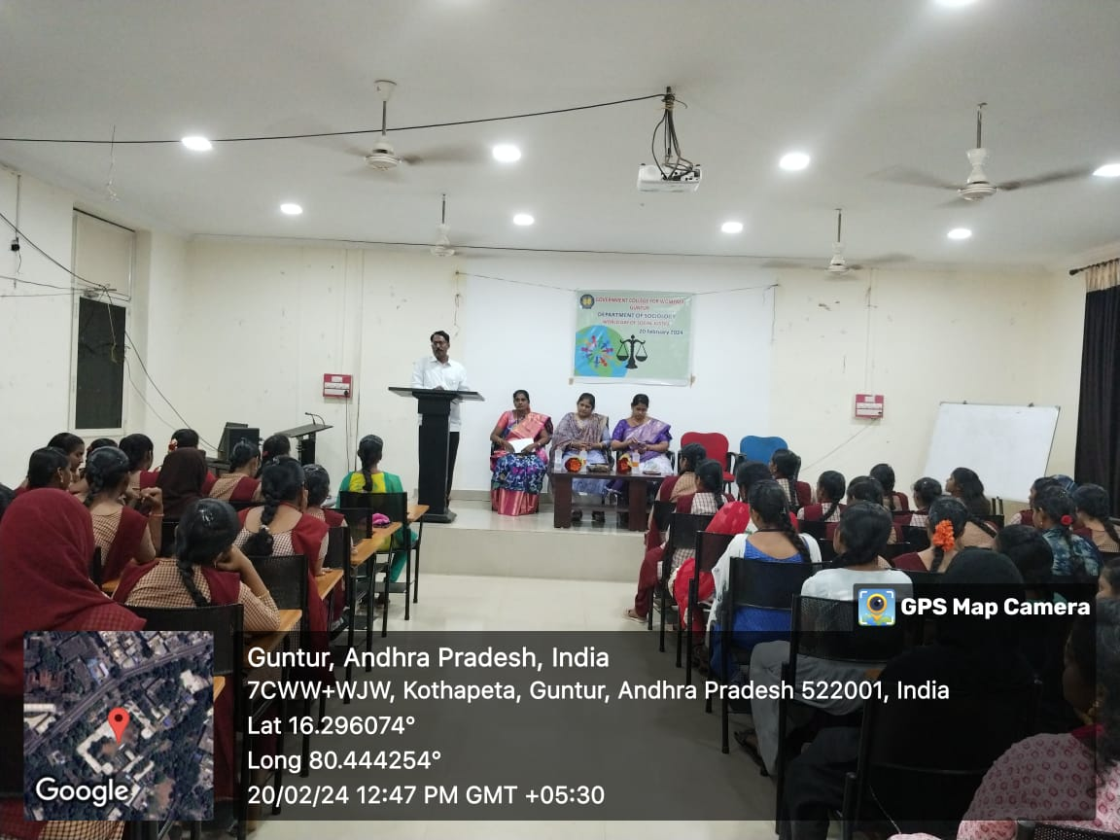
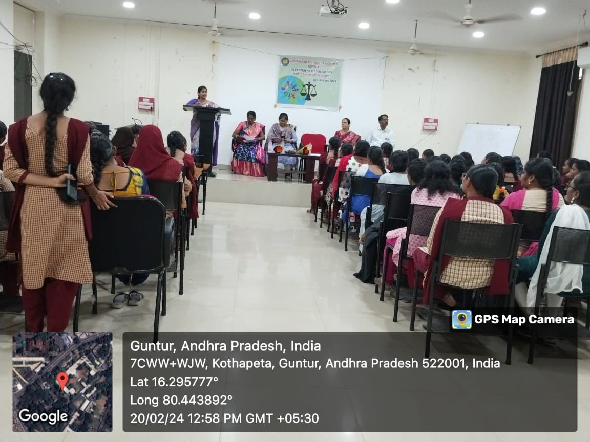
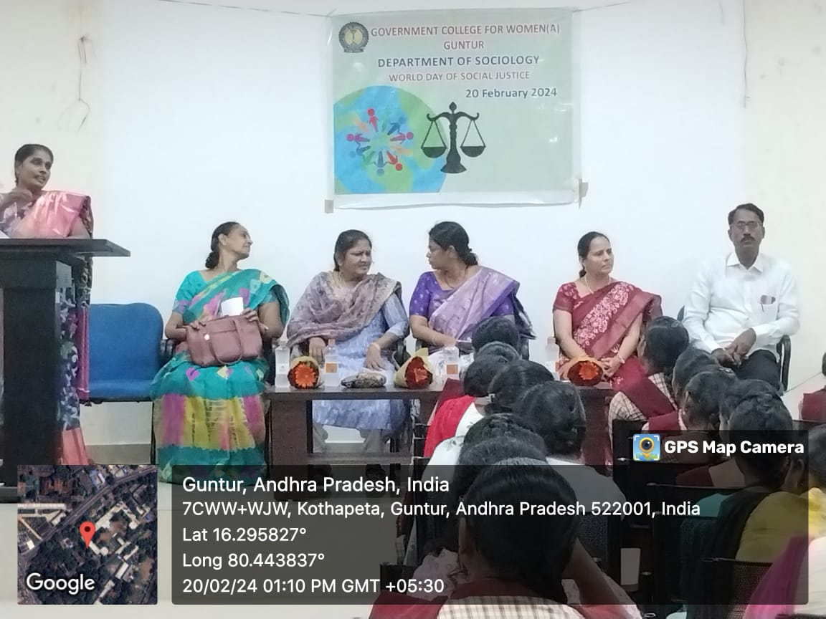
WORLD DAY OF SOCIAL JUSTICE: 20.02.2024.

