DEPARTMENT OF COMPUTER SCIENCE
ACTIVITIES FOR THE YEAR 2023-24

Certificate Course on “Android App Development”

The Certificate Course on “Android App Development” held from 27-6-2023 to 11-7-2023, 2023, final year Computer Science Students aimed to equip participants with comprehensive knowledge and practical skills required to create Android Apps. The course was focused on the in-depth understanding, hands-on experience in creating Android apps. The students who get above 40% in the final test were given the course completion certificate.
Course Overview:
- Dates: 27-6-2023 to 11-7-2023
- Duration: 30 Hours ( 10 Days -3 Hours/Day 10*3=30 Hours)
- Instructor: K. Deepthi, Lecturer in Computer Science, Govt. College for Women(A), Guntur
- No of students registered: 101
- No. of students passed the exam: 73

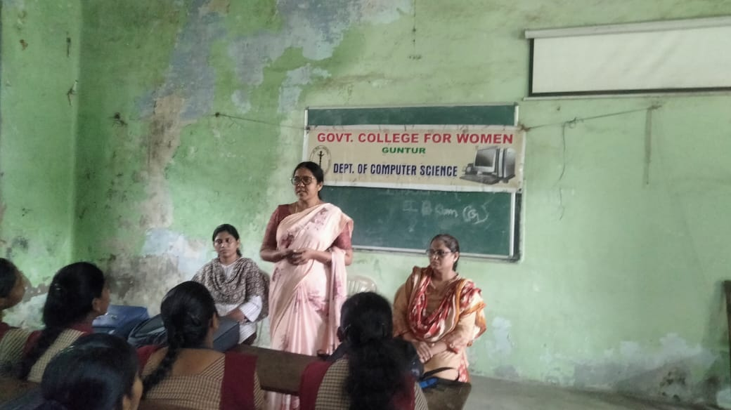
Vice Principal, Mrs. P. Nirmala Kumari, addressing the Students

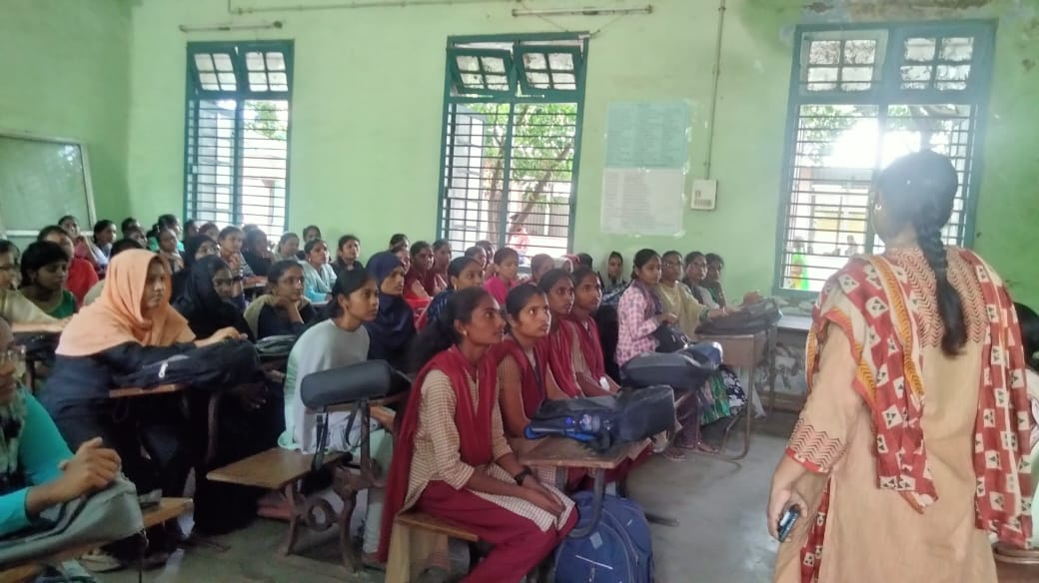
In-charge of Computer Science Department, Dr. Shaheda Akthar, addressing the students
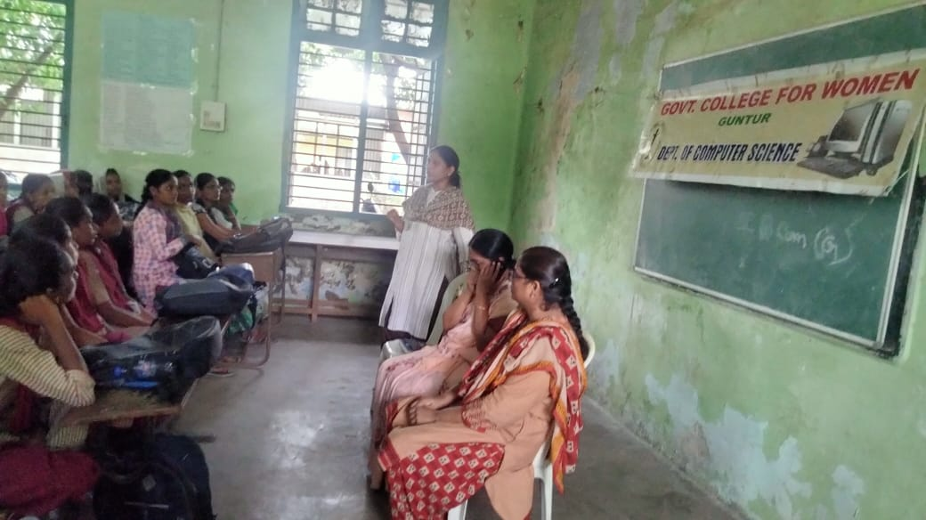
Resource Person, Mrs. K. Deepthi, Lecturer in Computer Science, Govt. College for Women(A), Guntur, addressing the students

Certificate Course on “Salesforce Administration”

The Salesforce Administration Certificate Course, held from July 17th to July 21st, 2023, for III B.Voc (SD) aimed to equip participants with comprehensive knowledge and practical skills required to effectively administer Salesforce platforms within their respective organizations. The course focused on in-depth understanding, hands-on experience, and practical application of Salesforce administration principles.
Course Overview:
- Dates: July 17th - July 21st, 2023
- Duration: 30 Hours ( Five days 6 Hours/Day 5*6=30)
- Instructor: G.V.S.Pranayani Devi
- No of Students Registered: 12

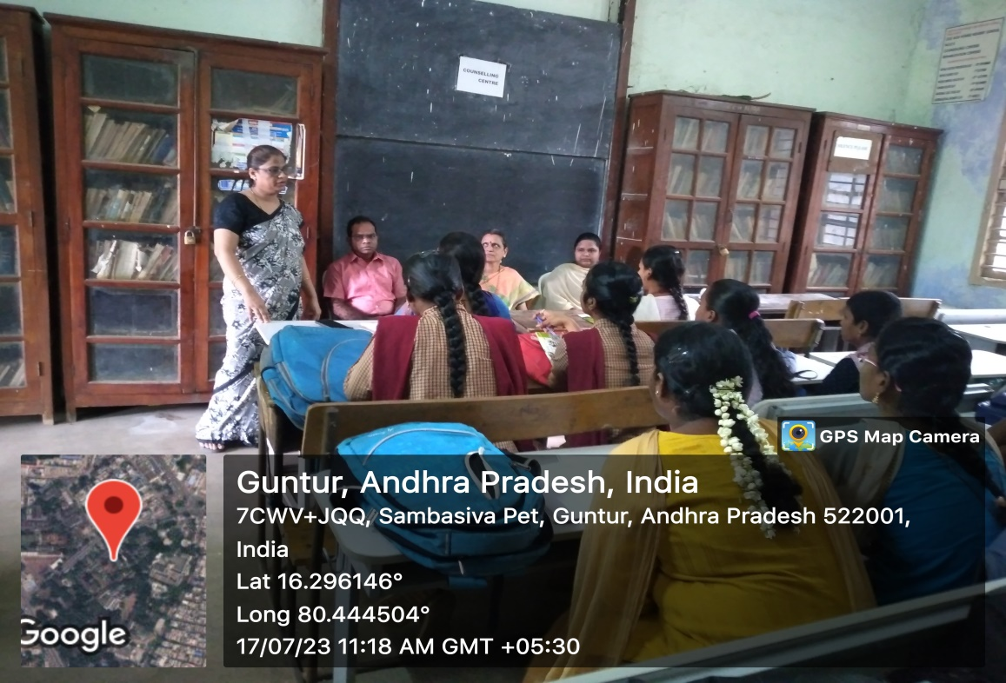
In-charge of Computer Science Department, Dr. Shaheda Akthar, addressing the students
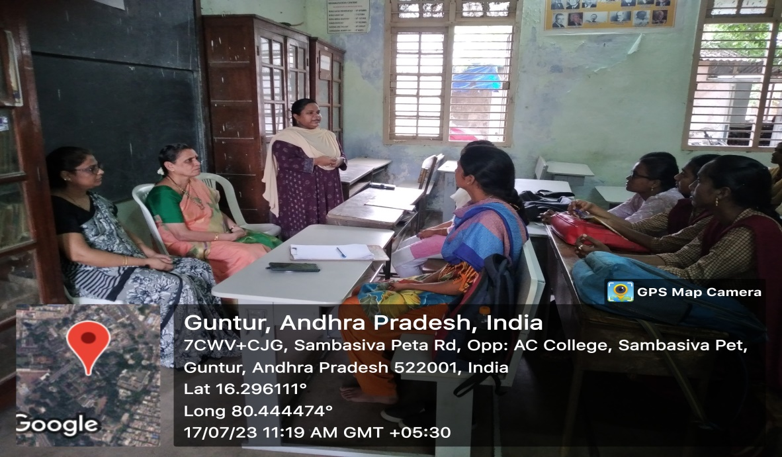
Instructor, Ms. G.V.S. Pranayani Devi, Lect. in Computer Science, Govt. College for Women(A), Guntur, addressing the students

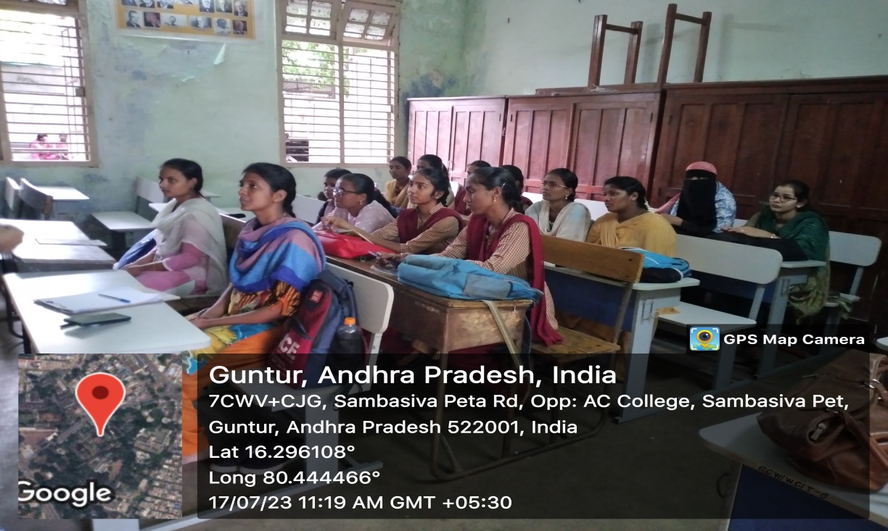
Students attending the Certificate Course

Guest Lecture on "Block Chain Technology"

In this enlightening lecture, the students delved into the transformative realm of blockchain technology, uncovering its foundational principles, diverse applications, and far-reaching implications across industries. Beginning with an exploration of blockchain's decentralized architecture and cryptographic security, the students navigated through its evolution from cryptocurrency origins to its adoption in fields such as finance, supply chain management, healthcare, and beyond. This was organized on 1-9-2023 from 3:00PM to 5:00 PM for all the Computer Science Students.
Through real-world examples and case studies, the students got an understanding of how blockchain enables transparent, immutable, and tamper-resistant record-keeping, revolutionizing traditional business processes and fostering trust in peer-to-peer transactions. Moreover, the students could dissect the potential impact of blockchain on enhancing efficiency, reducing costs, and mitigating fraud and errors in various sectors.
Furthermore, there was a discussion on the challenges and considerations associated with blockchain implementation, including scalability, regulatory frameworks, and interoperability. By critically examining both the opportunities and hurdles, the students gained a comprehensive understanding of the strategic implications of blockchain technology on organizational innovation and competitive advantage.
Ultimately, this lecture served as a catalyst for the students to envision new possibilities and embark on a journey of exploration and innovation, leveraging blockchain's disruptive potential to shape a decentralized future of transparency, efficiency, and trust.
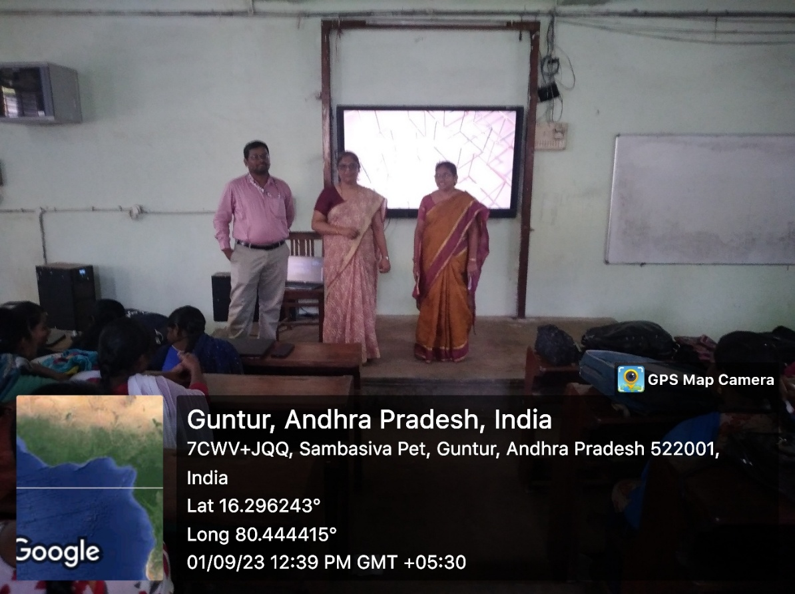
Incharge of the Computer Science Department Dr. Shaheda Akthar addressing the students

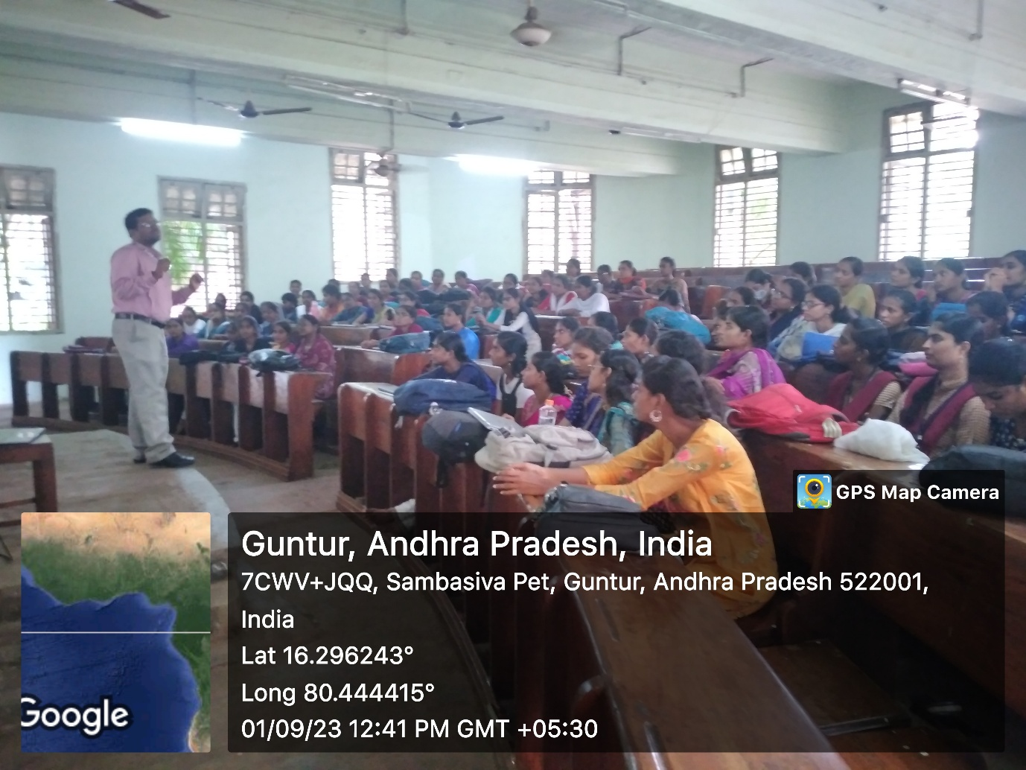
Resource Person Dr. Shaik Khaja Mohiddin, Associate Professor of CSE, KL University, addressing the students

Smart Certification Program on “Cyber Security”

As per the instructions of CCE, Cyber Smart certification programme is conducted for all the Students. All the participants got this certification by successfully completing the gamified video lectures and attempting the quiz. The principal Madam and the entire Department faculty attended this program.
The certification awarded to students as "Cyber Smart" and teachers as “Cyber Smart Teachers” not only recognize their accomplishments but also emphasizes the importance of cyber security education for all. It's commendable that the program includes engaging methods like gamified lectures to make learning enjoyable and effective.
By successfully completing these various components, participants demonstrate their commitment to cyber security education and their proficiency in the subject matter. The initiative to certify both students and teachers reflects a holistic approach to fostering a safer and more informed digital environment. This program equips individuals with essential cyber security knowledge
No of participants: 700
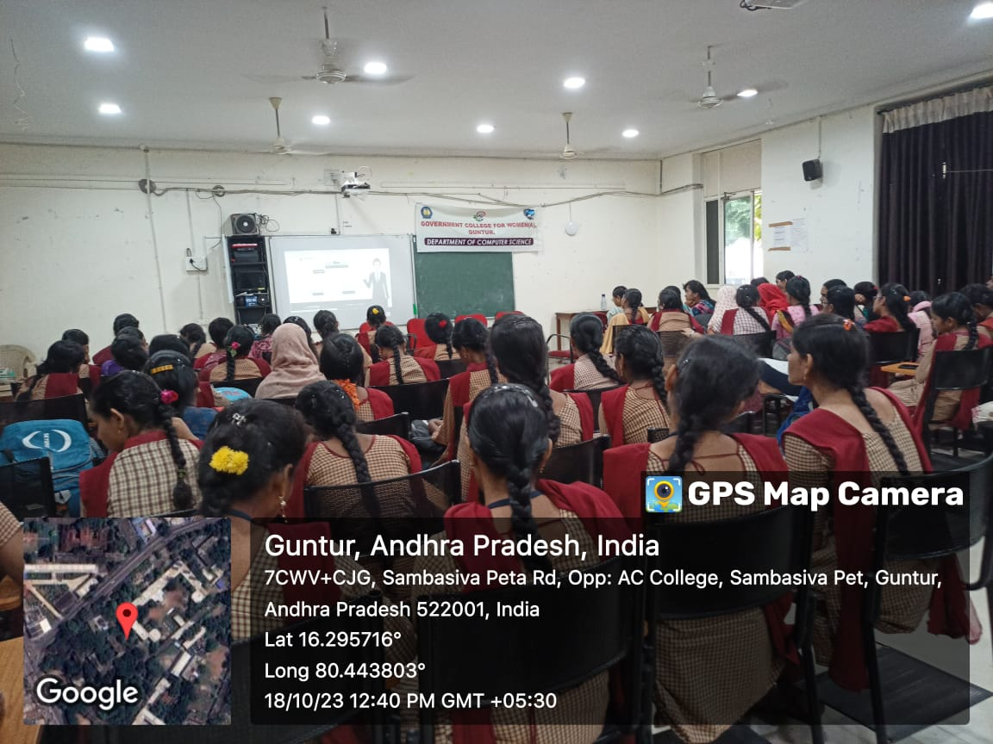
Students participating in the Event
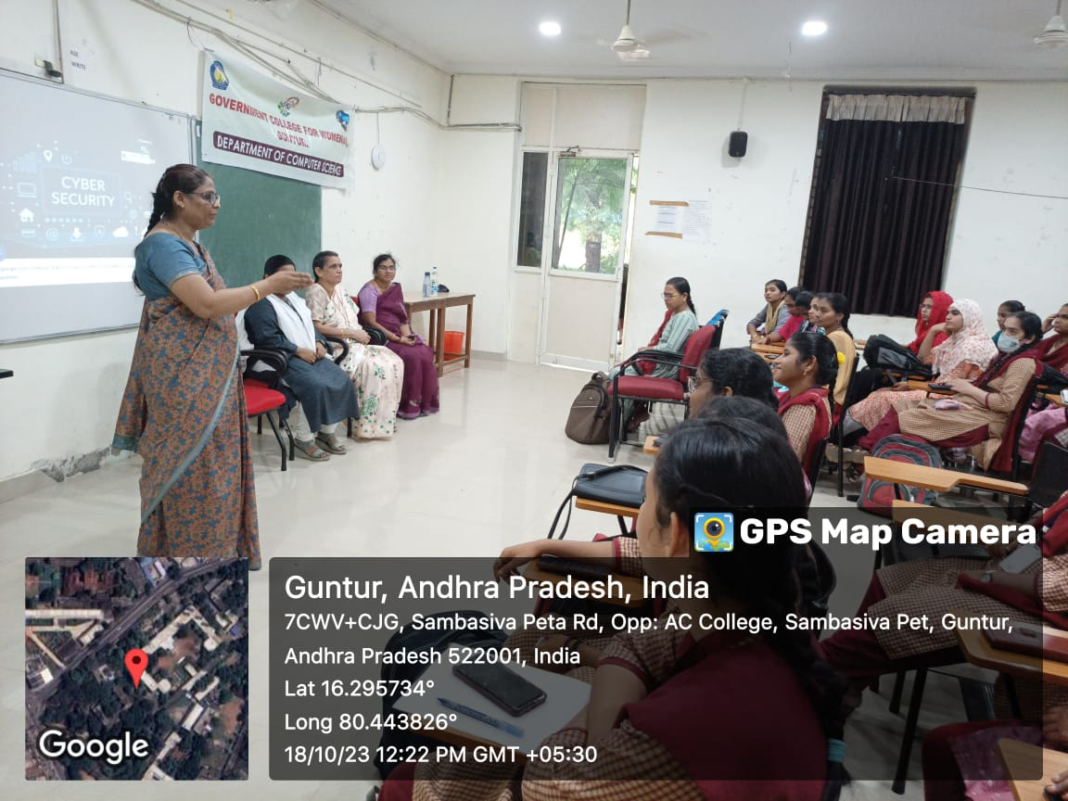
Dr. Shaheda Akhtar, Lect. in Computer Science, addressing the students

Celebration of “National Computer Security” day
On the account of National Security Day, The department of Computer Science has organized some competitions for the students of the college on Cyber Security on 30-11-2023 from 3:00PM to 5:00 PM.
Cyber-attacks are becoming increasingly sophisticated and frequent, and individuals and organizations must take steps to protect themselves from these threats. The first step in building a culture of cyber security is to create awareness about the risks and threats posed by cyber-attacks.
Cyber-attacks come in many forms, including phishing emails, malware, ransomware, and social engineering attacks. Without an understanding of these threats, individuals and organizations may not be aware of the steps they need to take to protect themselves from these attacks. By creating awareness about the importance of cyber security, individuals and organizations can learn about the various risks and threats and how to protect themselves from these attacks. This includes understanding the importance of strong passwords, the dangers of public Wi-Fi, and the need to update software and security systems regularly.
Role-play Details:
The students actively participated in the role play, portraying real-time scenarios of individuals falling victim to cyber frauds. At the conclusion of the role plays, they outlined methods to handle cyber frauds and highlighted precautions to prevent cyber-attacks.
Essay Writing Competition details:
The Essay writing competition in conducted on the topic “importance of cyber security awareness in this digital age”. Total 9 students participated in this competition. All the teaching staff actively involved in this activity.

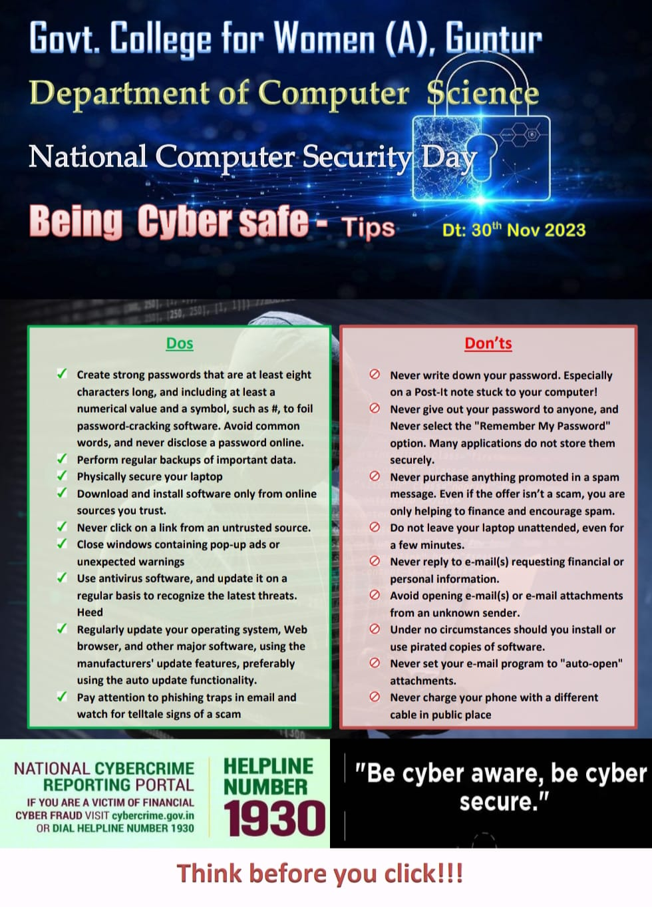
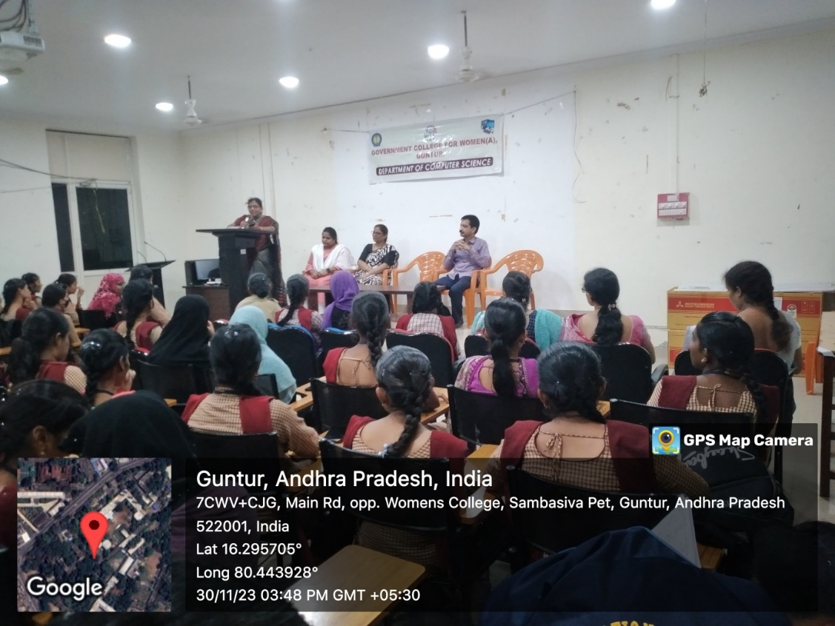
In-charge of the Computer Science Department, Mrs. K.M.S. Sailaja Rani, addressing the students in the inaugural of the event
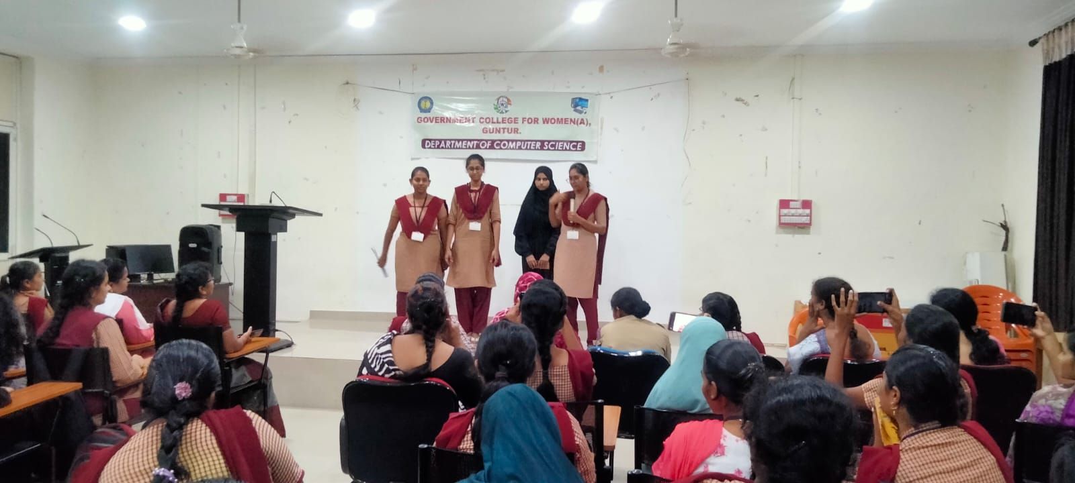
III B.Voc. Software Development Students performing Skits
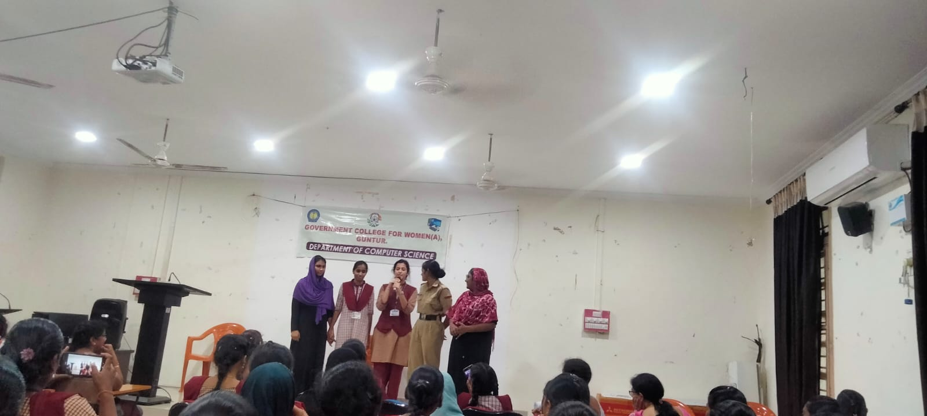
III B.Sc. Data Science Students performing Skits
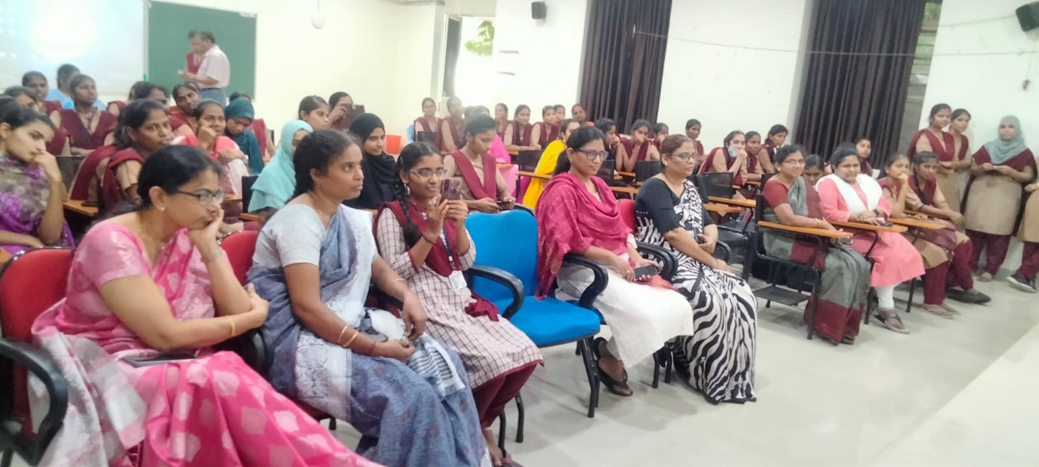
Students and Faculty of the Computer Science Department attending the event

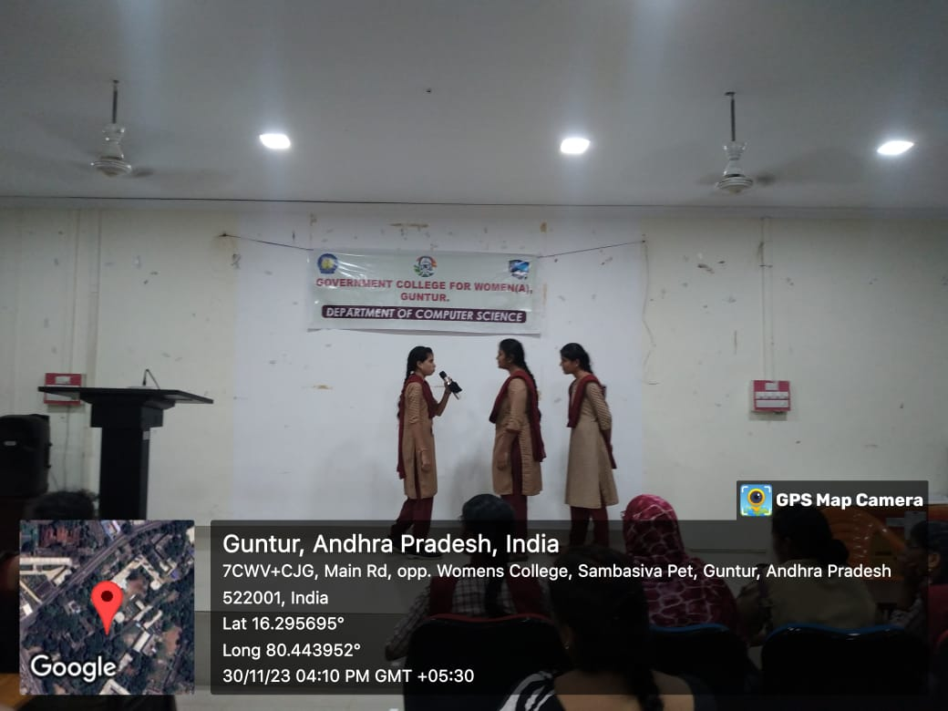
Students Performing Skits
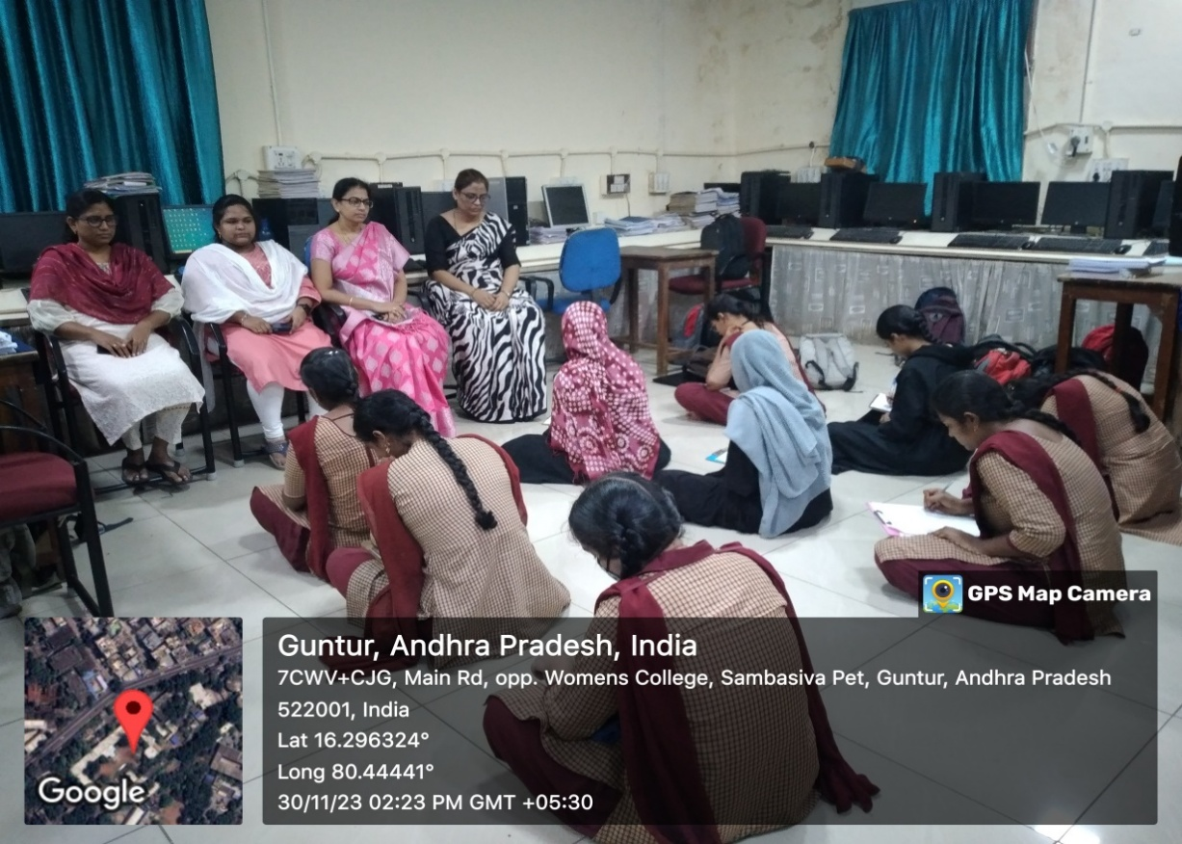

Students participating in the Essay-writing Competition and the faculty of Computer Science Department monitoring them.

Celebration of World Digital Literacy Day- Online Quiz
World Computer Literacy Day is observed on December 2, every year, to raise awareness about the role of computers in our lives and enhance digital literacy in all communities across the world
On this occasion Department of Computer Science organized a State level Quiz on the topic “Digital Literacy” for all 1st, 2nd& 3rd year students on 2nd December 2022. This event is conducted in online mode. Total 119 Students participated in this Quiz. E-Certificates issued to the all the participants who secured 80% and above score received.

Sample Certificate:

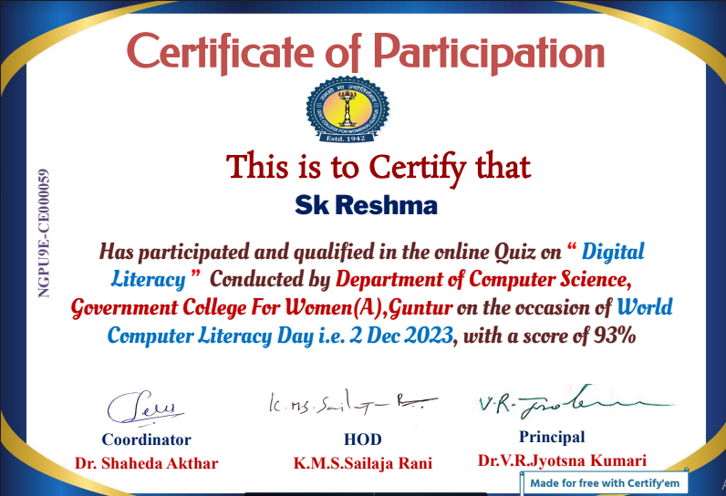

Calendar release by the Multimedia students
As one of the best practices of the Computer Science Department, we have been releasing a calendar designed by the multimedia students each year with a theme. This year (2024)also the students of multimedia group have designed a calendar which was given to the Principal and all the departments of the college.
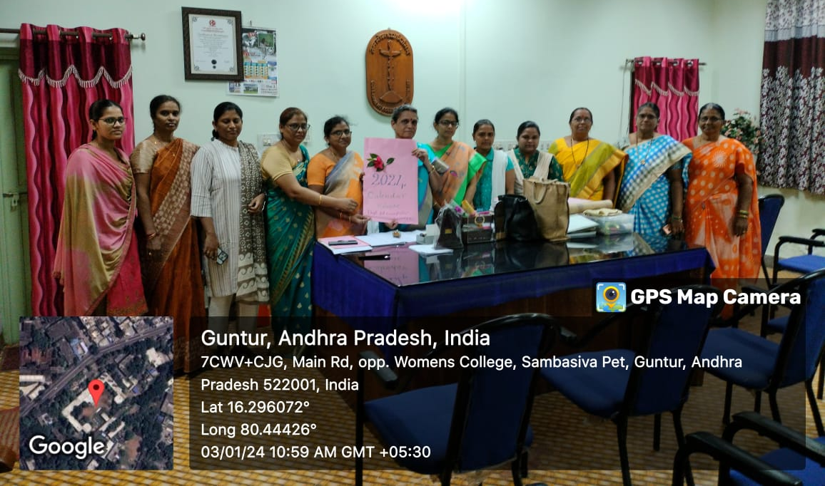
Calendar release by the Principal
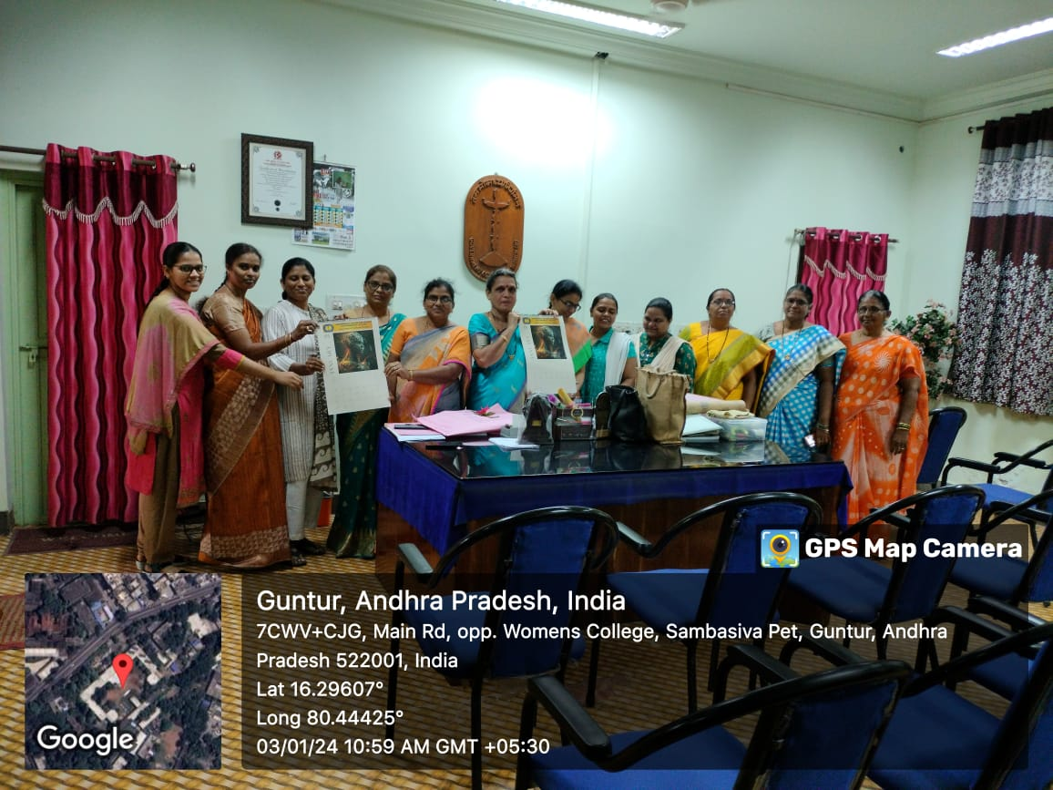
Calendar release by the Principal

Extension Activity : Awareness program conducted for the intermediate students about the career opportunities in Computer Science, Data Science and Cloud computing programs
The Department of Computer Science has organized an awareness program for the intermediate students about the career opportunities in Computer Science, Data Science and Cloud computing programs on 30-1-2024 from 4:00 PM to 5:00 PM
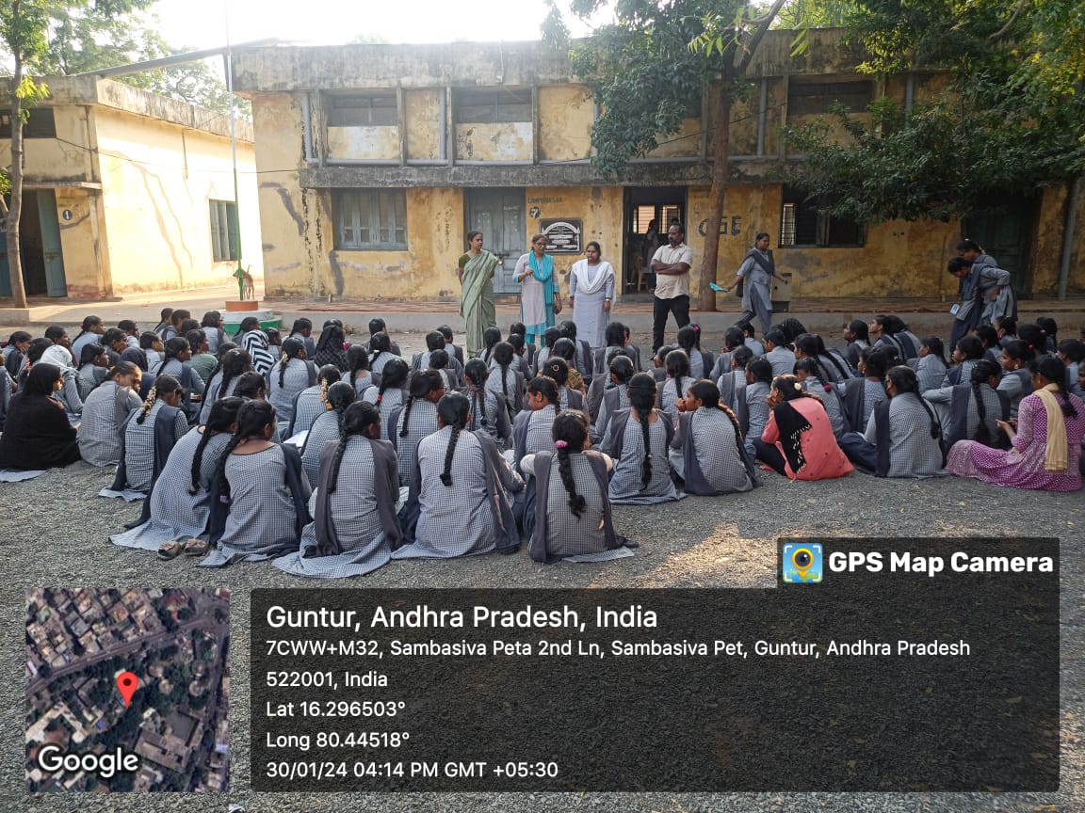
In-charge of the Computer Science Department Dr. Shaheda Akthar addressing the intermediate students.
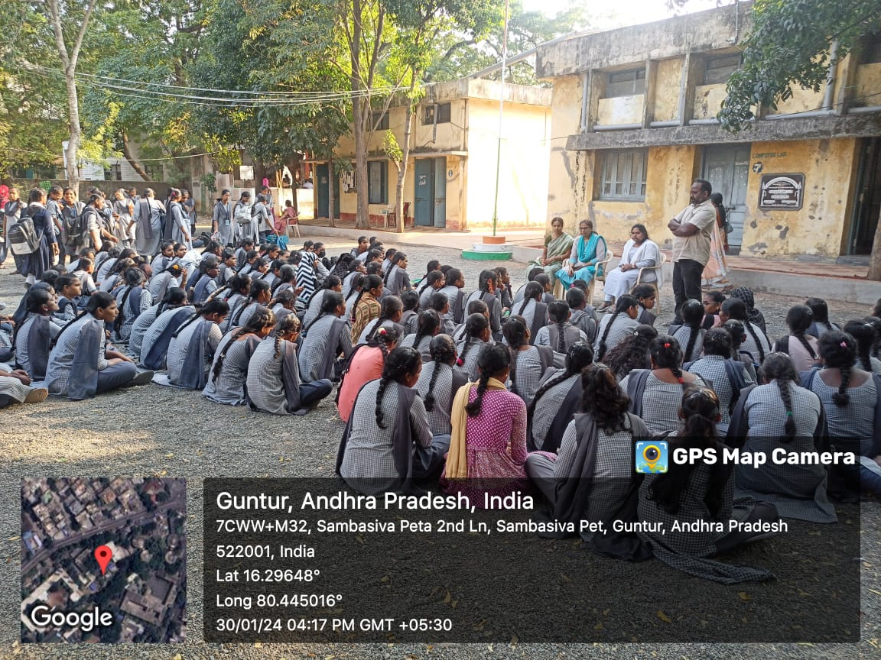
The intermediate students clearing their doubts in the interaction session

Field Trip to STPI (Software Technology Parks of India)
The Department of Computer Science has organised a Field trip for the students of B.Sc. Computer Science, B.Sc. Data Science, B.Voc. Software Development to STPI(Software Technology Parks of India) on 25th march 2024 from 10 AM to 5PM. The field trip to the STPI provided a comprehensive overview of its critical role in promoting software exports and nurturing the IT industry in India. Established in 1991, STPI offers state-of-the-art infrastructure, including data centers, incubation facilities, and co-working spaces, supporting start-ups and established IT companies alike. We explored various labs dedicated to emerging technologies such as AI, IoT, and blockchain, and observed innovative projects under development. Interactive sessions with STPI officials and industry experts highlighted the organization's efforts in fostering innovation, entrepreneurship, and global competitiveness through favorable policies and incentives. The visit underscored STPI's pivotal contribution to the growth and globalization of India's IT sector.
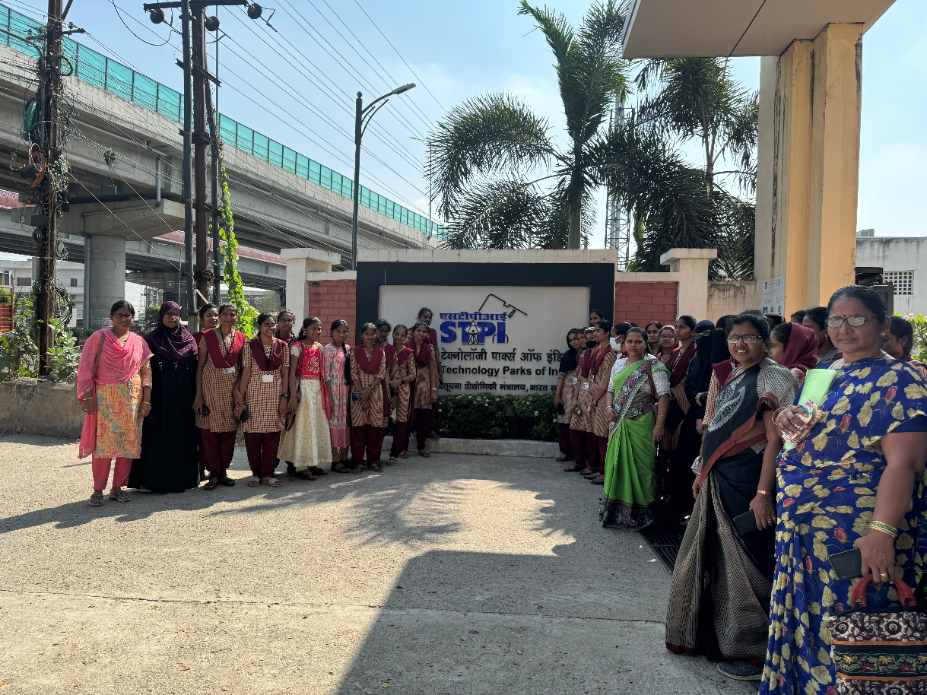
Students and the faculty visiting the STPI
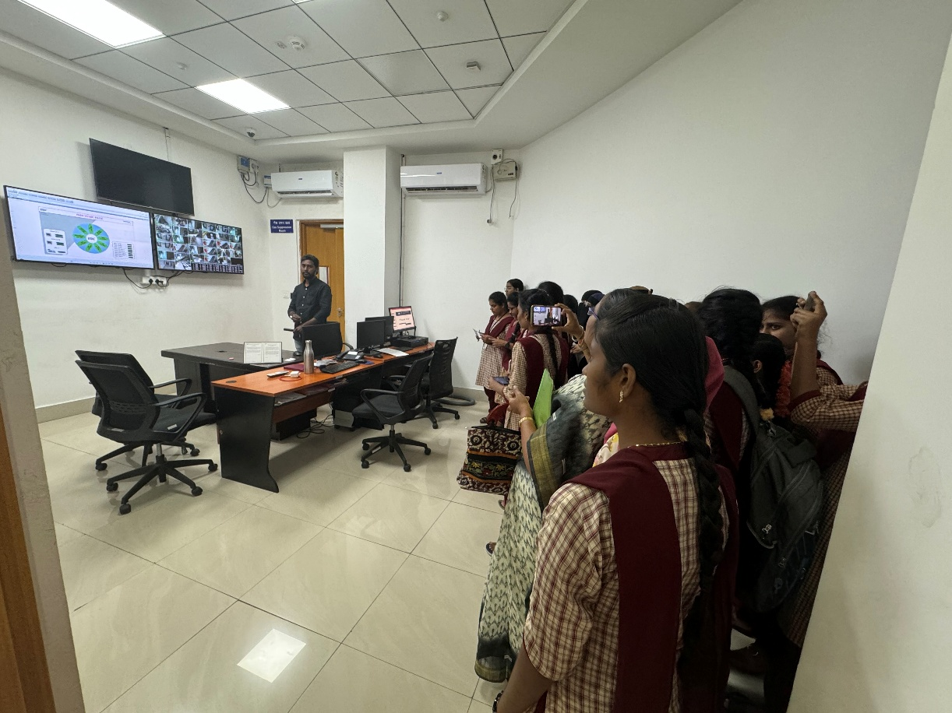
The STPI official interacting with the students
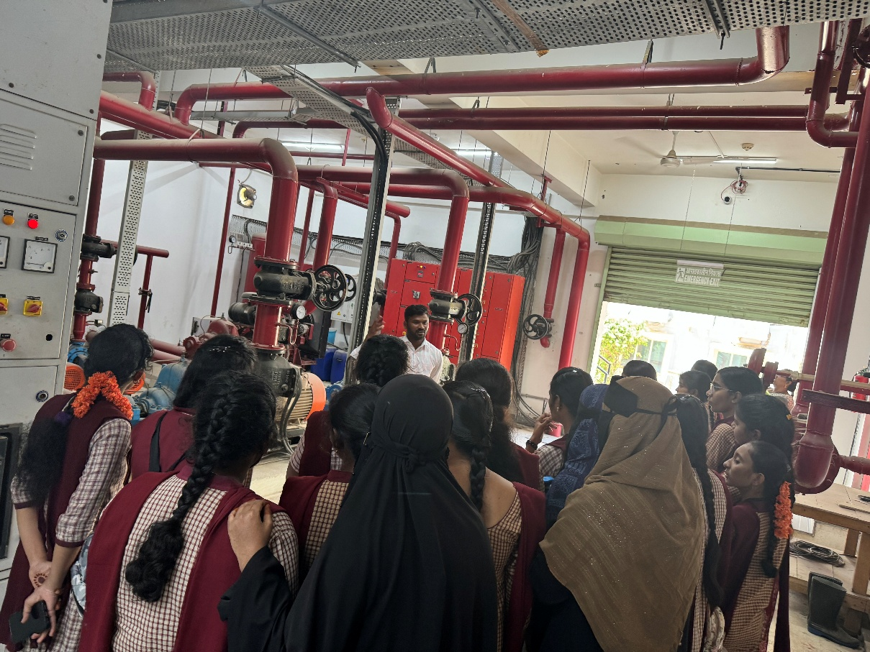
The students knowing about the internal Architecture
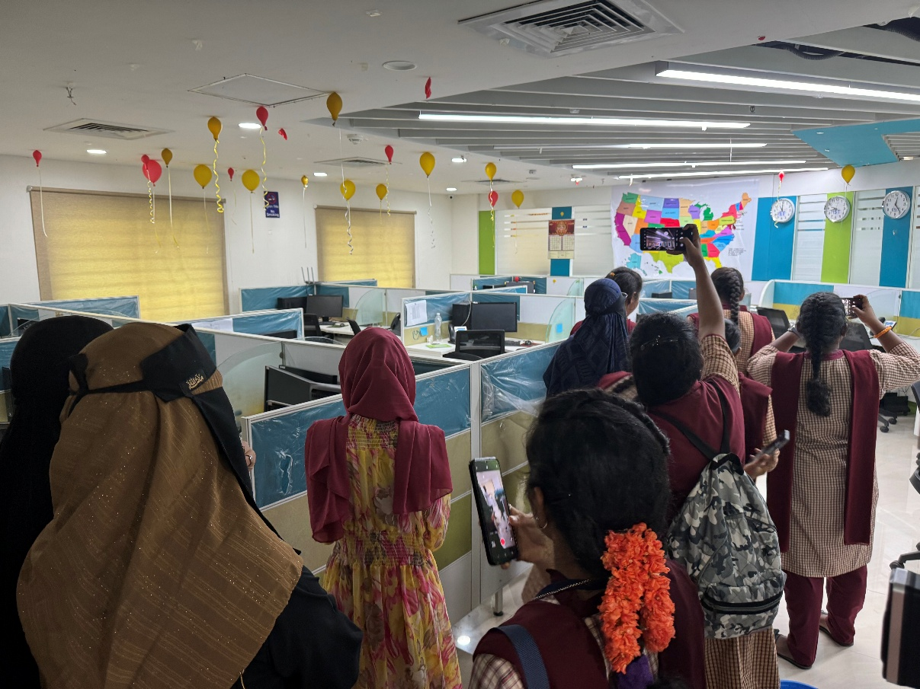
Students exploring the co-working space and the incubation centres provided by the STPI

