DEPARTMENT OF BIOCHEMISTRY
ACTIVITIES FOR THE YEAR 2023-24

Webinar on Potential of Mighty Millet
The U.N General assembly declared 2023 as the “International Year of Millets - IYO 2023”, as there is alarming increase of lifestyle diseases like diabetes, obesity etc., in recent years. In view of this the departments of Biochemistry & Food technology have organized ‘Webinar on Potential of mighty millets’ on 03-07-2023 by inviting Dr. M. Muthamilarasan, Asst. Profess Dept. of Plant Sciences, University of Hyderabad. He worked on Foxtail Millet, having many publications and rewards on it. Dr M. Muthamilarasan. has gave very clear information on the importance of millets in daily life and about millet cultivation. Millets help for better digestion, dietary fibre and protein which helps to lower glucose and improve insulin response. Hence now a days they most of the diabetic patients are preferring millet as their regular diet. Compared to other millets, foxtail millet having less glycemic index and rich with other mineral content.
The participants learned about the importance of millets in the diet and disease prevention. They specifically explored the benefits of foxtail millet, which is known for its high nutritional value and potential to reduce the risk of various health conditions.
No of participants- No of Students-45
No of Faculty-04
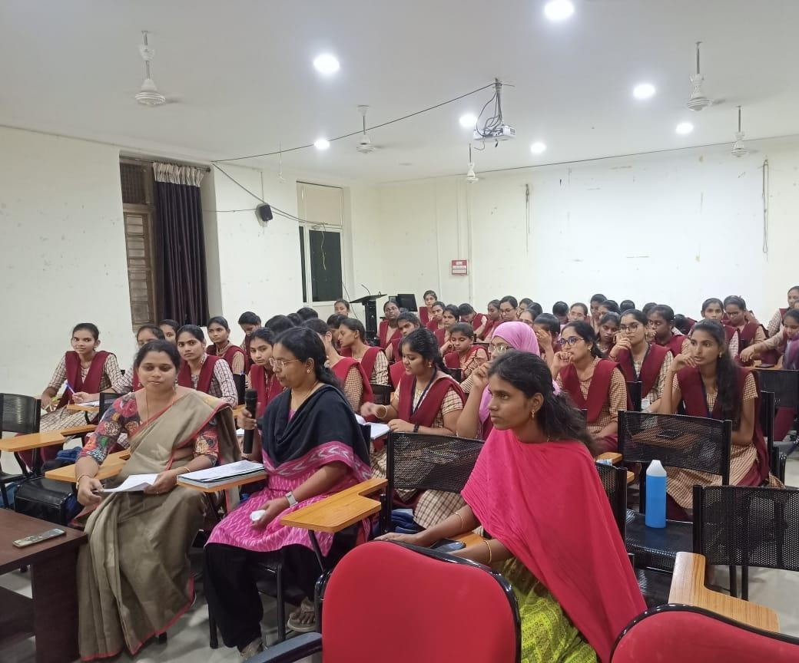

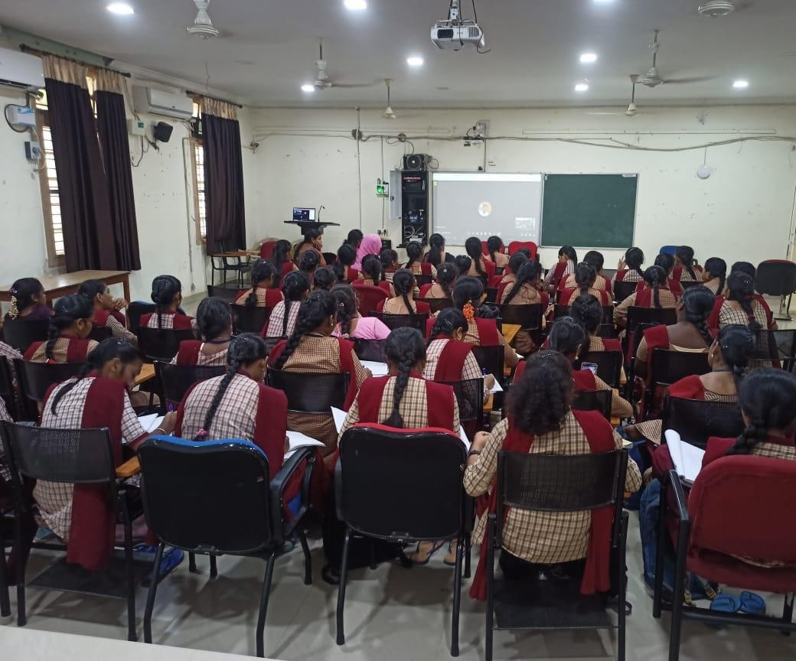

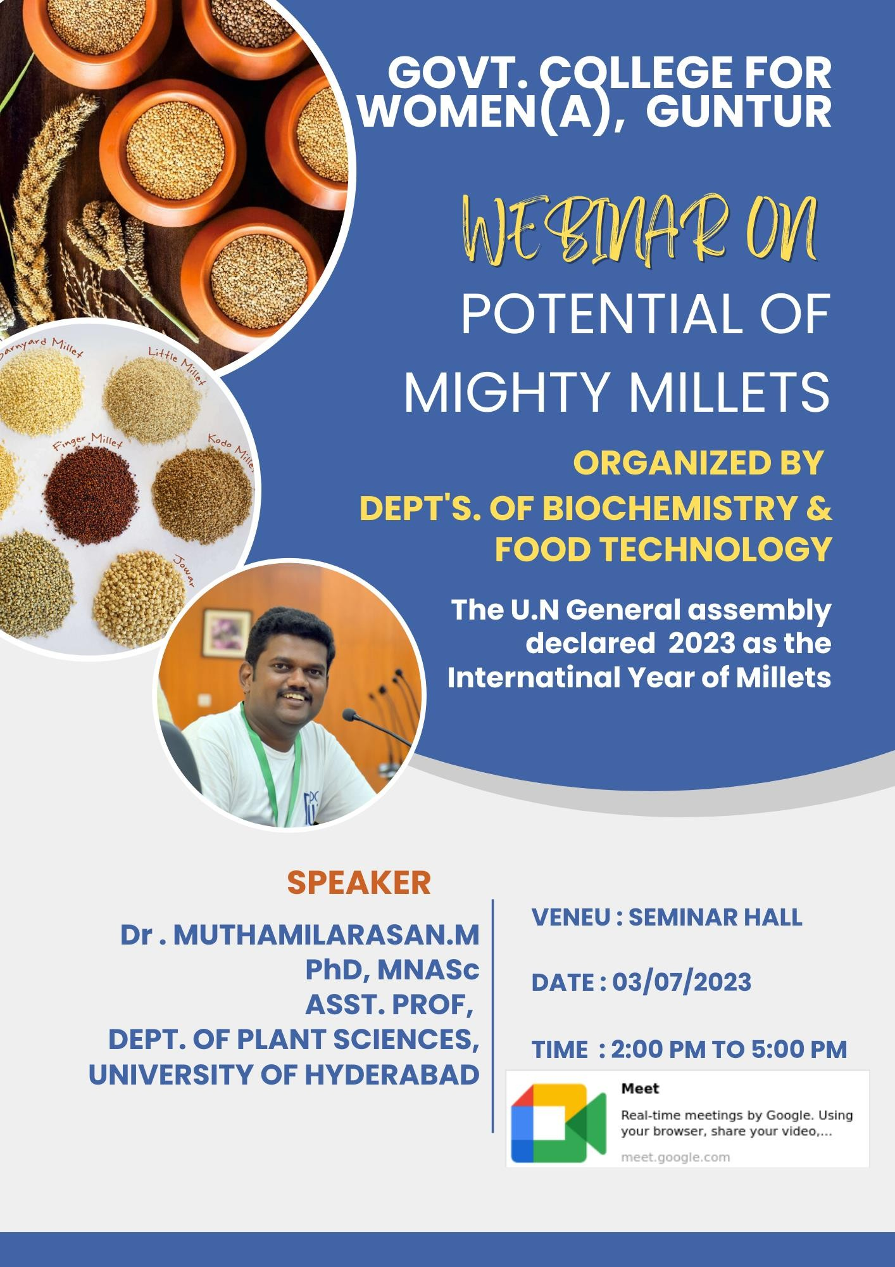

Hands On Session On “Teach with Tech: Navigating ChatGPT in Education”-
An awareness program was conducted by the Department of Biochemistry to explain the trends in technology to all the faculty and students on 14-12-2023. The resource person, Smt B Dorka Vijaya Kumari gave information regarding usage of technology in Teaching & evaluation, mainly focussing on Chat GPT in planning lessons, Power point making, formulating Cos, Pos, PSOs, In framing the syllabus etc. She also gave information regarding an app called Questionpaper.ai for generating a question paper as per blooms taxonomy & as per the model of the question paper.
By the end of the program, the faculty successfully created comprehensive lecture notes, PowerPoint presentations, and objective-type questions based on the provided prompts. These resources were designed to enhance the students' learning experience and provide clear, structured content for their studies. Additionally, students were able to utilize these prompts to generate their own objective questions in preparation for postgraduate entrance exams.
Participants of the programme: No of students-24
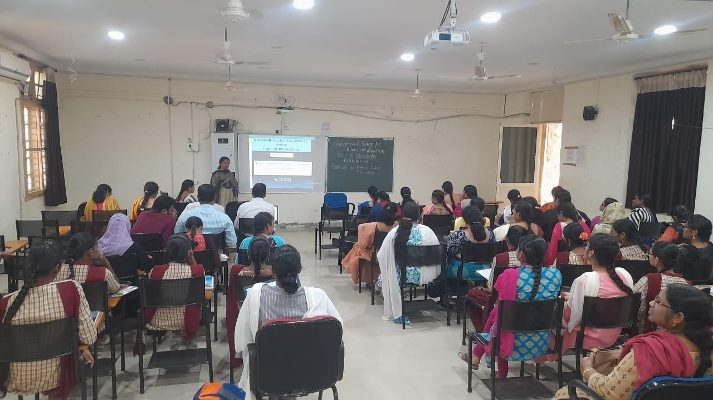
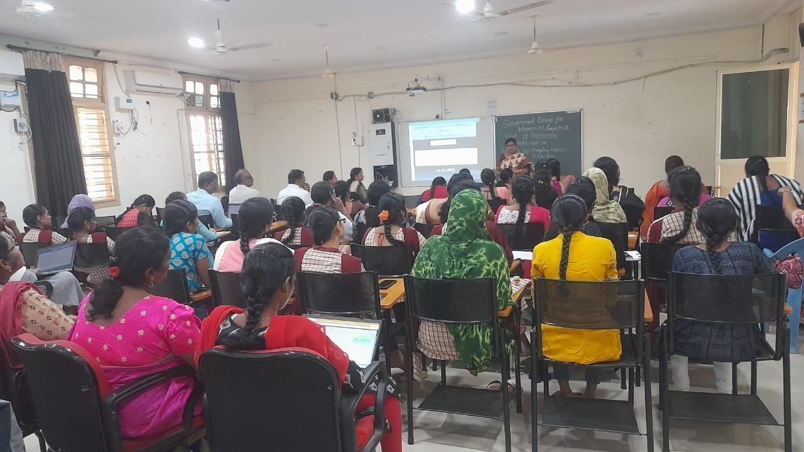
No of Faculty-30

Expert Talk on Career counselling in Medical Coding-
An expert talk was conducted for all the life science students, on unlocking opportunities: career counselling in Medical coding on 20-12-2023. The programme was organized by the Departments of Applied Sciences. Smt R Sireesha, Managing Director, Healtx Healthcare gave a detailed presentation on availability of job opportunities in medical coding covering various aspects such as demand, job market, skills required etc.
The participants have learned a career in medical billing and coding offers numerous benefits, including competitive salaries, remote work flexibility, and ample opportunities for career advancement. Additionally, this field provides a stable job market and the chance to work in various healthcare settings, making it an attractive option for those seeking long-term career growth. A total number of 70 students and 10 faculty members attended the programme.

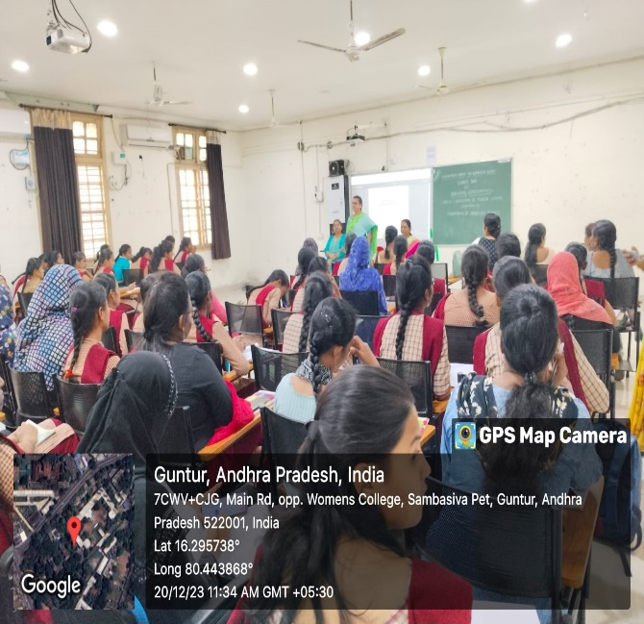

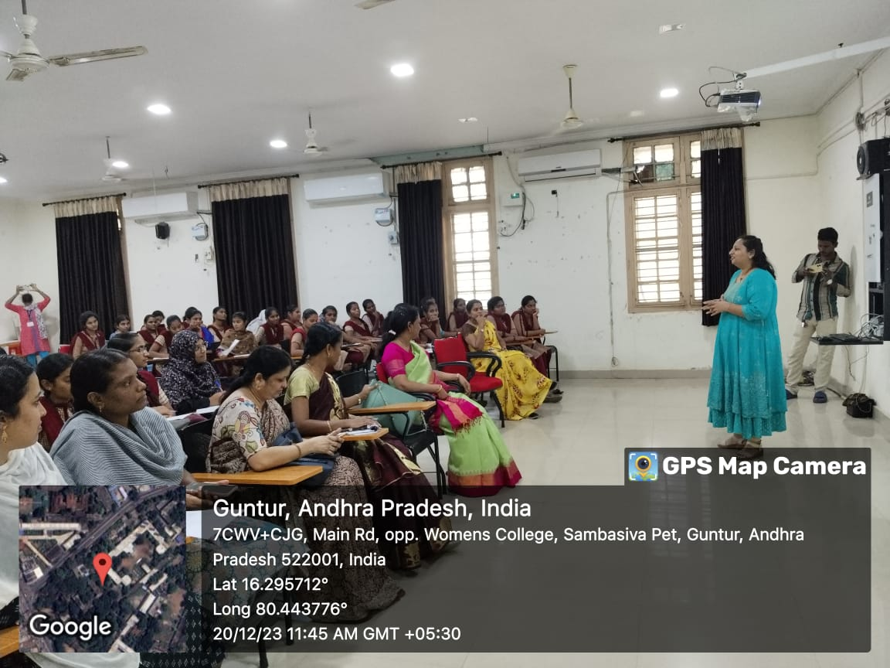

Workshop on DNA Finger printing
With an aim to provide the participants with a comprehensive understanding of DNA fingerprinting techniques and practical skills through hands-on training sessions, the Dept. of Biochemistry organized Hands on Training on “DNA Finger Printing” in collaboration with Tulasi Seeds Pvt. Ltd, Guntur on 21-12-2023.
In this workshop Students learned about various crucial concepts in molecular biology, including molecular markers, restriction endonucleases, DNA replication, PCR (polymerase chain reaction), and electrophoresis. In addition to theoretical instruction, they gained hands-on experience with these techniques, enabling them to apply their classroom knowledge in practical laboratory settings. This practical experience not only reinforced their understanding of the subject matter but also helped them develop essential technical skills and competencies required for advanced research and professional work in the field of molecular biology. 21 students of Biochemistry along with the faculty members participated in the workshop.
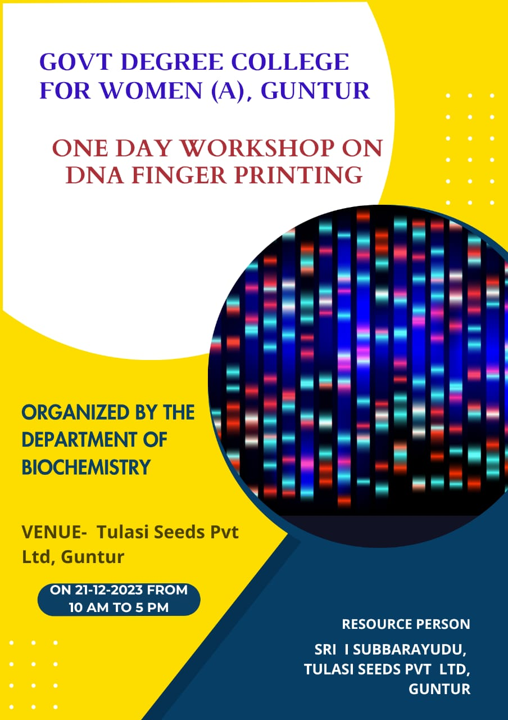

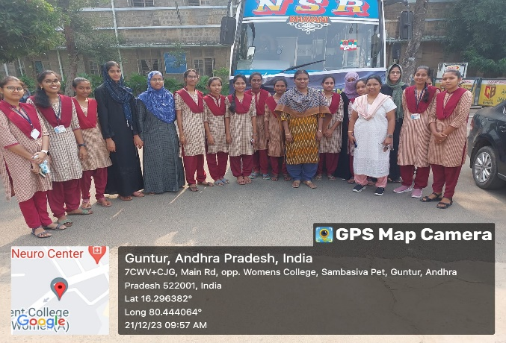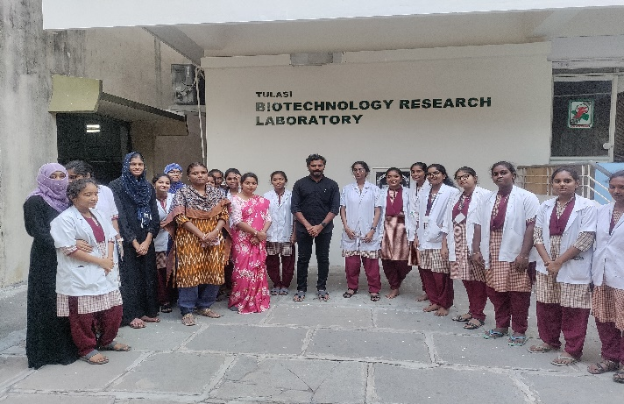
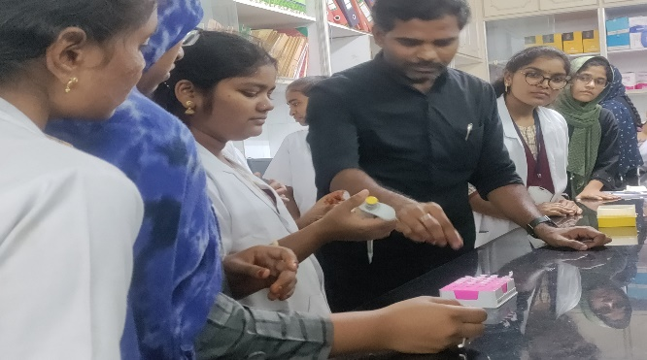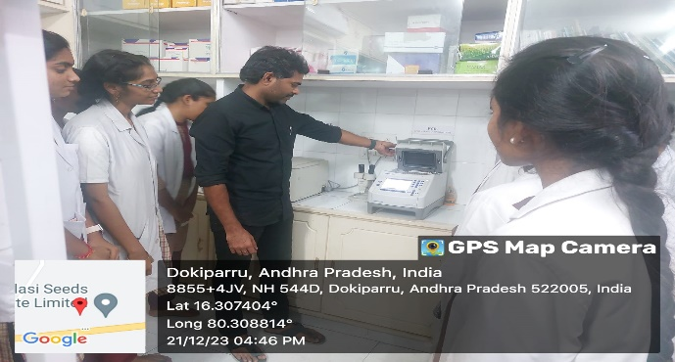
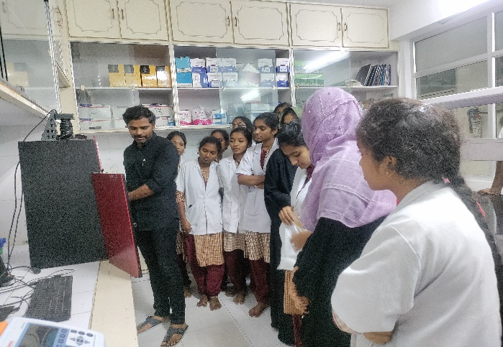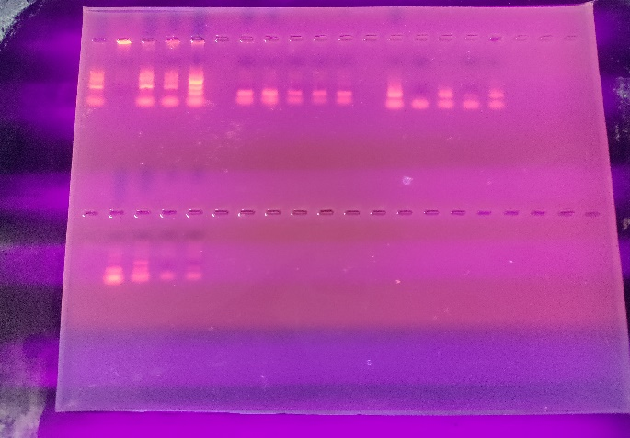

National Science Day
National Science Day in India is celebrated annually on February 28 to commemorate the discovery of “Raman Effect” by Indian Physicist Sir Chandrasekhara Venkata Raman. The occasion also serves as a platform to appreciate and raise public awareness about the contributions of our scientific community toward the development of our nation.
On the occasion of National Science Day, the departments of Applied Life Sciences organized an Essay Writing Competition and Bio Charades event on February 28, 2024, for all students within the Life Sciences disciplines. The students actively participated in these events, expressing their views on various scientific topics through their essays and engaging enthusiastically in the Bio Charades game. The competition and interactive activities provided a platform for students to showcase their knowledge, creativity, and passion for life sciences while also fostering a collaborative and stimulating learning environment.
The event was marked by a lively exchange of ideas and queries, highlighting the students' keen interest and dedication to the field. The program significantly enhanced the students' scientific approach and deepened their interest in the subject. A total of 50 students and 6 faculty members actively participated in the event, contributing to a vibrant and intellectually stimulating atmosphere.

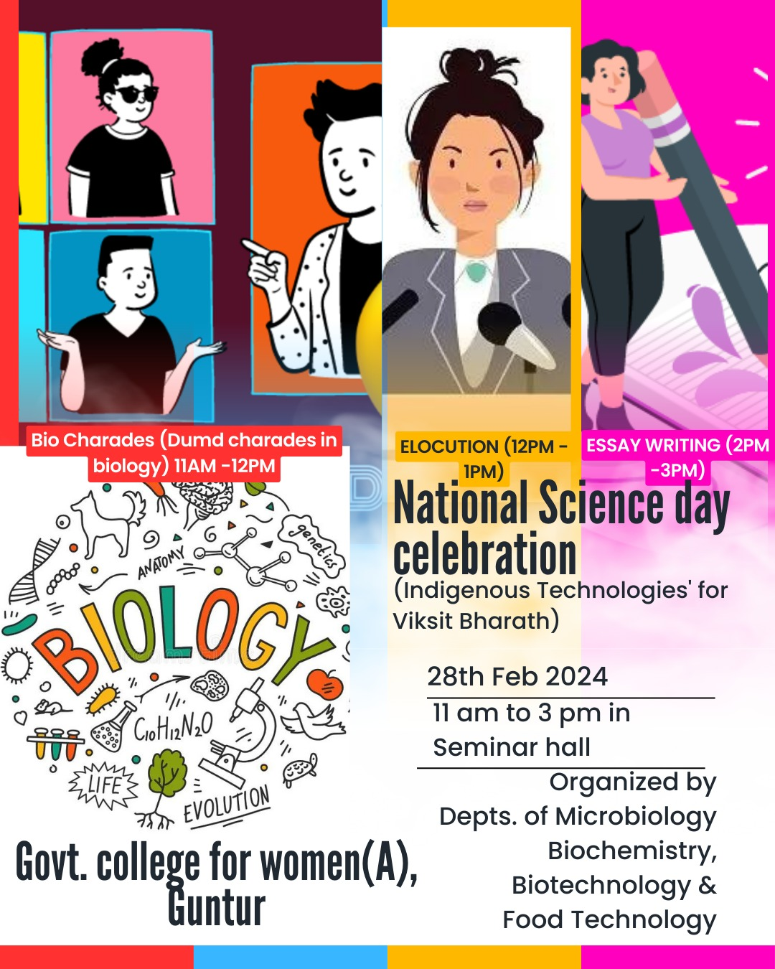

Pictures of the Event
